UNITED STATES

SECURITIES AND EXCHANGE COMMISSION

Washington, D.C. 20549

SCHEDULE 14A INFORMATION

Proxy Statement Pursuant to Section 14(a) of the Securities Exchange Act of 1934 (Amendment No. )

Filed by the Registrant ☒

Filed by a party other than the Registrant ☐

Check the appropriate box:

- Preliminary Proxy Statement

- Confidential, for Use of the Commission Only (as permitted by Rule 14a-6(e)(2)) ☒ Definitive Proxy Statement

- Definitive Additional Materials

- Soliciting Material under § 240.14a-12
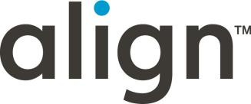

Align Technology, Inc.

(Name of Registrant as Specified In Its Charter)

(Name of Person(s) Filing Proxy Statement, if other than the Registrant)

Payment of Filing Fee (Check all boxes that apply):

- No fee required

- Fee paid previously with preliminary materials

- Fee computed on table in exhibit required by Item 25(b) per Exchange Act Rules 14a-6(i)(1) and 0-11

TABLE OF CONTENTS

LETTER TO OUR STOCKHOLDERS | iv
NOTICE OF 2026 ANNUAL MEETING OF STOCKHOLDERS | viii
PROXY STATEMENT SUMMARY | 1
Voting Roadmap | 2
Our Business | 3
2025 Performance Highlights | 3
Governance Highlights | 6
Director Highlights | 7
Fiscal Year 2025 Executive Compensation Highlights | 8
CORPORATE GOVERNANCE | 9
Strong Corporate Governance Policies and Practices | 10
Key Policies | 11
Board Structure and Independence | 12
Role of Our Board | 12
Board Risk Oversight | 12
Risk Oversight Program | 13
Committee Responsibilities and Oversight | 14
Annual Committee and Board Evaluations | 19
Board Meetings | 19
Stockholder Communications with our Board | 19
STOCKHOLDER ENGAGEMENT | 20
Stockholder Outreach and Engagement | 21
Meaningful Compensation and Governance Changes Reflects Stockholder Feedback | 22
CORPORATE ACCOUNTABILITY | 23
Accountability and Governance | 25
Sustainability | 26
Employees | 28
Community | 30
DIRECTORS | 33
Board Composition and Refreshment | 35
Director Nominees | 38
DIRECTOR COMPENSATION | 48
Cash Compensation | 49
Equity Compensation | 49
Total Compensation | 50
EXECUTIVE COMPENSATION – COMPENSATION DISCUSSION AND ANALYSIS | 51
Named Executive Officers | 52
Executive Summary | 53
Our Executive Compensation Program | 55
Principle Elements of Executive Compensation | 58
How We Implement and Manage Our Executive Compensation Program | 65
Severance and Change of Control Arrangements | 70
2025 Stockholder Say-on-Pay Vote Results | 71
Compensation and Human Capital Committee Report | 71
COMPENSATION TABLES | 73
Summary Compensation Table for Fiscal Year 2025 | 74
Grants of Plan-Based Awards for Fiscal Year 2025 | 76
Outstanding Equity Awards at Fiscal 2025 Year End | 79
Option Exercises and Stock Vested During Fiscal Year 2025 | 81
Potential Payments Upon Termination or Change of Control | 82
CEO Pay Ratio | 88
Pay Versus Performance | 89

ii

AUDIT COMMITTEE | 95
Our Auditor | 96
Report of the Audit Committee | 97
SECURITY OWNERSHIP AND RELATED PARTY TRANSACTIONS | 99
Security Ownership of Certain Beneficial Owners and Management | 100
Certain Relationships and Related Party Transactions | 101
PROPOSALS | 103
Proposal 1: Election of Directors | 104
Proposal 2: Advisory Vote to Approve the Compensation of our Named Executive Officers | 106
Proposal 3: Ratification of Appointment of Independent Registered Public Accounting Firm | 107
Proposal 4: Ratification of Special Meeting Provision in our Bylaws | 108
GENERAL INFORMATION | 110
VIRTUAL ANNUAL MEETING INFORMATION | 111
VOTING INFORMATION | 113
ADDITIONAL INFORMATION | 118
OTHER MATTERS | 120
Appendix A (Special Meeting Provision) | 121

Cautionary Note Regarding Forward-Looking Statements

In addition to historical information, this proxy statement contains forward-looking statements within the meaning of Section 27A of the Securities Act of 1933, as amended and Section 21E of the Securities Exchange Act of 1934, as amended (the “Exchange Act”). These statements include, among other things regarding, our ability to transform the way doctors deliver and patients experience digital orthodontics and restorative dentistry, expand the adoption of clear aligners and create lasting value for all stakeholders; our strategies and financial performance; our development of new and existing products and technologies; our momentum, profitability, and ability to accelerate long-term growth; the ability of DSOs to leverage standardized digital workflows, patient financing, and consumer marketing to drive adoption and utilization at scale; the long-term growth potential of the teens and growing kids category; our portfolio strategy, including Invisalign Doctor Subscription Plans, flexible treatment configurations, and Vivera retainers, and its ability to expand access to care, maintain healthy margins, and drive growth; the continued evolution of the Align Digital Platform and our software and treatment-planning technology as competitive advantages; broader industry shifts toward prevention, early intervention, and digitally enabled workflows and the anticipated benefits thereof; the expected benefits of direct printing technology, including design flexibility, sustainability, and improvements to our long-term cost structure, and the anticipated timing of initial limited market releases; our technology leadership, global scale, clinical data assets, and doctor-centered model and the anticipated benefits thereof; and other statements that are not historical fact. These statements may contain words such as “anticipate,” “believe,” “estimate,” “expect,” “future,” “intend,” “may,” “opportunity,” “plan,” “project,” “should,” “strategy,” “will,” “will be,” “will continue,” “will likely result,” “would” and similar expressions.

These forward-looking statements are subject to certain risks and uncertainties that could cause actual results to differ materially from those reflected in the forward-looking statements. Factors that could cause or contribute to such differences include, but are not limited to, those discussed in Part II, Item 7 “Management’s Discussion and Analysis of Financial Condition and Results of Operations,” and in particular, the risks discussed in Part I, Item 1A “Risk Factors” of our Annual Report on Form 10-K for the year ended December 31, 2025, which was filed with the Securities and Exchange Commission on February 27, 2026. We undertake no obligation to revise or update these forward-looking statements. Given these risks and uncertainties, readers are cautioned not to place undue reliance on such forward-looking statements.

Unless otherwise expressly stated or context requires otherwise, information in this proxy statement is as of April 7, 2026.

iii

 Letter to Our Stockholders

iv



“Together, with our customers, we

are transforming the way doctors deliver and patients experience digital orthodontics and

restorative dentistry, expanding the adoption of clear aligners, and creating lasting value for all

stakeholders.”

- Major milestones: 22 million Invisalign® patients treated—including over 6.5 million teens and kids—over 295 thousand active Invisalign® trained

practitioners, and over 2.4 billion clear aligners manufactured worldwide

    - FY 2025 Total Revenues of $4.0 billion

  - FY 2025 Operating Margin of 13.5%, or 21.8% on a non-GAAP basis

- FY 2025 Diluted Net Income per share of $5.65, or $10.51 on a non-GAAP basis

      - Repurchased $466 million of Align
common stock during 2025

April 7, 2026

Dear Stockholders,

As I reflect on fiscal 2025, I am proud of how Align navigated a year that demanded focus, resilience, and disciplined execution. The operating environment remained uneven across regions, consumer demand was pressured in parts of the world, and we made difficult organizational decisions to better position the company for the future. Yet through these challenges, our teams stayed anchored to what matters most—serving doctors and their patients—and delivered a strong finish to the year.

Across our customer base, we saw continued strength from Orthodontists globally, growing engagement from GP Dentists adopting digital orthodontic and restorative workflows, and sustained momentum from Dental Service Organizations, which continue to scale Invisalign® clear aligners, iTero™ scanners, and software adoption across large practice networks. From a regional perspective, EMEA, Latin America, and APAC delivered the strongest growth, while North America showed improved stability, supported by increased utilization, conversion initiatives, and DSO performance.

2025 was not defined by the obstacles we faced, but by how we responded. We sharpened execution, elevated quality, and improved the experience we deliver every day through the Align™ Digital Platform. As a result, we exited the year with increased momentum, improved profitability, and a stronger foundation to accelerate long-term growth.

Delivering Results While Building for the Future

For fiscal 2025, Align delivered record total revenues of approximately $4.0 billion and record Clear Aligner volumes of 2.6 million cases, reflecting continued global adoption of the Invisalign system across orthodontists, general practitioners, and dental service organizations. While growth varied by region in a challenging macroeconomic environment, our focus on operating discipline translated into meaningful profitability improvement.

We delivered a non-GAAP operating margin of 22.7%, exceeding our outlook and representing our strongest full year margin performance since 2021. This improvement reflects tighter execution across manufacturing, treatment planning, and commercial operations, as well as the benefits of scale across our global digital and 3D printing infrastructure.

We ended the year with a strong balance sheet, over $1 billion in cash and cash equivalents, no debt, and continued to deploy capital in a disciplined manner. During 2025, we returned capital to stockholders through approximately $466 million in share repurchases, while maintaining the flexibility to invest in innovation, global infrastructure, and long-term growth opportunities.

Invisalign Clear Aligners: Expanding Access and Clinical Applicability

Our Invisalign Clear Aligner business, which includes aligners and Vivera™ retainers, remains the cornerstone of Align’s growth. In 2025, Clear Aligner revenues reached approximately $3.2 billion, supported by record case volumes and continued adoption across adults, teens, and growing kids.

Orthodontists remain our largest and most engaged customer segment globally, while GP Dentists continue to represent a meaningful growth opportunity as they increasingly adopt Invisalign treatment as part of comprehensive digital dentistry. DSOs continue to outperform other customer segments, leveraging standardized digital workflows, patient financing, and consumer marketing to drive adoption and utilization at scale.

v

We saw particular strength internationally, with double‑digit volume growth in EMEA, Latin America, and APAC, and improved stability in North America as we focused on utilization, conversion, and affordability. The teens and growing kids category remains a critical long‑term growth driver, with nearly one million teens and kids starting Invisalign treatment in 2025, supported by products such as Invisalign First™, the Invisalign® Palatal Expander System, and the Invisalign® System with mandibular advancement solutions.

Our portfolio strategy continues to expand access to care. Programs such as Invisalign® Doctor Subscription Plans and more flexible treatment configurations maintain healthy margins, drive growth and give doctors additional options to meet patient needs. Vivera retainers play an increasingly important role in long‑term retention, reinforcing ongoing doctor‑patient relationships beyond active treatment.

Systems and Services: Powering the Digital Standard of Care

Our Systems and Services segment, which includes iTero intraoral scanners, exocad CAD/CAM software, and related services, continues to play a critical role in driving digital adoption and recurring revenue across orthodontic and restorative workflows.

In 2025, Systems and Services revenues approached $790 million, reflecting continued growth in our active units and increased utilization of digital solutions globally. Adoption of the iTero Lumina™ platform accelerated across regions, supporting faster scanning, enhanced visualization, and improved chairside communication for doctors and patients.

exocad strengthened its leadership position in dental CAD/CAM software, expanding its footprint across dental labs, which remain a critical channel in restorative dentistry. Labs serve as an essential connection point between scanning, treatment planning, and fabrication, and exocad’s flexible architecture enables efficient collaboration among orthodontists, GP dentists, and lab partners.

We continued piloting exocad ART (Advanced Restorative Treatment) solutions, which integrate orthodontic tooth movement with restorative planning, enabling less invasive, more predictable outcomes. In parallel, we advanced Invisalign ART pilots, bringing orthodontic planning earlier into restorative cases. Together, these pilots reflect our long‑term strategy to connect orthodontics, restorative dentistry, and lab workflows within a unified digital ecosystem.

iTero scanners, exocad CAD/CAM software, and our services portfolio elevate the value of the Align Digital Platform by driving recurring software revenue, strengthening customer retention, and enabling more integrated, efficient, and predictable workflows across the dental ecosystem.

Software and Treatment Planning: Intelligence at the Core

At the heart of the Align Digital Platform is our software and treatment‑planning technology, which continues to evolve rapidly and represents one of our most innovative, differentiating and customer centric competitive advantages.

In 2025, we expanded adoption of ClinCheck® signature experience, our next‑generation treatment‑planning experience that integrates AI‑driven automation with real‑time doctor control. ClinCheck signature experience brings together capabilities such as Live Plan and Live Update, enabling doctors to review, modify, and finalize treatment plans dynamically—reducing planning cycles from days to minutes and moving closer to real‑time treatment planning.

Tools such as Invisalign® Personalized Plan (IPP) further tailor treatment plans to individual doctor preferences and clinical protocols, increasing predictability, consistency, and confidence across cases. As automation continues to scale, these software capabilities improve efficiency for doctors while also strengthening Align’s operating excellence by reducing touchpoints and cycle time within our treatment‑planning workflow.

Importantly, these capabilities extend beyond orthodontics. Along with iTero scanning, exocad software, and lab workflows, Align’s treatment‑planning intelligence increasingly supports ortho‑restorative cases, strengthening our role across the full continuum of care.

vi

Advancing Oral Health Through Digital Diagnostics and AI

Increasingly, Align’s role extends beyond tooth alignment to broader oral health. With Align’s portfolio of technologies, doctors can identify conditions earlier, communicate more clearly with patients, and integrate orthodontic tooth movement as part of comprehensive oral care.

In 2025, we continued expanding capabilities such as the Align™ Oral Health Suite and Align™ X‑Ray Insights, which harness AI‑driven diagnostics to help doctors detect and visualize oral health issues using digital scans and radiographs. When combined with iTero scanning, ClinCheck treatment planning, exocad ART workflows, and

Invisalign treatment, these tools help connect orthodontics, function, and restorative care—supporting better long‑term oral health outcomes for patients.

This integrated approach reflects a broader shift in dentistry toward prevention, early intervention, and digitally enabled workflows that improve both clinical outcomes and patient experience.

Innovation, Discipline, and Long‑Term Value Creation

Innovation remains the foundation of Align’s strategy, complemented by disciplined execution. In 2025, we continued investing in AI‑driven software, integrated treatment planning, ortho‑restorative workflows, and direct fabrication through 3D printing, which represents the next evolution in orthodontic manufacturing. While still early, direct printing unlocks new design flexibility, improves sustainability, and strengthens our long‑term cost structure, with initial limited market releases beginning in 2026.

Align operates in a large, underserved global market where the majority of people who could benefit from orthodontic and restorative treatment still do not receive care. Our strategy remains clear: expand international adoption, increase utilization—particularly among teens and kids—accelerate GP and lab engagement across restorative workflows, and improve consumer demand conversion through localized, data‑driven marketing.

Looking Ahead

As we enter 2026, I am cautiously optimistic. Our technology leadership, global scale, deep clinical data, and a doctor‑centered model —are strong. Realizing their full potential requires continued focus, consistent execution, and an unwavering commitment to our customers.

I want to thank our employees for their dedication and resilience, our doctor and lab partners for their trust, and our stockholders for their continued confidence in Align. Together, we are advancing the digital transformation of orthodontics and restorative dentistry, expanding access to care, improving oral health outcomes, and creating lasting value for patients, customers, and shareholders alike.

Sincerely,
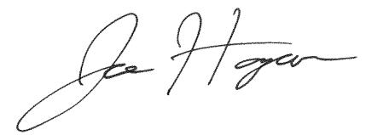

Joe Hogan, President & CEO

Align Technology, Inc.

vii

Notice of 2026 Annual Meeting of Stockholders

Date and Time | Record Date | Virtual Meeting Location
Wednesday, May 20, 2026 | March 23, 2026 | Online at https://web.viewproxy.com/aligntech/2026
10:00 a.m. Mountain Standard Time | March 23, 2026 | Online at https://web.viewproxy.com/aligntech/2026


ITEMS OF BUSINESS

COMPANY PROPOSALS

Proposal 1: Election of Directors

Proposal 2: Advisory Vote to Approve the Compensation of our Named Executive Officers

Proposal 3: Ratification of Appointment of Independent Registered Public Accounting Firm

Proposal 4: Ratification of Special Meeting Provision in our Bylaws

FOR EACH
NOMINEE

FOR

FOR

FOR

YOUR VOTE IS IMPORTANT

Please vote as promptly as possible by using any of the following methods: You may vote your shares over the Internet or by telephone. If you received a paper copy of a proxy card by mail, you may submit your proxy for the Annual Meeting by completing, signing, dating and returning your proxy card in the pre-addressed envelope provided. For specific instructions on how to vote your shares, please refer to the section entitled, “Voting Information—How do I vote my shares during the Annual Meeting?”

OTHER BUSINESS

Consideration of other business as may properly come before the Annual Meeting or any adjournments or postponements thereof

On or about April 7, 2026, we will mail to our beneficial and registered stockholders a Notice of Internet Availability of Proxy Materials (“Notice”) containing instructions on how to access our Proxy Statement and Annual Report and how to vote online. The Notice also contains instructions on how to request and receive a printed paper copy of the Proxy Statement, Proxy Card and Annual Report.

Stockholders of record as of the close of business on March 23, 2026 are entitled to vote at the Annual Meeting and any adjournments or postponements thereof.

Thank you for your ongoing support of, and continued interest in, Align Technology, Inc.

Sincerely,
Align Technology, Inc.


Julie Coletti
Executive Vice President, Chief Legal and
Regulatory Officer

viii

Important Notice Regarding the Availability of Proxy Materials for the Stockholder Meeting to be Held on May 20, 2026.

The Proxy Statement and Align Technology, Inc.’s Annual Report on Form 10-K are available
electronically at https://web.viewproxy.com/aligntech/2026

Virtual Meeting Admission

All stockholders as of the Record Date (March 23, 2026), or their duly appointed proxies, may attend our virtual Annual Meeting. Online access will begin at 9:30 a.m. Mountain Standard Time, and we encourage you to join early. To be admitted to the Annual Meeting, eligible stockholders must register in advance at https://web.viewproxy.com/aligntech/2026

Technical Issues

Contact 866-612-8937(toll-free) or 973-873-7684 (international) for any technical difficulties or trouble accessing the virtual meeting or if you are unable to locate your digital control number.

Adjournments and Postponements

Any action on the Items of Business may be considered at the Annual Meeting at the time and on the date specified above or at any time and date to which the Annual Meeting may be properly adjourned or postponed.

Proxy Statement Summary

Voting Roadmap

Our Business

2025 Performance Highlights

Governance Highlights

Director Highlights

Fiscal Year 2025 Executive Compensation Highlights


Proxy Statement Summary

This Proxy Statement Summary highlights selected information contained elsewhere in this proxy statement of Align Technology, Inc. (“we,” “us,” “our,” “Align” or the “Company”). It does not contain all the information you should consider, and as such, we urge you to carefully read this proxy statement in its entirety prior to voting. For additional information, please review our Annual Report on Form 10-K for the fiscal year ended December 31, 2025, available at https://investor.aligntech.com/financial-information/annual-report.

1

Voting Roadmap

Proposals | For More |  |  | Board
Proposals | Information |  |  | Recommendation
COMPANY PROPOSALS
Proposal 1: Election of Directors. Our Board of Directors (the “Board”) and its Nominating and
Governance Committee believe that the ten nominated directors (the “Nominees”) encompass a range of | Page 104 |  |  | FOR EACH
talents, skills, expertise, diversity of backgrounds and experiences sufficient to provide sound and prudent |  |  |  | FOR EACH
guidance for Align’s operations and interests and the interests of Align’s stockholders. See the section |  |  |  | NOMINEE
entitled “Director Nominees.”
Proposal 2: Advisory Vote to Approve the Compensation of our Named Executive Officers. Our
executive compensation program is designed to align pay with performance, taking into account stockholder | Page 106 |  |  | FOR
feedback and interests. See the section entitled “Executive Compensation—Compensation Discussion and |  |  |  | FOR
Analysis.”
Proposal 3: Ratification of Appointment of Independent Registered Public Accounting Firm. Our Board
believes the continued retention of PricewaterhouseCoopers LLP is in the best interests of Align and our | Page 107 |  |  | FOR
stockholders. Our Board submits the appointment of PricewaterhouseCoopers LLP to our stockholders for |  |  |  | FOR
ratification as a matter of good corporate practice. See the section entitled “Company Proposal 3: Ratification
of Appointment of Independent Registered Public Accounting Firm.”
Proposal 4: Ratification of Special Meeting Provision in our Bylaws. Our Board believes that the existing
right of our stockholders who have continuously held a combined 25% of our outstanding common stock for | Page 108 |  |  | FOR
one year to require our Board to call a special meeting of stockholders strikes the appropriate balance |  |  |  | FOR
between enhancing stockholder rights and protecting the long-term interests of Align and our stockholders.
2

Our Business

Align is a global medical device company focused on the treatment of malocclusions, or the misalignment of teeth, through doctor-led digital orthodontics and restorative dentistry solutions. We generate revenues from the design, manufacture, market and sale of the Invisalign® system of clear aligners, Vivera™ retainers, iTero™ intraoral scanners, imaging systems and services, and exocad™ computer-aided design and computer-aided manufacturing (“CAD/CAM”) software directly to orthodontists, general dental practitioners (“GPs”), dental and orthodontic service organizations (DSO/OSO), as well as dental laboratories. Our vision is to make tooth alignment using clear aligner therapy the standard of care (solution of choice) by revolutionizing traditional treatment modalities, appliances, tools, practice workflows, and business and go-to-market models across the dental industry. By focusing on oral health and the benefits of tooth alignment as part of orthodontic or restorative treatment, we develop products and technologies to help doctors deliver the best treatment experience and clinical outcome for their patients. From initial digital iTero scan at the doctor’s chairside, digital diagnostics and digital treatment planning implemented through innovations such as the Align™ Digital Platform, an integrated suite of proprietary technologies and services designed to deliver a seamless, end-to-end solution for patients, consumers, orthodontists, GPs and lab partners. We strive to achieve our vision and strategy through key objectives made possible with the proprietary technologies and services of the Align™ Digital Platform to establish: clear aligners as the principal solution for the treatment of malocclusions with the Invisalign system as the treatment solution of choice by orthodontists, GPs and patients globally, our iTero intraoral scanners as the preferred scanning technology for digital dental scans and our exocad CAD/CAM software as the dental restorative solution of choice for dental labs.

2025 Performance Highlights

In 2025, we remained steadfast in our commitment to our doctor customers and their patients and further extended our leadership in digital orthodontics and restorative dentistry by focusing on and executing our strategic growth drivers, which are:

International Expansion | GP Dentist Treatment | Patient Demand | Orthodontic Utilization





We continue growing our global | We strive to enable GPs, who | Our goal is to make the Invisalign® | We continue to innovate and
presence by increasing | treat the general patient | brand a highly recognized name | increase product applicability and
awareness of our products and | population, to more easily identify | brand worldwide by creating | predictability to address a wide
making them available in more | potential cases they can treat with | awareness for Invisalign treatment | range of cases, from simple to
countries to more customers and | the Invisalign System, monitor | among consumers and motivating | complex, thereby enabling doctors
consumers. We continue | patient progress or, if needed, help | the potential 600 million patients | to confidently diagnose and treat
expansion of our sales and | refer cases to orthodontists while | who can benefit from treatment of | children and adults with the
marketing by reaching into new | providing high-quality restorative, | malocclusion to seek treatment | Invisalign System.
countries and regions, including | orthodontic and dental hygiene | using the Invisalign System.
new areas in Africa, Asia, and | care.
Latin America.

3

In 2025, we achieved new milestones towards our strategic priorities.

REVENUES AND MILESTONES
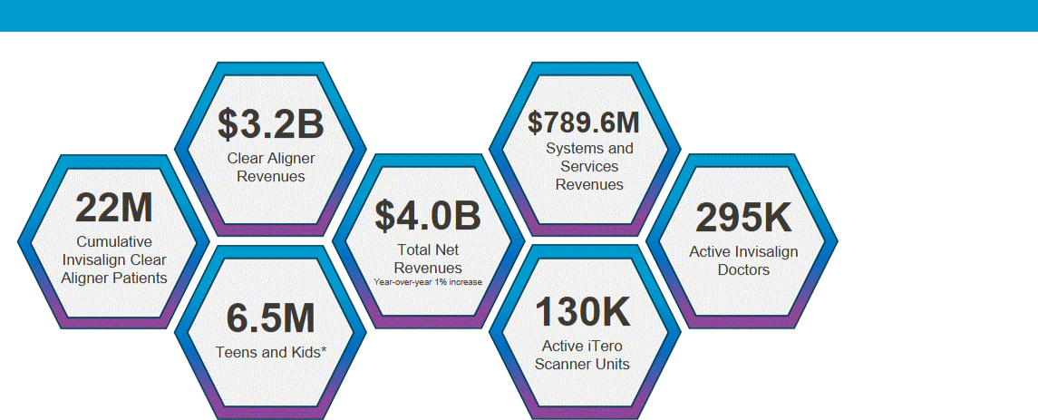

*Included in cumulative Invisalign Clear Aligner Patients’ total

For the full year 2025, total revenues were $4.0 billion, of which Clear Aligner revenues were $3.2 billion, and Systems and Services revenues were $789.6 million. During 2025, we reached the 22 millionth Invisalign clear aligner patient milestone, which included over 6.5 million teens and kids. In 2025, we had a record number of 295 thousand active Invisalign® trained practitioners globally, reinforcing our commitment to doctor-directed and managed care for clear aligner treatment to achieve the safest, most predictable and best possible clinical treatment outcomes for patients. We have also manufactured over 2.4 billion clear aligners.

As we further evolve the treatment planning experience for doctors through new technological research and development innovations, we expect to introduce new technologies, features and functionality that improve personalization of treatment planning, predictability, clinical preferences, and 2D/3D imaging, including digital tools for faster and more accurate final tooth positions.

In 2025, we announced several new enhancements to the AlignTM Digital Platform.

- In March, we announced the addition of restorative capabilities to our iTero Lumina™ intraoral scanner (without iTero NIRI technology) and the new iTero Lumina™ Pro dental imaging system (with iTero NIRI technology).

- In March, we also announced the launch in European Union countries and the United Kingdom of Align X-ray Insights, a new software-based computer aided detection (CADe) solution that uses artificial intelligence (“AI”) to automatically analyze 2D radiographs.

- In October, we announced a series of new innovations for iTero Digital Solutions, a comprehensive ecosystem that includes intraoral scanners and integrated software tools, including enhancements to the Align™ Oral Health Suite, Invisalign® Outcome Simulator Pro with ClinCheck® Smile Video, and the iTero™ Design Suite.

- In December, we announced limited commercial availability of the Invisalign® System with mandibular advancement featuring occlusal blocks (MAOB), the latest clinical innovation that expands Align’s Class II treatment portfolio by offering practitioners a comprehensive solution for treating growing patients with Class II malocclusions caused by mandibular retrusion.

4

In addition to these and other innovations expected in the coming years, we intend to continue to build the Align™ Digital Platform and add new capabilities to improve clinical outcomes and elevate patient experiences to drive continued practice growth and positive patient experiences.

Net Revenues and Operating Income

The following graphs show Align’s net revenues and operating income from fiscal year 2016 to 2025.
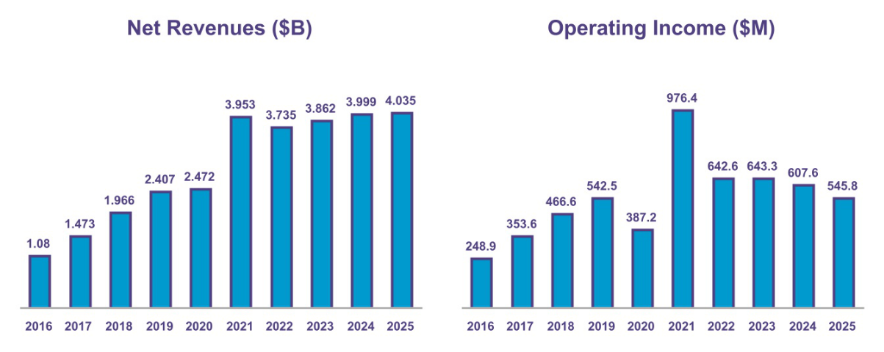

Revenue and Profit CAGR

The following graph provides the eight-year compound annual growth rate for our revenue and operating income in comparison to our 2025 peers over the same period.
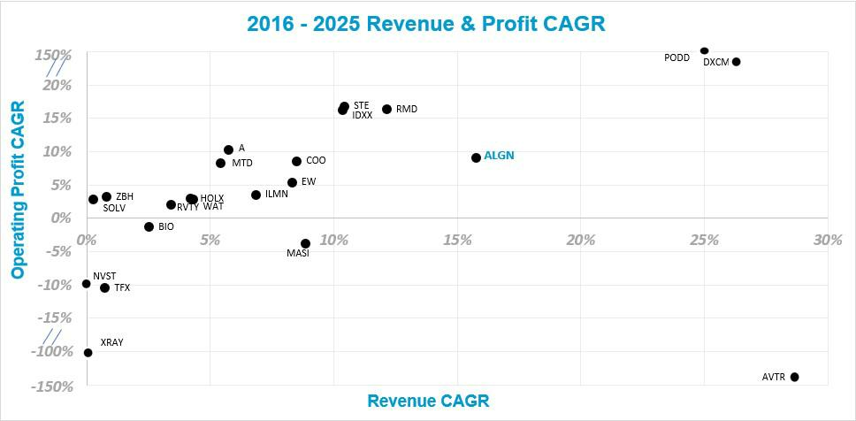

5

Governance Highlights

We recognize the importance of strong corporate governance as the foundation for long-term stockholder value. Our Board is responsible for ensuring our governance practices are well-designed and appropriate for our business. We continually review and update our corporate governance practices and frequently meet with stockholders to ensure that our policies are aligned with their interests and corporate governance best practices. As of the date of this proxy statement, these best practices include:


CEO and independent Chairman of the Board (“Chair”) are separate positions

90% of our director nominees are independent

Our Board is made up of seasoned executive leaders with a diversity of viewpoints, backgrounds, national origins, and experiences

Since 2017, we have added six new members to our Board

We have significant stock ownership thresholds for our officers and directors that were further increased in 2025 and our CEO has purchased $8 million of our common stock since his last sale in 2021⁽¹⁾

Our independent directors hold routine executive sessions without management present

Employees and directors are prohibited from engaging in short-selling, hedging or pledging transactions

Our Board oversees our overall risk management infrastructure

We promote a culture of integrity and quality that manages risks as part of our corporate strategy and day-to-day operations

Since 2023, we have expanded stockholder rights by adopting proxy access bylaws (2023), eliminating supermajority voting requirements (2025) and empowering our stockholders to call special meetings (2026)

- To ensure alignment with Align’s long-term growth objectives and that his interests are closely aligned with those of our stockholders, our CEO has purchased approximately $8 million (as valued at the time of each purchase) of our common stock using his personal funds since his last sale of our common stock in 2021.

6

Director Highlights

Our Board has nominated ten (10) talented directors with skills, experiences and professional backgrounds representing a breadth of perspectives and characteristics particularly relevant to Align’s business and strategies.
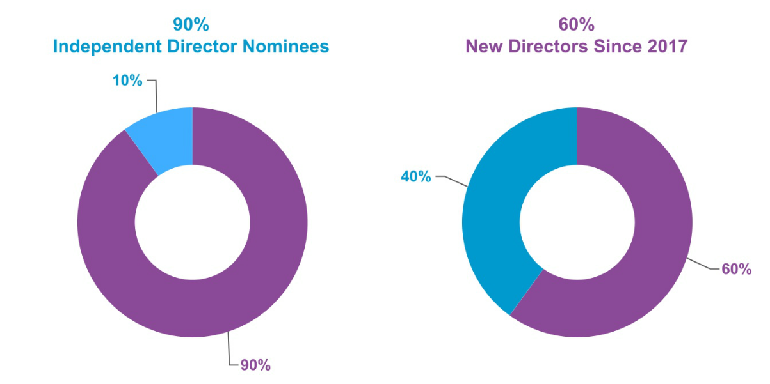

7

Fiscal Year 2025 Executive Compensation Highlights

Pay for Performance

In 2025, we retained all of the key elements of our long-standing, stockholder-supported, performance-focused executive management compensation program, which has historically received strong support in our annual say-on-pay vote. As in prior years, the 2025 program directly tied a substantial portion of the target direct compensation of executive management to at-risk compensation, with 91% and 82% of the target compensation of our CEO and our other named executive officers (collectively, “NEOs”), respectively, being at risk. Base salary remained the only fixed direct compensation component. Highlights of our 2025 executive compensation program are in the table below. For a more detailed understanding of our compensation program, see the section “Executive Compensation—Compensation Discussion and Analysis.”

Aligned Pay with Long-Term | Cash Incentives Aligned with | CEO Pay
Performance | Company Performance | CEO Pay




The three-year performance- | For fiscal 2025, our annual cash | Our CEO’s target annual long-
based market stock units | incentive bonus paid out at 58.1% | term incentive value was reduced
(“MSUs”) granted to our NEOs in | of target to our NEOs under our | by $1 million to $12.5 million in
February 2023 paid out at 79.8% | short-term cash incentive bonus | 2024 and was again reduced by
of target in February 2026 due to | program due to performance that | an additional $1 million to $11.5
stock underperformance from | fell short of rigorous targets set by | million in 2025, a reduction of
2023 to 2025, all relative to | our Compensation and Human | approximately 15% over the two-
companies comprising the Nasdaq Capital Committee. |  | year period. Additionally,
Composite Index. |  | realizable pay declined from
 |  | $27.32 million in 2024 to $19.19
 |  | million in 2025.

CEO Realizable Pay and
Stockholder Alignment


Our CEO’s cumulative 3-year realizable total direct compensation (“TDC”) was 83% of his cumulative 3-year target TDC and 53% of his cumulative 3-year reported total compensation, as further discussed in the section entitled “Executive Compensation —Compensation Discussion and Analysis” under the heading “Realizable Pay.”

Alignment with Stockholder Interest and Company Performance
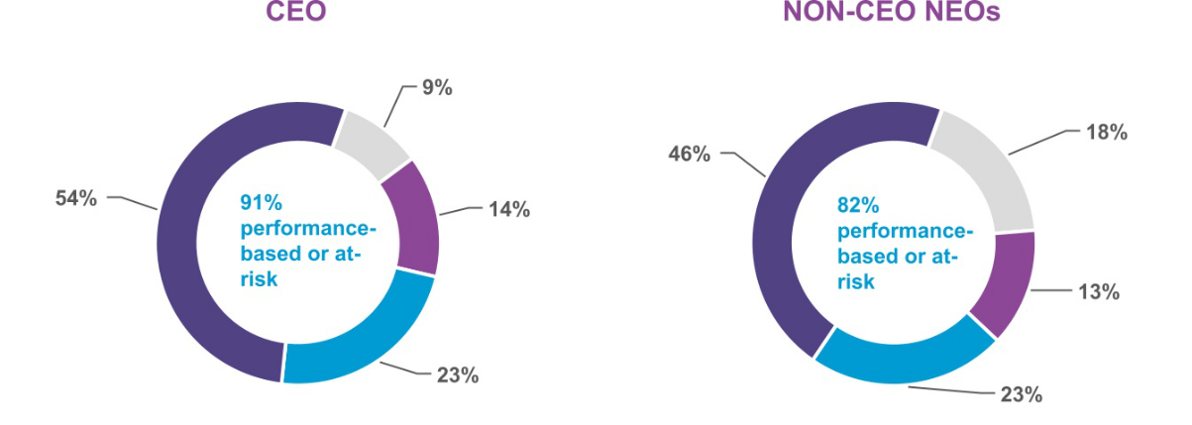

 | Base |  | Bonus |  | Restricted Stock Units |  | Market Stock Units

8

Corporate Governance

Strong Corporate Governance Policies and Practices Key Policies

Board Structure and Independence

Role of our Board

Board Risk Oversight

Risk Oversight Program

Committee Responsibilities and Oversight

Annual Committee and Board Evaluations

Board Meetings

Stockholder Communications with the Board


9

Corporate Governance

We remain committed to high standards of corporate governance, which we believe are foundational to the success of our business, create stockholder value and maintain our credibility in the marketplace.

Strong Corporate Governance Policies and Practices

Our policies and practices are the framework by which we govern our business. Our Board, along with management, regularly reviews our corporate governance policies and practices to ensure they are appropriate and reflect our high standards. In reviewing these policies and practices and making recommendations, management and our Board consider the feedback of stockholders to be essential.

We maintain a corporate governance page on our website which includes many of our policies and practices, including our Global Code of Conduct (our “Code”), Corporate Governance Guidelines (our “Guidelines”), and the charters for each of the standing committees of our Board. The corporate governance page can be found by clicking on the “Corporate Governance” link in the “Investors” section of our website at aligntech.com.

The policies and practices we maintain and review regularly foster responsible corporate governance. These policies include the following:

Global Code of Conduct

Our Code emphasizes our ongoing commitment to conducting business with integrity and complying with the law. It applies to all our directors, officers and employees, third parties acting on our behalf and our customers. In addition to finding the Code on our website, stockholders may request a free copy of it by writing to Align Technology, Inc., 410 N. Scottsdale Rd., Suite 1300, Tempe, AZ 85288, Attn: Investor Relations or investorinfo@aligntech.com. We post on our website any amendments to our Code, as well as any required waivers pursuant to the rules of the Securities and Exchange Commission (“SEC”) or the Nasdaq Stock Market LLC (“Nasdaq”).

Corporate Governance Guidelines

Our Guidelines describe the size and composition of our Board, Board membership criteria, independence requirements, nominations and elections, director compensation review and approval, Board evaluations, director orientation, stock ownership guidelines, and leadership development and succession, among other topics.

Committee Charters

Our Committee Charters establish the practices and procedures applicable to each committee. Our Board maintains four standing committees:

- an Audit Committee;

- a Compensation and Human Capital Committee;

- a Nominating and Governance Committee; and

- a Technology Committee.

10

Key Policies

Our corporate governance policies and practices establish the following key governance requirements:

One share equals one vote | We have a single class of shares with equal voting rights.
Annual director elections | All directors are elected annually for a one-year term and our Board is declassified.
Majority voting | We have a majority voting standard for uncontested elections of directors.
Proxy Access | An individual or a group of up to 20 stockholders owning at least 3% of our outstanding shares continuously for
Proxy Access | three years may nominate directors for election of up to the greater of two directors or 20% of our Board.
Special Meeting Rights | Stockholders who continuously hold 25% or more of our outstanding common stock for at least one year may
Special Meeting Rights | require our Board to call a special meeting of stockholders.
Separation of Chair | Our CEO focuses on managing Align and our independent Chair of the Board drives accountability at the Board
and CEO roles | level.
Stockholder engagement | We have a longstanding and comprehensive year-round stockholder engagement program.
Access to management | Our Board has significant interaction with senior management and access to other employees.
Time commitment practice | Our Nominating and Governance Committee reviews each director’s various time commitments.
Succession planning | Our Nominating and Governance Committee annually reviews Board and CEO succession planning and provides
Succession planning | recommendations to the Board for CEO succession planning. Our Compensation and Human Capital Committee
 | regularly reviews succession planning for executives.
Board, committee, and individual self- | Our Board, committees, and individual directors conduct annual performance self-evaluations led by our
evaluations | independent Chair of the Board.
Independent Committees | All committees are comprised of independent directors.
Access to Advisors | The Board and each of its committees are empowered to retain outside advisors and consultants at their
Access to Advisors | discretion.
 | We support the ongoing education, development and expansion of knowledge of our directors through regular
Board Training | updates on trends and best practices in areas including governance, compliance, ethics and other topics deemed
Board Training | relevant to the fulfillment of their fiduciary duties and encourage and organize third-party trainings, seminars and
 | workshops.
 | We maintain meaningful stock ownership guidelines for executive management and non-employee directors: (i)
Significant Stock Ownership | CEO - 6x annual base salary, (ii) other executive management - 3x annual base salary and (iii) non-employee
Significant Stock Ownership | directors - $450,000. Our directors and executive officers have five years after becoming subject to the guidelines
Guidelines
Guidelines | to attain the requisite stock ownership. As of December 31, 2025, all such individuals were in compliance with
 | these guidelines.⁽¹⁾
Hedging, pledging, and other | We prohibit short sales, transactions in derivatives, pledging and hedging of our securities and holding our
transactions | securities in margin accounts by directors, executive officers, and employees.
 | Our Global Speak Up Policy (“Speak Up Policy”) encourages current and former directors, employees and third-
Global Speak Up Policy | party business partners such as contractors, consultants, suppliers, distributors and even customers to voice their
Global Speak Up Policy | questions and concerns regarding conduct they believe in good faith to be inconsistent with the Code so that we
 | may respond promptly, objectively, fairly, appropriately and without retaliation.
Cybersecurity Leadership | We employ a dedicated Chief Information Security Officer (“CISO”) responsible for enterprise-wide information
Cybersecurity Leadership | security strategy and standards.
Corporate Accountability Leadership | We maintain a Vice President of Human Resources, Employee Programs and Community Engagement that
Corporate Accountability Leadership | enables us to dedicate our time, talents, and resources to organizations and programs that make a positive
 | difference in the lives of others.

- For purposes of this policy, “ownership” includes shares of our common stock directly held or held in trust for the benefit of such director, member of executive management or their family members living in the same household and shares of our underlying restricted stock units held directly, whether or not yet vested. “Ownership” does not include vested or unvested options to purchase our common stock or shares underlying unvested MSUs.

11

Board Structure and Independence

Our Board currently consists of eleven (11) directors.

Mr. George Morrow, who currently serves on our Board and as a member of our Compensation and Human Capital Committee and our Nominating and Governance Committee, will not stand for re-election at the Annual Meeting. His term as a member of our Board and the committees on which he currently serves will end at the commencement of the Annual Meeting. As a result, our Board has resolved that the size of our Board will be automatically reduced from eleven to ten directors at the conclusion of Mr. Morrow’s term of office.

Applicable Nasdaq rules require that a majority of our Board of Directors are independent. Our Board has determined that all Board members, other than our President and CEO, Mr. Hogan, are independent under applicable Nasdaq rules.

Our Board maintained four standing committees in 2025: an Audit Committee, a Compensation and Human Capital Committee, a Nominating and Governance Committee and a Technology Committee. Our Board has furthermore determined that under applicable Nasdaq and SEC rules for committee memberships, all committee members are independent, and each member of our Audit Committee also meets the additional independence criteria set forth in Rule 10A-3(b)(1) under the Exchange Act. Our Board has also determined that each of Ms. Anne Myong and Mr. Britt Vitalone qualify as an “audit committee financial expert” as that term is defined under SEC rules.

The roles of CEO and Chair of the Board are separated in recognition of the differences between the two roles. Our CEO is responsible for setting our strategic direction and establishing key initiatives after consultation and input from our Board. Our CEO furthermore provides day-to-day leadership and monitors our performance against initiatives. On the other hand, the Chair of the Board provides guidance to our CEO and, in consultation with the CEO and other Board members, sets the agenda for Board meetings and presides over meetings of the full Board. We believe this separation of duties allows the CEO and Chair to most efficiently use their time and fulfill their respective responsibilities, which are critical to our success. While our Amended and Restated Bylaws (“Bylaws”) and Guidelines do not require our Chair and CEO to be separate positions, our Board believes having separate positions and an independent outside director serve as Chair is the appropriate leadership structure for us at this time.

Role of our Board

Our Board is responsible for reviewing our overall performance, overseeing management, and assuring the long-term interests of stockholders are served. To satisfy its duties, our Board sets corporate objectives and strategies, establishes significant policies and determines allocation of corporate resources, selects, evaluates and provides for the succession of executive management and, subject to oversight by our Nominating and Governance Committee, nominates individuals for election at stockholder meetings to serve as our directors and appoints individuals to fill any vacancies on our Board.

Board Risk Oversight

Our Board takes an active role in overseeing corporate strategy with the intent to secure the long-term interests of stockholders. While management is responsible for the day-to-day management of the risks we face, our Board, as a whole and through its committees, is responsible for overseeing management in the competent and ethical operation of Align. Our Board does not have a standing risk management committee; instead, it fulfills its oversight responsibilities directly and via various standing committees, each of which addresses risks inherent to their respective areas of oversight. The risk oversight roles of the Board, committees and management are outlined below under our risk management program. The Board meets periodically with committee chairs and members of management to review risk assessment reports and implement risk management strategies.

12

Risk Oversight Program


Board of Directors

The Board directly oversees corporate strategy and other matters reserved for the full Board. The Board reviews and discusses with management and its committees potentially significant matters and risks affecting Align. Our directors take a proactive, focused approach to their responsibilities by setting standards to ensure our business success is achieved through the highest standards of responsibility and ethics.


Audit Committee

Our Audit Committee oversees and monitors risks associated with finance and investment, internal financial controls, cybersecurity, data privacy, crisis preparedness, and legal and regulatory requirements, including by overseeing Align’s anti-bribery and anti-corruption compliance program.

Compensation and Human

Capital Committee

Our Compensation and Human Capital Committee assesses whether our compensation policies and practices encourage excessive risk-taking and an evaluation of ways to mitigate and such risk.

Nominating and Governance

Committee

Our Nominating and Governance Committee assists our Board to manage risks associated with Board membership, structure, responsibilities and organization, long-term and emergency CEO and Board succession planning, and corporate accountability.

Technology Committee

Our Technology Committee assists our Board to manage risks associated with technical and market risks associated with product development and investment, with data and analytics capabilities, and initiatives that leverage these capabilities, including AI, and data privacy.

Management


Led by our CEO and executive team, management implements and supervises day-to-day risk management processes and reports significant matters to the Board and its committees. Executive management, other employees, consultants and advisors routinely attend and present at Board meetings and are available to address questions or concerns raised by our Board on risk management-related and other matters.


Internal Audit

Internal Audit is directly overseen by our Audit Committee. Internal Audit identifies and helps mitigate risk and improve internal controls.

Risk Management Program

Our Board encourages management to maintain a culture that actively promotes risk identification as part of our corporate strategy and day-to-day business operations. Furthermore, our Board encourages full and open communication between it and management. The Chair of the Board meets regularly with our CEO and other members of executive management to discuss strategy and the risks we face. Our directors take a proactive, focused approach to their responsibilities by setting standards to ensure our business success is achieved through the highest standards of responsibility and ethics.

13

Succession Planning


Effective and proactive succession planning is essential for the seamless operation of our organization. To reduce risks related to the departure of key personnel, we have established a structured process for succession planning through our committees. Our Nominating and Governance Committee oversees succession planning for our Board and our Chief Executive Officer, and our Compensation and Human Capital Committee oversees succession planning for our other executives.

First Quarter


PERFORMANCE REVIEW AND COMPENSATION AWARDS

Compensation and Human Capital Committee: Finalizes and approves performance reviews and compensation decisions for the prior year and sets target compensation for the current year, with deliberation and input from the entire Board.

Second Quarter |  | Third Quarter |  | Fourth Quarter
REVIEW OF MARKET TRENDS |  | REVIEW OF COMPENSATION |  | PERFORMANCE
AND STOCKHOLDER |  | RISKS AND DIRECTOR |  | ASSESSMENT AND
FEEDBACK |  | QUALIFICATIONS |  | SUCCESSION PLANNING
Compensation and Human |  | Nominating and Governance |  | Compensation and Human
Capital Committee: Annually |  | Committee: Reviews and |  | Capital Committee: Reviews
reviews recruitment, executive |  | determines desired |  | the performance of the executive
compensation market trends and |  | qualifications, skills, expertise |  | officers in connection with
compensation philosophy. |  | and characteristics for the full |  | compensation analysis and
Annually reviews say-on-pay |  | Board. |  | succession pipelines.
voting results following annual
meetings of stockholders. |  | Compensation and Human |  | Nominating and Governance
 |  | Capital Committee: Annually |  | Committee: Reviews
 |  | reviews risks associated with our |  | succession plans for Align’s
 |  | compensation |  | directors and CEO.
 |  | policies and practices.

Committee Responsibilities and Oversight

Our Board maintains four standing committees: the Audit Committee, the Compensation and Human Capital Committee, the Nominating and Governance Committee and the Technology Committee. Each of the committees assists our Board with risk management oversight within their areas of responsibility and apprises the full Board of significant matters and management’s response.

14

Audit Committee
Report of the Audit Committee on Page 97

Committee

Members

Anne M. Myong

Kevin J. Dallas

Andrea L. Saia

Mojdeh Poul

Financial Reporting and Audits
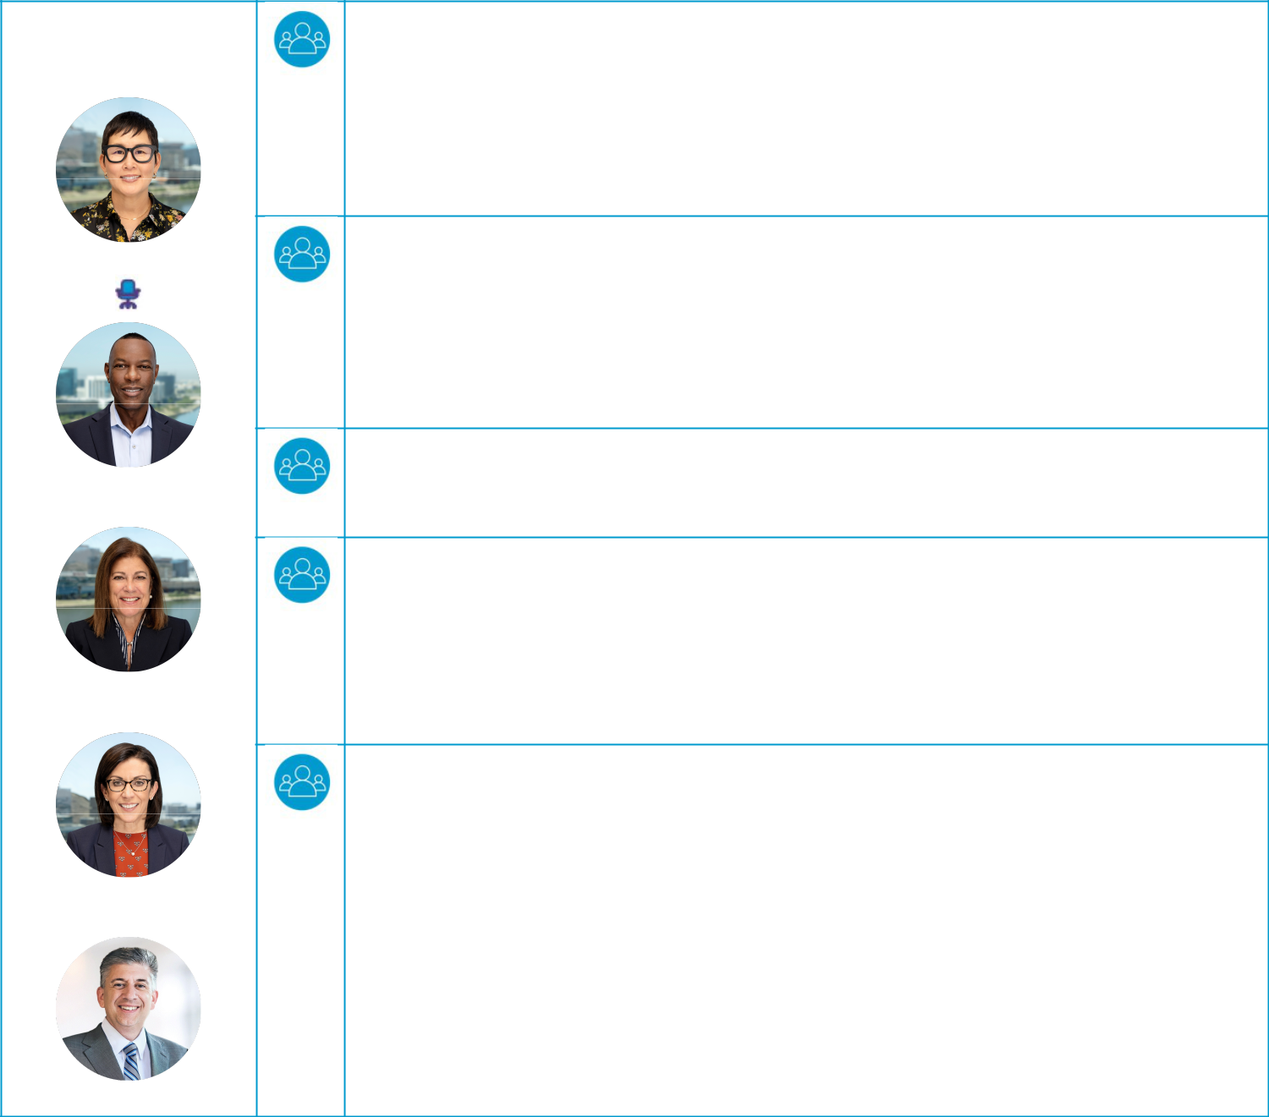
Our Audit Committee oversees and monitors our accounting and financial reporting processes, financial statement audits, internal accounting and financial controls, and Internal Audit Department. It is responsible for appointing, compensating, retaining, terminating, evaluating and overseeing the work of our independent auditors and reviewing the auditors’ proposed scope of work, approach and independence. The Committee also establishes procedures for receiving, retaining and responding to complaints regarding accounting, internal accounting controls or auditing matters and procedures for the confidential, anonymous submission by our employees of concerns regarding questionable accounting or auditing matters.

Compliance and Ethics

Our Audit Committee is responsible for reviewing compliance and ethics risks as well as the steps management takes to understand and mitigate these risks. The Committee also reviews, approves and monitors our Code and Speak Up Policy. Our Chief Compliance Officer (“CCO”) is responsible for implementing and maintaining an effective compliance and ethics program, including the Code, Speak Up Policy and other policies, trainings and communications related to key risk areas such as anti-bribery, anti-corruption and ethical interactions with healthcare professionals. Our CCO is responsible for reviewing and assessing the effectiveness of our program against related laws and industry best practices.

Anti-Bribery and Anti-Corruption Compliance

Our Audit Committee reviews and oversees our Global Anti-Bribery and Anti-Corruption Compliance Program (“ABAC Program”). The Committee receives periodic updates from the CCO concerning the ABAC Program and related activities. In 2025, our CCO met with the Committee twice to discuss our ABAC Program.

Cybersecurity
Our Audit Committee is responsible for overseeing and reviewing our cybersecurity and other information technology risks, controls and procedures, including our plans to mitigate cybersecurity risks and to respond to data breaches. The Committee also reviews with management any specific cybersecurity issues that could affect the adequacy of our internal controls and disclosure procedures and any public disclosures about our cybersecurity controls and procedures, the Board’s cybersecurity expertise, and its oversight of cybersecurity risk. The Committee periodically reports on its review of cybersecurity risks and our cybersecurity program to the Board. In 2025, the CISO or his team met with the Committee twice to discuss cybersecurity risks and threats.

Data Privacy

Our Audit Committee is responsible for overseeing and reviewing our data privacy risks, controls and procedures, including our efforts to mitigate cybersecurity risks and to respond to data breaches. The Committee receives periodic updates on our data privacy program and in its oversight role, sets the expectation that we address the risks we face and take action to mitigate those risks. We have various technical, administrative, and physical safeguards in place to help protect against unauthorized access to, use, or disclosure of customer, consumer and patient information and data we collect and store. Our CCO and dedicated privacy experts advise the business on privacy risks and assesses the effectiveness of privacy controls and compliance with various legislative and regulatory requirements. In 2025, our CCO and AI experts met with the Committee twice to discuss data privacy matters.

Britt Vitalone⁽¹⁾

(1) Mr. Vitalone joined our Board and was appointed to our Audit Committee in July 2025.
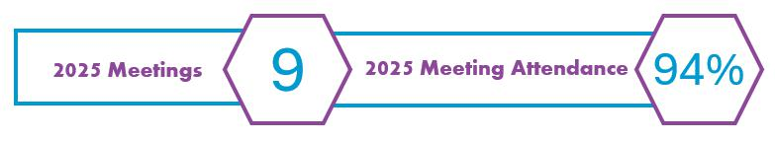

15

Compensation and Human Capital Committee

Compensation and Human Capital Committee Report on Page 71


Committee Members

Kevin T. Conroy

George J. Morrow⁽¹⁾

Anne M. Myong

Andrea L. Saia

Our Compensation and Human Capital Committee assists our Board to manage risks associated with our compensation policies and practices. It works to ensure our compensation programs successfully align the interests of employees, including executive management, with those of our stockholders. We routinely seek stockholder feedback regarding our compensation practices through our stockholder engagement program and members of our Compensation and Human Capital Committee join those discussions as appropriate. The Committee furthermore assists our Board to manage and oversee long-term and emergency succession planning for our non-CEO executives.

Our Compensation and Human Capital Committee also reviews and administers all compensation arrangements for executive management and reviews general compensation goals and guidelines for our employees and the criteria for which bonuses are determined. It evaluates the various elements of our compensation programs to avoid encouraging, and to mitigate against, excessive risk-taking by promoting behaviors that support sustainable value creation. Additionally, it retains, oversees and assesses the independence of our compensation consultants and advisors.

The Compensation and Human Capital Committee also oversees our human capital management-related activities, including matters regarding employee hiring, retention, advancement, engagement, and workplace culture. It periodically reviews the human capital management strategies, programs and policies.

Compensation Committee Interlocks and Insider Participation

None of the members of our Compensation and Human Capital Committee is, nor has ever been, a member of our executive management or an employee. None of the members of executive management currently serves, or in the past year has served, as a member of the board of directors or compensation committee (or other committee performing equivalent functions or, in the absence of any such committee, the entire board of directors) of any entity that has one or more members of executive management serving on the Committee or our Board.

- George Morrow will retire from the Board and therefore from the Committee at the commencement of the Annual Meeting.
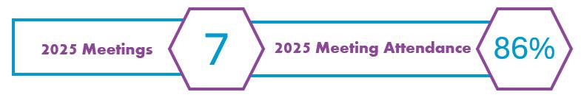

16

Nominating and Governance Committee

Committee
Members

Joseph Lacob

C. Raymond Larkin, Jr.

George J. Morrow(1)

Susan E. Siegel

Our Nominating and Governance Committee educates and assists our Board to oversee and make recommendations regarding corporate governance programs, policies and practices, manage risks associated with Board membership, structure, responsibilities and organization as well as long-term and emergency CEO and Board succession planning. Additionally, our Nominating and Governance Committee advises and educates our Board on corporate governance issues, including developments in legislation, regulation and related trends.


At the request of our Board, our Nominating and Governance Committee conducts annual reviews and evaluations and makes recommendations concerning Board and CEO succession. It evaluates the current size, composition, organization and governance of the Board and its committees and identifies, evaluates and recommends nominees to the Board, including as it relates to their independence, skills, expertise, characteristics and ability to dedicate sufficient time and attention to meet their responsibilities as directors. In 2025, one new director was appointed to our Board as a result of the Board succession planning process. The Committee also develops and recommends corporate governance principles applicable to Align and oversees and coordinates our sustainability, governance and corporate accountability initiatives, policies, practices and programs.

⁽¹⁾George Morrow will retire from the Board and therefore from the Committee at the start of the Annual Meeting.
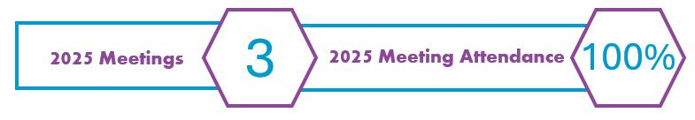

17

Technology Committee
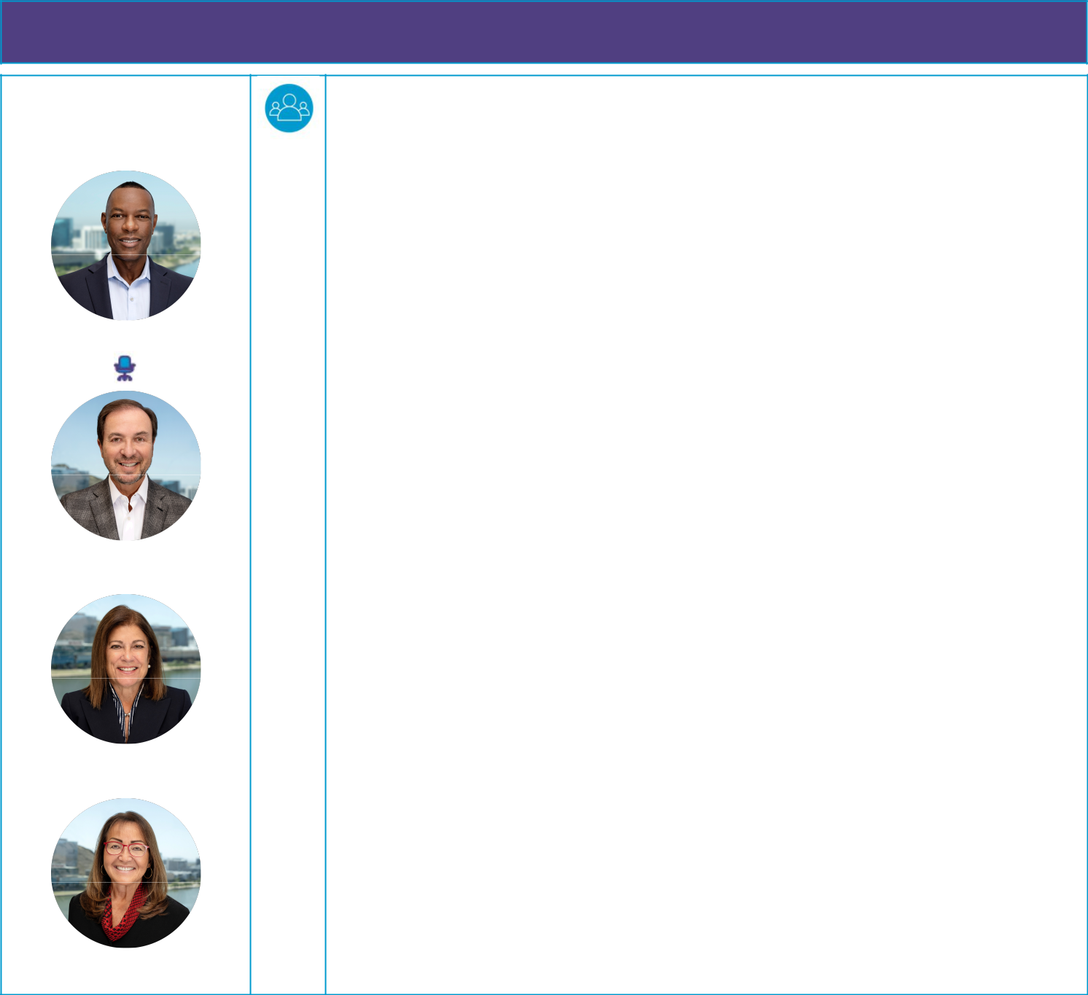

Committee
Members

Kevin J. Dallas

Joseph Lacob

Andrea L. Saia

Susan E. Siegel

Our Technology Committee assists our Board to evaluate major technology plans and strategies, including technical and market risks associated with product development and investment. It reviews our technology and development activities, evaluates and monitors our intellectual property portfolio, and oversees and advises our Board on matters of innovation and technology. It also reviews and monitors delivery of data and analytics capabilities, and initiatives that leverage these capabilities, including AI. Additionally, it assesses existing and potential new advanced technology markets. The Technology Committee also monitors future technology trends that may affect Align’s strategic plans.
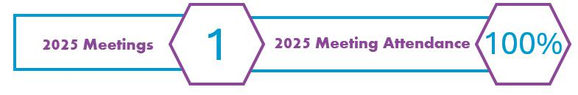

18

Annual Committee and Board Evaluations

To facilitate our Board and its committees performing effectively and in our best interests and those of our stockholders, our directors perform annual assessments of our Board and its committees, as described below.


Ú

- QUESTIONNAIRES Each director completes a self-assessment questionnaire as a member of the Board and for each committee on which the director serves. Each questionnaire requests ratings and solicits detailed suggestions for improving the structure and composition of the Board, effectiveness and culture, meeting content and conduct, access to information, responsibilities, access to independent advisors and overall performance. Additionally, for the committees, the questionnaires are further tailored to their respective roles and responsibilities.

Ú

- DIRECTOR REVIEW Self-assessment questionnaire results are compiled and summarized by our Chief Legal and Regulatory Officer. The summaries include all specific comments from directors, without attribution. Each director receives the Board self-assessment summary and the self-assessment summary for each committee on which the director serves.

Ú

- BOARD SUMMARY & FEEDBACK Committee self-assessments results are discussed by each committee, and Board self-assessments results are discussed by the full Board. Each committee and the Board identify areas for further consideration and opportunities for improvement and implement plans to address those matters.

Ú
- ONGOING FEEDBACK Throughout the year, directors may discuss concerns separately with the Chair.

Board Meetings

Our Board holds meetings at least quarterly, and the committees hold meetings at least annually. For the period of their service on the Board and each applicable committee in 2025, each director attended at least 75% of the aggregate of the total number of meetings of our Board and the committees on which each served. Our Board held six meetings in 2025.

Our Guidelines provide that the independent directors of our Board meet in executive session at least twice a year. The independent directors met in executive sessions four times in 2025.

Our Board members are encouraged, but not required, to attend annual meetings of stockholders. Last year, three directors attended our 2025 annual meeting of stockholders.

Stockholder Communications with our Board

Stockholders may communicate with our non-management directors by sending an email to Board@aligntech.com. These communications are monitored to ensure appropriate summaries of all received messages are provided to our Board at its regularly scheduled meetings, or in advance if they are deemed time-sensitive. Where the nature of a communication warrants, our Executive Vice President, Chief Legal and Regulatory Officer may decide to obtain the more immediate attention of an appropriate committee of our Board or a non-management director, executive management or independent advisors. After reviewing stockholder messages, our Board determines an appropriate response if they deem a response necessary or warranted.

19

Stockholder Engagement

Stockholder Outreach and Engagement

Meaningful Compensation and Governance Changes


20

Stockholder Outreach and Engagement

Recognizing that stockholders are the owners of Align, we maintain consistent, frequent and open dialogue as part of our proactive Investor Relations function to actively inform and educate existing and potential stockholders on Align’s business and financial performance, as well as encourage and welcome feedback from stockholders regarding all aspects of our business, including our executive management compensation program and the outreach program itself. Our engagement is year-round day-to-day communication with stockholders and is managed by our Investor Relations Officer (“IRO”). Proactive outreach can include members of our Board and various members of executive management, including our CEO, CFO, IRO and other organizational leaders from select internal organizations, including Finance, Human Resources, Legal, Regulatory Affairs, Quality Assurance, Operations, Sales and Marketing, Research and Development, Clinical, and Product Development. We use this outreach to provide stockholders with timely, accurate, consistent and transparent information on our strategy, products and technology and business performance, as well as addressing issues expressed by our stockholders, sharing our underlying vision, the rationales for our compensation programs and the impact of Board oversight in key areas.
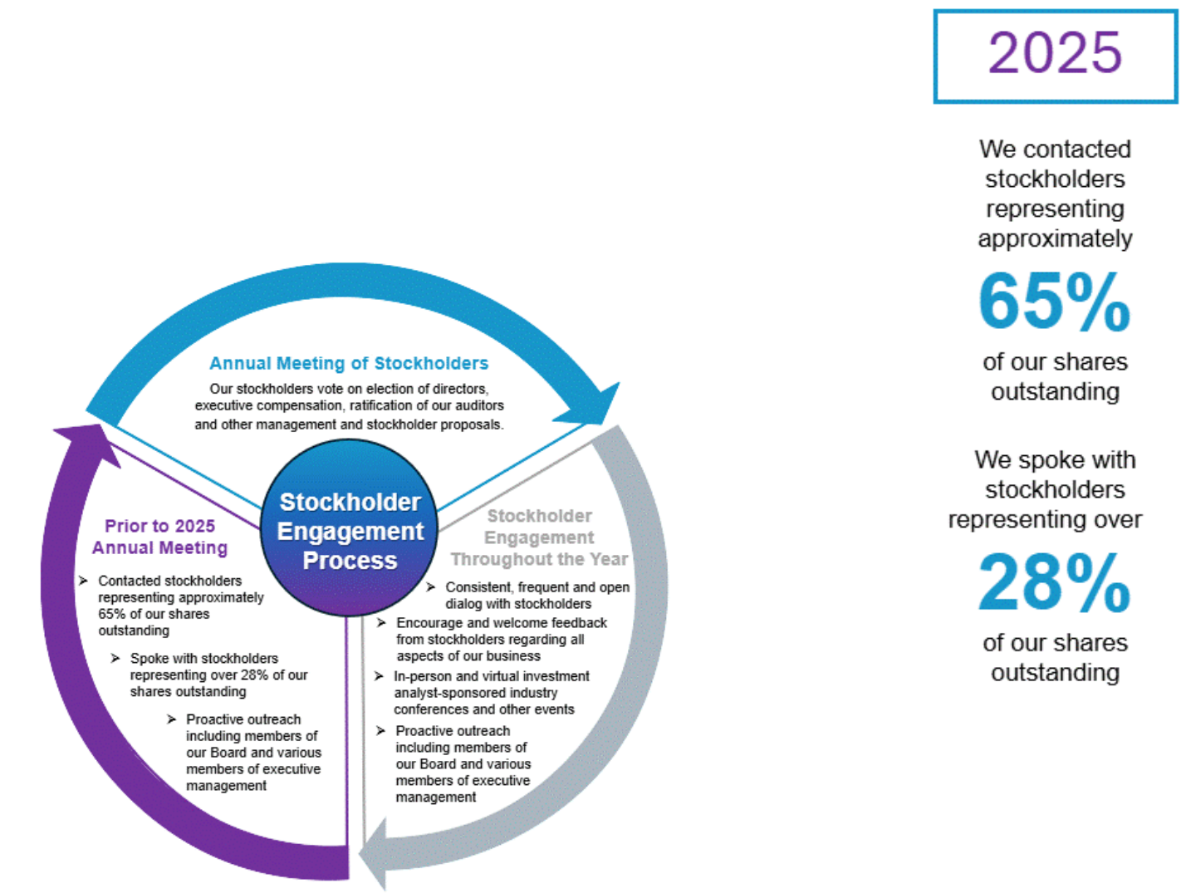

Input from stockholders, analysts and customers is shared internally, including with our Board and its committees, to be used in future strategic, operational, compensation and governance decisions, as appropriate. Feedback from the majority of stockholders with whom we spoke in 2025 was positive despite challenging macroeconomic conditions. Throughout our many discussions with stockholders, they remained engaged and willing to provide feedback and suggestions regarding our Board structure and composition, executive compensation practices, sustainability policies, human capital management, Board and CEO succession planning, executive management, governance, diversity and inclusion and other various topics of importance to them, including our strategy, financial model, business performance, competition, and guidance practices. While several stockholders offered suggestions for alternative ways to structure our executive management compensation program, including diversifying and enhancing our annual cash incentive compensation plan and long-term equity compensation components, none insisted modifications were required.

21

Meaningful Compensation and Governance Changes Reflects Stockholder Feedback

In recent years, our Board, Nominating and Governance Committee, and Compensation and Human Capital Committee have carefully considered feedback from our stockholders and taken action where appropriate. Recent examples include the following:

Proxy Access and Director Nomination

Amending our Bylaws to include proxy access provisions and clarifying director nomination requirements. See “Board Composition and Refreshment” below for more information

_{No Supermajority Voting} Following stockholder approval at our 2025 annual meeting of stockholders, we amended and restated our
_{Requirements} Charter to replace all voting requirements that call for greater than a simple majority vote with a simple majority vote

 | Following extensive stockholder engagement, we amended our Bylaws in February 2026 to permit stockholders
Special Meeting Rights | that have continuously held 25% or more of our common stock for at least one year to require our Board to call a
 | special meeting of stockholders
New Board Members | Appointing six new Board members since 2017, including two in 2023 that replaced two longer-tenured directors,
New Board Members | and one new member in 2025, has increased the diversity of experiences and skills of our Board
Clawback Policy | Adopting a clawback policy that provides for the recoupment of executive compensation in certain circumstances
_{Reduction of CEO Target} Reducing the target value of Mr. Hogan’s long term incentive grant by $1 million compared to 2023 and further
_{Pay} reducing to it by an additional $1 million in 2025 (a reduction of approximately 15% over two years), to better align with stockholder expectations

NGC Charter | Amending the charter of our Nominating and Governance Committee to assign to it oversight of sustainability and
NGC Charter | corporate accountability efforts and disclosures
_{Audit Committee Charter} Amending_{privacy} the charter of the Audit Committee to assign to it oversight responsibilities of cybersecurity and data

 | Amending the charter of the Compensation and Human Capital Committee to assign to it oversight
C&HCC Charter | responsibilities of human capital management strategies, programs and policies. In doing so, the Board deemed
C&HCC Charter | it important to rename the committee as the Compensation and Human Capital Committee in recognition of its
 | additional responsibilities
Technology Committee | Amending the charter of the Technology Committee to assign to it oversight responsibilities of delivery of data
Charter | and analytics capabilities, and initiatives that leverage these capabilities, including artificial intelligence
Expansion of | Expanding disclosures concerning sustainability related matters, including corporate responsibility and human
Sustainability | capital management, on our website and in our securities filings including, most recently, those set forth in our
Disclosures | Annual Report on Form 10-K filed with the SEC on February 27, 2026, and in this proxy statement
_{Corporate Accountability} Forming a Corporate Accountability Committee overseen by key members of executive management to gather
_{Committee} data and develop strategies in ways that allow us to incorporate sustainability, human capital and culture principles into our strategic objectives

No One-Time Equity Pledging not to award significant one-time equity awards to members of executive management, including our Awards to Executives CEO, without prior consultation with stockholders
Increasing the focus, frequency, and breadth of stockholder engagement in order to consistently foster Stockholder Engagement relationships and more effectively capture and address stockholder suggestions and feedback regarding

governance, executive compensation and other matters

22

Corporate Accountability

Accountability and Governance

Sustainability

Employees

Community


23

Corporate Accountability
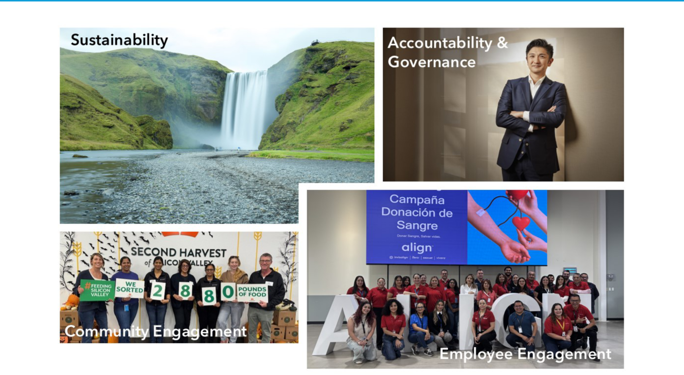

Our vision is to make oral health through comprehensive digital dental technologies, including diagnostic imaging innovations and clear aligner orthodontic treatment, accessible to everyone globally and realize our purpose of transforming smiles and changing lives through doctor directed and supervised treatment. We understand our impact is not limited to improving patient health through advances in oral health technologies and the medically supervised use of a prescription medical device. We believe we are responsible for increasing awareness of the overall physical and mental health benefits of improved oral health, including straighter teeth and better oral hygiene, and to incentivize both by making digital dentistry through diagnostic imaging, doctor supervised treatment planning and clear aligner therapy the standard of care for the prevention and treatment of dental diseases, malocclusion and restorative dentistry.

Straightening teeth is not only about aesthetics and a beautiful smile, but can also improve chewing and speech function, ease pain related to TMJ disorder, and reduce the risk of cavities, gum disease and other oral health issues. The majority of the world’s population have some form of malocclusion or crooked teeth, however, only a fraction receives orthodontic treatment because access to care is limited by a number of factors including the manual nature of traditional orthodontic treatment using metal wires and brackets. By continually innovating and developing digital technologies and services that enable more dental health professionals to easily diagnose and treat patients with crooked teeth and other oral health conditions as well as helping retain patients’ healthy, functionally correct bites and beautiful smiles, we are increasing access to care for millions of people who might not otherwise receive oral health care, including needed orthodontic treatment. We believe the digital transformation of dental practices and treatment modalities has a significant positive impact on people’s oral health, overall health, and our society.

It does not stop there, however. We believe that establishing a sound foundational skeletal and dental structure is fundamental for lifetime oral and overall physical and mental health, equally as important as good oral hygiene and regular check-ups are to helping prevent oral diseases closely linked to non-communicable diseases such as community acquired pneumonia, diabetes, heart disease and a host of other serious conditions that exact a costly toll on people, governments and society. We are driving the evolution of comprehensive digital dentistry from diagnosis and prevention through orthodontic and restorative dental treatments, and treatment monitoring with

24

technologies such as our upgraded iTero Lumina™ scanner and iTero Lumina™ Pro dental imaging system, that improve and increase patient access and outcomes, expand doctors’ reach, capacity and accelerate practice efficiencies.

We also understand that as an organization our impact is not limited to improving patient oral and overall health. Interacting ethically and constructively with our employees, customers, patients, suppliers, and stockholders around the globe is fundamental to achieving our purpose and creating value for investors who put their trust in us.

We continuously assess our actions and evaluate our success based on four areas: the standards we set for ourselves and how we hold ourselves and those around us accountable to those standards; ecological continuity and resilience; establishing and maintaining a corporate culture that encourages respect, wellness and the growth of our employees; and contributing to the communities in which we live and work.

Accountability and Governance
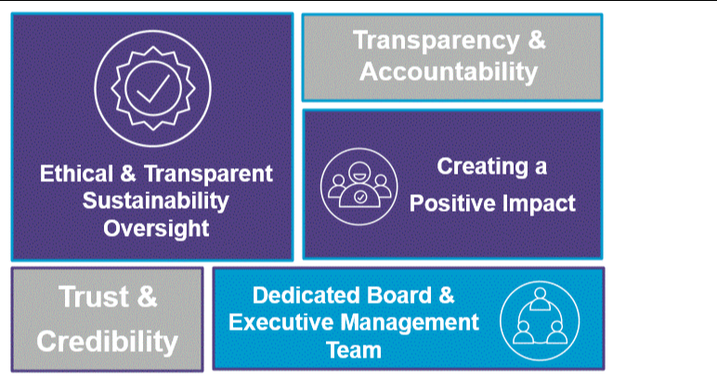

Evaluating the impact we have on our employees and the communities in which we operate, and proactively making improvements to create a positive impact.

Our Board and senior management believe that for us to fulfill our mission, we must conduct our business ethically and demonstrate integrity through open and clear disclosures that foster transparency and accountability. This is not only the right thing to do, but essential to building the trust and credibility required to generate engagement and loyalty in our employees, deliver against our business goals and improve the lives and health of those we serve. It strengthens our brand and ultimately increases value for all of our stakeholders.

We focus first on those matters most closely associated with the impact of our operations and products on our customers, patients and employees, and then more broadly on the impact to our communities and the world at large. We then tailor our initiatives to align with our strategic growth drivers, allowing us to also meet the demands placed on us by our stockholders and the constituents we serve. We believe that maintaining ethical, transparent oversight starts at the top with dedicated time and attention from our Board and executive management team.

25

- Our Nominating and Governance Committee oversees our ecological and governance strategy, initiatives, and disclosures and receives regular updates from our CEO and other members of executive management throughout the year.
- Our cross-functional Corporate Accountability Committee – drawn from our Executive Management Committee and senior leadership

– is tasked with assessing the regional and global impacts and risks of our operations and the products we produce in the areas of sustainability, human capital management, and philanthropy. The Corporate Accountability Committee also coordinates the policies, practices and initiatives needed to meet our corporate goals.

- Our Compensation and Human Capital Committee is specifically chartered and empowered to oversee our corporate culture, particularly those matters relating to human capital management.

- Our Audit Committee is tasked with overseeing a wide variety of risks related to our operations, including violations of our Code and Speak Up Policy, cybersecurity risks, and data privacy amongst many others.

- Our Technology Committee is charged with supervision of our artificial intelligence processes, governance, implementation and risk management.

Sustainability
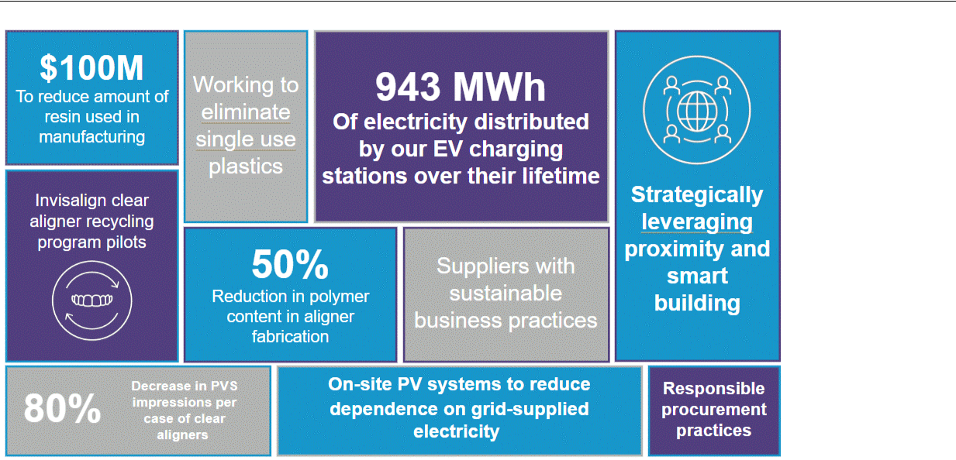

Focused on strengthening the long‑term resilience of our operations, reducing environmental impacts across our value chain, and creating durable value for our stakeholders.

We recognize that achieving a sustainable business requires protecting the interests of our employees, the communities in which we operate, and safeguarding the environment on which our business, employees and communities rely. We advance these commitments by integrating sustainable practices and using renewable or recyclable materials across our operations and products. This approach helps us manage our environmental impact, mitigate risks, reduce costs, and enhance value for our stockholders.

We are on a multi-year strategy to advance resilient and enduring operational initiatives that are intended to mitigate risks to our operations and the communities in which we operate and that we serve. This includes:

- Expanding our capabilities to comply with emerging domestic and international regulations governing the impacts of our operations.

- We continue to obtain limited assurance for our Scope 1 & 2 greenhouse gases (“GHG”) emissions, water and waste data by a third-party auditor.

26

- Publishing our Financial Year 2024 Sustainability Report, which was issued in compliance with Swiss law. A copy of the report can be found in the Corporate Accountability section of our website.
- Evaluating the ecological and social impacts of our operations through a Double Materiality Assessment as we prepare to comply with reporting obligations under the European Union’s Corporate Sustainability Reporting Directive as early as 2028.

As we continue to evaluate our global sustainability and operating risks and impacts, we have various research, development, and operational initiatives underway.

- Energy Consumption and Generation. We believe it is important to diversify our sources of energy to mitigate overdependence on any particular form of energy. This includes:

  - Renewable Electricity Procurement. Clean energy programs and renewable energy credits comprised 47% of our total electricity consumption in 2025. Grid-supplied electricity for our San Jose campus is sourced from 100% renewable energy, and we are advancing efforts to further maximize the use of renewable energy sources across global operations where economically feasible and in furtherance of our efforts to avoid dependence on any one form of energy.

  - Energy Generation. We utilize on-site solar PV systems as one of several means to reduce our reliance on grid-supplied electricity. In 2024, we installed three additional PV systems. In total, our PV systems generated approximately 2,441 MWh of electricity in 2025.

- Strategically Leveraging Proximity and Smart Building Design. We continue to diversify operating risks, bring operations closer to our customers, and reduce shipping and transportation costs. This includes the expansion of our Wroclaw, Poland operations to speed delivery of our products to customers in Europe, Africa and portions of Asia while reducing shipping costs and ecological impacts. In addition, Wroclaw, Poland continues to maintain its Leadership in Energy and Environmental Design (LEED) Gold certification.

- Water Conservation. Through Best Management Practices, we reduced costs and water consumption through initiatives that have recycled over 24 million gallons of water since January 2023.

- Waste Reduction and Recycling. We continued to add comprehensive recycling programs to address the entire waste profile ranging from everyday operations to manufacturing and product use by our customers and patients.

  - The majority of plastic we use is diverted from landfills through energy recovery programs or via recycling.

  - We responded to customer and patient feedback for recycling initiatives by launching recycling model programs in Brazil and piloting new models in the United States and Australia, providing customers with options for recycling used aligners they have requested.

- Other Initiatives

  - We began limited direct fabrication of certain products. In the future, we expect direct fabrication will significantly reduce the amount of resin used in the manufacturing process as we scale the production process and thereby reduce our per unit materials costs.

  - Since 2016, product design and manufacturing innovations to traditional manufacturing processes have reduced our material costs by reducing the polymer content used in our aligner fabrication process by approximately 50% and the amount of resin in aligner molding by approximately 33%. Us of our iTero intraoral scanners removes the need for traditional polyvinyl-siloxane (PVS) dental impressions. Since 2018, PVS impressions per case of clear aligners have decreased by 80%, thereby helping to avoid the consumption of more than four thousand metric tons pf PVS in our process and reduced greenhouse gas emissions associated with mining, transportation, storage, energy necessary to convert the PVS impressions to digital images for molds and their disposal. Digital scans increase treatment accuracy which reduces the need for re-makes and additional shipments, further lowering resources consumption and emissions. Redesigning our packaging materials decreased costs related to shipping as well as the ecological impact of product packaging and increased compliance with packaging regulations.

27

- Responsible Procurement Practices. Our suppliers are essential to all aspects of our business, and our supplier relationships are based on trust and shared commitments to ethical and legal conduct. We select key suppliers that have implemented sustainable business practices to serve our core business processes.

  - We expect our supply partners to follow the highest standards in the industry, such as ISO 14001, and we require our suppliers to adhere to responsible sourcing. We prohibit our suppliers from profiting from the sale of tantalum, tin, tungsten, and gold (“conflict minerals”) that funds conflict in the Democratic Republic of the Congo and adjoining countries and require them to source such minerals from socially responsible suppliers.

  - Our suppliers are asked to comply with our Code through which we expect them to respect human rights and treat others fairly, including complying with labor and employment laws, namely minimum wages, overtime, forced and child labors, not unlawfully confiscating immigration documents, and respecting the rights of individuals to return to their home countries.

Employees
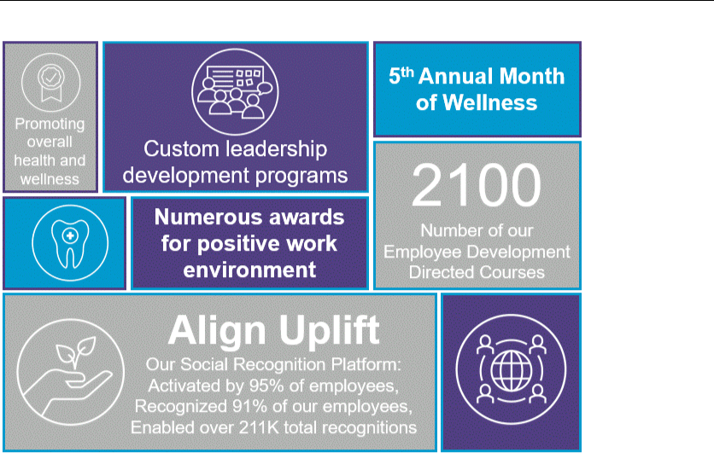

Prioritizing our employees' development, wellness and safety, and valuing our employees' differences and perspectives.

We believe our success is driven by a global workforce characterized by differing backgrounds, beliefs, perspectives and skills. We also strongly believe that the motivation, support, safety, and well-being of employees is fundamental to our success. Our employees must comply with our Code and are regularly asked to read and acknowledge their obligations under the Code. We also strengthen our organization by creating and following values that honor our employees:

28

- Authenticity and Integrity. We are committed to a culture in which we conduct our business ethically, responsibly and transparently and inform our employees of our expectations through well-designed policies and procedures that start with our Code.
- Listening and Empathizing. We encourage active listening and development of healthy and respectful relationships in which employees can openly and honestly express their thoughts, opinions, hopes and concerns for the betterment of the organization and all its stakeholders. We value our employees' collective voices and as a result utilize a continuous employee listening strategy that includes globally managed pulse surveys, employee lifecycle surveys, and a self-service feature to support listening efforts for our global employees to have a continuous listening strategy. We leverage survey results and comments to seek ways to make positive changes throughout the organization.

Building on the insights we gather through these continuous listening efforts, we also invest in programs that reinforce positive behaviors and celebrate contributions across our workforce. As part of our ongoing investment in building a strong, values-driven culture, Align Uplift is out global employee regards and recognition platform designed to foster a culture of appreciation by enabling meaningful, timely acknowledgment of great work across out organization. It provides a streamlined points-based recognition experience — localized by country and integrated into daily workflows — to celebrate contributions, reinforce our values, and strengthen connection across teams.

- Developing our Talent. At Align, we believe employees learn best when skill development is driven by the changing and immediate needs of our employees and by empowering all employees to take action and ownership of their careers. We also believe learning should be relevant and actionable, as well as rooted in our purpose and values. Out develop@align platform enables our global employee population to access a diverse portfolio of approximately 2,100 self-directed courses in up to 23 languages. We also offer a full suite of custom leadership development programs, beginning with aspiring leaders, continuing with managers and directors, and culminating with executive development opportunities. We also recognize we must continually evolve by providing employees with the resources they need to continue to learn, grow and thrive. To this end, we created Voyage Voyage is a global initiative that offers a set of tools, resources and a new mindset, empowering employees to start thinking differently about career growth by embracing development opportunities in new and sometimes unexpected ways. Our Voyage Compass helps employees experience their careers through four distinct lenses: self, networks, experience and skills. Since launching in 2022, over 70% of the population has interacted with Voyage, and there have been over 164,000 visits to the Voyage website. In addition to our navigations site, we annual host a Voyage Set Sail Month, where we offer experiential learning for individuals and teams utilizing activities that keep professional development front and center in employees’ minds.

- Balanced and Fair. We welcome differences as opportunities for learning, overcoming challenges and thinking creatively. We serve customers and patients in over 100 countries, making inclusion and belonging essential for our growth. We are committed to building a workforce of diverse cultural backgrounds and life experiences through fair and balanced policies and practices. A variety of employee resources and standards embody our commitment to inclusion and belonging, including our employee-led employee resource groups which are based on shared characteristics or life experiences. These are open to all employees, including those who do not directly identify with other members.

- Health, Wellness and Safety. We prioritize the health, safety and well-being of our employees and their families.

  - We have implemented extensive training programs focused on keeping our employees safe while on our premises and while working remotely.
  - We offer compensation that is competitive in our industry so employees can feel financially secure and can in turn contribute to the well-being of their families and the economies and communities in which they live.
  - We offer a wide variety of robust programs and initiatives designed to promote the overall health and welfare of all our employees and their families. Every year, we have a month dedicated to well-being, called Month of Wellness. Throughout the Month of Wellness, employees participate in a variety of activities such as informational sessions and health fairs and receive useful resources aligned to our wellness pillars - mental resilience, physical well-being and healthy living, social/family connections, and financial wellness. This provides our employees with a variety of meaningful ways to embrace wellness and well-being including mindfulness, meditation, nutrition and mental wellness activities, exercise, hikes, yoga, volunteer activities, financial education sessions, social events, and stress management.

29

We have received numerous awards for our positive work environment and culture. Some of the certifications, awards and recognitions recognized or received in 2024 and 2025 include:

- Best Workplaces for Women, China
- Best Workplaces for Parents, Korea

- Great Places to Work and Best Places to Work based on our employee-validated great workplaces in the following countries: Australia, Brazil, Canada, China, India, Israel, Korea, Singapore, Taiwan, Thailand, Turkey, Vietnam and Raleigh, North Carolina (United States)

- Forbes America’s Best Employers: Dream Employers, Best Midsize Employers, Best Employers for Engineers, Best Employers for New Grads, Best Employers for Company Culture

- LinkedIn Top Companies, Israel

- Mercer China, Healthiest Workplace Award for Outstanding Women Care

- Newsweek, America’s Greatest Workplaces: Overall, By State (California), Gen Z, Inclusion, Mental Well-Being, Parents & Families

For further discussions of our inclusion initiatives as well as our many employee policies, benefits, achievements and awards please see “Human Capital” under Part I, Item 1 “Business” of our Annual Report on Form 10-K filed with the SEC on February 27, 2026.

Community
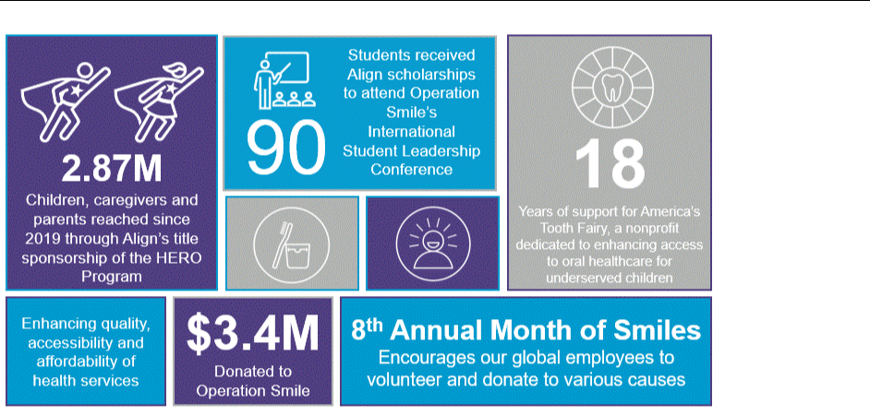

Contributing to the communities in which we live and work by using our talents and resources.

Contributing to our communities is important in our culture. Our overall philanthropic philosophy is to support organizations whose visions tie closely to our own - emphasizing the significant benefits to oral health and overall physical and mental health from digital dentistry, transforming smiles, supporting and educating youth/teens, and advancing technology through research and other partnerships with learning institutions and/or foundations. We also focus on the needs of our communities, employees, customers and their patients, and healthcare workers in general.

Launched in 2020, the Align Foundation provides a structured means by which significant donations are directed from a donor-advised fund overseen by Fidelity Charitable, with the flexibility to provide smaller monetary donations,

30

processes to donate our products, as well as an organized way to involve our employees in giving activities. Below are some of our key community initiatives in 2025:

- Since 2013 we have been a proud supporter of Operation Smile, a global medical nonprofit that has provided hundreds of thousands of free surgeries for people born with cleft lips and cleft palates in low and middle-income countries. For the fifth year, we were the title sponsor of Operation Smile’s International Student Leadership Conference (ISLC), a powerful opportunity for youth in high schools and colleges around the world to develop leadership skills and impact their communities. Operation Smile’s ISLC brought together almost 400 passionate young leaders from 34 countries to build leadership skills, connect with people from different cultures and support children with cleft conditions around the world. As part of our 2025 sponsorship, we provided full scholarships for 90 participants including those born with cleft conditions and those facing financial barriers. As of December 31, 2025, we had donated over $3.4 million to Operation Smile.

- As part of Align’s commitment to improving oral health, we partner with the INCAE Business School and the CAHI Jeffe Fellowship to strengthen the quality, accessibility, and affordability of care in Latin America. Over the past two years, we have supported four fellows advancing in oral-health education and access for low-income communities. With a network now spanning 160 health innovators across the region, this partnership reflects Align’s dedications to scalable, community-driven solutions that improve health outcomes.

- For 18 years we have supported America’s ToothFairy, an organization with a mission to ensure underserved children in the United States have access to dental care and learn about oral health by supporting nonprofit clinics and community partners. As of December 31, 2025, we have provided almost $2 million for the foundation’s operational expenses and children’s oral health programs. As Title Sponsor of the HERO Program since 2019, we have helped the program reach an estimated 2.87 million children, caregivers, and parents. During America’s ToothFairy’s 2025 fiscal year, which ended June 30th, the HERO Program positively impacted 1,082,150 children and caregivers using downloadable resources, which are also available in multiple languages. With Align’s support, America’s ToothFairy’s Dental Resource Program (DRP) member clinics provided clinical care to 213,675 children — on average, a 25% increase over last year. Among these:

  - 191,204 children received fluoride varnish, nearly 36% more than in 2025.

  - 75% of patients served live at or below the poverty line.

  - 44% of children treated live in rural communities where access to care is limited.

  - 52% of care was delivered through school-based programs.

  - 85% of patients rely on state-funded insurance.

- We have also established programs to support our doctors that treat patients who may not be well-suited for wearing and managing fixed appliances due to health issues, allergies, disabilities or specific health disorders through discounted fees and other support.
- We held our 8th annual Month of Smiles in October 2025, where each of our more than 20,000 employees are encouraged to participate and make a positive difference through volunteerism, charitable donations, fundraising activities, and intentional acts of goodness. Although the Month of Smiles happens in October, the giving continues through the rest of the year, and we are continuously amazed with the participation by and impact of our employees.

- Our partnership with Benevity, a corporate purpose platform, continues to transform our workplace, culture, and the communities where we live and work. It is a platform where employees can find ways to make a difference through volunteer activities, donation opportunities, charitable education, ad hoc matching programs, and volunteer rewards.

- In Canada, EMEA and the United States, Invisalign® product donation programs bring smiles to young individuals. Through Align’s Acts of Random Kindness (ARK) program, Invisalign-trained doctors collaborate to provide a straight smile to young patients dealing with health conditions. Since 2019, Align has extended a helping hand to hundreds of patients by waiving the lab fees for their treatments through the ARK program. In 2023, Align established a partnership with two non-profit organizations serving the US and Canada: Smiles Change Lives and Smile for a Lifetime. These organizations offer an affordable option for families who cannot bear the full cost of teeth straightening treatment for their children. As part of this program, Align waives lab fees and enables treatments through Invisalign-trained doctors who donate their time, skills, and practice resources.

- Employees at our site in Juarez, Mexico which represents our largest aggregate employee population, have a longstanding partnership with United Way Chihuahua, an organization that advocates for the health,

31

education, and financial stability of every person in every community. Through our site’s voluntary payroll deduction program for United Way, approximately 70% of our employees participated and almost $90,000 USD was raised through 2024, earning recognition by United Way Chihuahua as one of their top donors in 2024. During 2025, our Align employees donated the equivalent of $52,000 USD to different causes supported by the United Way. Beyond monetary contributions, Juarez employees engaged in numerous volunteer events with United Way and other organizations providing hair donations for cancer patients and providing groceries to food banks. Together, these efforts reflect the unwavering generosity and community spirit that define our Juarez team’s impact year after year.

- We partnered with universities, dental schools, hospitals, and clinics that support education, leadership and diversity among current and future GP doctors and orthodontists. In 2010, Align began the Research Award Program with the goal to support clinical and scientific orthodontic and dental research in universities across the globe. Since its inception in 2010, we have funded over approximately $4 million in research awards. Research has provided insights into various areas including tooth movement efficacy with clear aligner therapy, oral hygiene and microbial bacteria presence or absence with clear aligners, and comparisons in quality of life with aligners as compared to fixed appliances. We awarded $300,000 to university faculty for scientific and technological research initiatives in 2025 to advance patient care in the fields of orthodontics and dentistry.

32

Directors

Board Composition and Refreshment

Director Nominees

Summary of Director Experience, Skills and Attributes


33

Directors

Our Board consists of a unique and varied group of highly qualified leaders in their respective fields, all of whom have senior leadership experience at large domestic and multinational companies, which has given them significant and extensive management experience. Our directors also have in-depth public company experience serving as executive officers, including several current or former chief executive officers, or on boards of directors and board committees, and have a robust understanding of corporate governance practices and trends. Our Board and Nominating and Governance Committee believe the skills, qualities, attributes, and experiences of our directors provide us with business acumen and a diverse range of perspectives to effectively address our evolving needs and represent the best interests of our stockholders.

Director Skills Matrix

The matrix below represents some of the key experiences, attributes, and skills that our Board has identified as particularly valuable to the oversight of Align, and illustrates how the director nominees collectively represent them. While all these qualifications were considered in connection with this year’s director nomination process, the matrix does not encompass all of the skills, qualities, attributes, and experiences of the director nominees. Our Board firmly believes that its highly qualified director nominees provide the Board with a robust complement of backgrounds, skills, qualifications, and perspectives necessary for effective oversight.

Nominee Skills Matrix

Finance (6/10) | Healthcare Industry (8/10)
Medical Device (8/10) | Technology & Innovation (9/10)
Global Company (10/10) | Enterprise Risk Management (5/10)
Consumer Marketing/Brand Management (5/10) | Business Strategy & Operation (9/10)
Cybersecurity/IT/AI (3/10) | Mass Manufacturing (2/10)









Human Capital, Sustainability & Corporate Governance (7/10)


34

Board Composition and Refreshment

Our Board considers its composition and refreshment annually and our Nominating and Governance Committee is tasked with managing succession planning and recruitment.

Identifying Nominees

Our Nominating and Governance Committee considers candidates for Board membership suggested by our Board, executive management and stockholders. The Committee also periodically retains third-party executive search firms to identify independent director candidates. Most recently, in 2025, the Committee retained a third-party executive search firm to assist with the identification and evaluation of potential independent director candidates, one of whom, Britt Vitalone, was appointed to our Board and Audit Committee in July 2025. In considering candidates for director nominees, the Committee generally assembles information regarding candidates’ backgrounds and qualifications. The Committee, in its discretion, may designate one or more of its members to interview any candidate. In addition, the Committee may seek input from executive management and other members of our Board, who may interview any candidate. The Committee recommends nominees on its assessment of the backgrounds, experiences and overall suitability to serve on our Board in accordance with our policy regarding nominations and qualifications of directors.

Under our Guidelines, our Nominating and Governance Committee considers candidate recommendations from stockholders holding at least 1% of the total outstanding shares of our common stock continuously for at least 12 months prior to the date they submit a recommendation. The Committee will consider persons recommended by our stockholders in the same manner as nominees recommended by our Board, individual board members and executive management. A stockholder may also nominate a person directly for election to our Board at an annual meeting of our stockholders provided their proposal meets the requirements set forth in our Bylaws and the rules and regulations of the SEC related to stockholder proposals.

Pursuant to our proxy access provisions, a stockholder (or a group of not more than 20 stockholders) holding at least 3% of our outstanding common stock continuously for at least three years is entitled to nominate and include in our proxy materials director nominees constituting up to the greater of two individuals or 20% of our Board, provided that the nominating stockholder(s) and the nominee(s) satisfy the requirements specified in our Bylaws, including providing us with advance notice of the nomination and other ownership requirements. The required notice must include the information and documents set forth in our Bylaws and, with respect to our 2027 annual meeting of stockholders, must be provided to the Corporate Secretary between November 8, 2026 and December 8, 2026 at the following address: Align Technology, Inc., 410 N. Scottsdale Rd., Suite 1300, Tempe, AZ 85288, Attn: Investor Relations or investorinfo@aligntech.com.

Any notice of director nomination submitted to Align other than as described above must include the additional information required by Rule 14a-19(b) under the Exchange Act. The process for properly submitting a stockholder proposal, including a proposal to nominate a person for election to our Board at an annual meeting, is described below in the answer to the question, “Is there any information that I should know regarding future annual meetings?”

35



Board Skills & Qualifications

Qualifications and

6

Directors
Appointed

Since 2017


4
Female
Directors

Diverse Skills

and
Backgrounds

Backgrounds

Our Nominating and Governance Committee requires the following minimum qualifications it believes should be met by a nominee for a position on our Board:

- the highest personal and professional ethics and integrity;

- proven achievement and competence in the nominee's field and the ability to exercise sound business judgment;

- skills and experience that are complementary to those of the existing directors;

- the ability to assist and support management and make significant contributions to our success; and

- an understanding of the fiduciary responsibilities required of a member of our Board, including care, loyalty, and good faith along, with the commitment of time and energy necessary to diligently seek out, oversee and make decisions consistent with those responsibilities.

Professional ^{Strong}

Integrity ^{Personal}

Ethics
Proven _{Field}

Achievements _{Expertise}


Sound Business
Judgment


Our Board seeks directors who represent a mix of backgrounds, skills, and experiences that will enhance the quality of deliberations and decisions. Moreover, our directors have diverse business and professional backgrounds, including experience as current and former chief executive officers, and experience in the following areas: global company leadership, technology and innovation, business strategy and operation, healthcare industry leadership, medical device, human capital, sustainability and corporate governance, finance, enterprise risk management, consumer marketing/brand management, cybersecurity, IT and AI, and mass manufacturing. Such considerations are discussed by our Nominating and Governance Committee in connection with the general qualifications of each potential nominee.

36



2025

Britt Vitalone


2023

Mojdeh Poul Kevin T. Conroy


2019

Anne M. Myong


2018

Kevin J. Dallas


2017

Susan E. Siegel


2015

Board Refreshment


In 2025, our Board added one new independent director and has added 6 independent directors since 2017 (60% of the nominees for election
as directors at the Annual Meeting), each of whom has brought valuable and diverse backgrounds and perspectives to our Board

overall. Moreover, between 2021 and following the start of our 2026 Annual Meeting of Stockholders, four longer-tenured directors will

have rotated off the Board. As an innovative technology company in the highly regulated medical device industry, our directors bring

considerable experience overseeing sales and marketing, operations, finance and accounting, research and development, legal, regulatory

and compliance and corporate governance, all practices essential to our success. Our refreshment process reflects a balanced

approach that allows us to benefit from our valued tenured members who know and understand our company, while also seeking

new members with experiences that add future value. We are committed to maintaining a Board that blends a breadth of backgrounds

with strategic expertise in varying fields and who offer perspectives in areas key to our mission, vision and strategic growth and

expansion of our business into key domestic and international markets.


Joseph M. Hogan



2013

Andrea L. Saia



Pre-
2010

Joseph Lacob C. Raymond Larkin Jr.

37

Director Nominees


Kevin T. Conroy
Age: 60
Director Since: 2023
Roles: Independent Director; Chair of
Compensation and Human Capital Committee Committees: Compensation and Human Capital Committee

Election Term: 2026-2027

Experience:
2009 - 2026 | CEO and Chairman of the Board (2014), Exact Sciences Corp.
 | (molecular diagnostics company)
2005 - 2008 | President and CEO, Third Wave Technologies, Inc. (molecular
 | diagnostics company)
2004 - 2005 | General Counsel, Third Wave Technologies, Inc. (molecular
 | diagnostics company)
Prior | Various Leadership Positions at GE Healthcare (medical
 | technology company)

Other Board Positions

Exact Sciences Corp. (2014-2026)

Fuze Health (2025-present)

Adaptive Biotechnologies Corporation (2019-2023)

Epizyme, Inc. (2017-2022)

CM Life Sciences II Inc. (2021)

SomaLogic, Inc. (2021)

Arya Sciences Acquisition Corp. (2018-2020)

Notable Experience and Key Board Contributions

- Mr. Conroy has extensive experience creating stockholder value as a business, legal, corporate strategy, and executive leader and has significant experience in the healthcare and the molecular diagnostics industries.

- At Exact Sciences, Mr. Conroy helped to develop Cologuard and the company has grown to $2.76B in revenue while serving 4.5 million patients.

- At Third Wave, Mr. Conroy developed and brought a novel cervical cancer screening test, Cervista, to patients.

Education

B.S. in Electrical Engineering from Michigan State University J.D. from the University of Michigan Law School

38



Kevin J. Dallas
Age: 62
Director Since: 2018
Roles: Independent Director;
Chair of Technology Committee Committees: Technology Committee; Audit Committee

Election Term: 2026-2027

Experience:
2023 | - Present | CEO, EnterpriseDB Corporation (software company)
2020 | - 2022 | CEO, Wind River Systems, Inc. (software company)
1996 | - 2020 | Corporate Vice President, Cloud & AI Business Development,
 |  | Microsoft (software company)
Prior |  | Various Positions, NVIDIA Corporation and National
 |  | Semiconductor, now Texas Instruments Inc. (technology
 |  | company)

Other Board Positions

EnterpriseDB (2023-present)

Notable Experience and Key Board Contributions

- Mr. Dallas brings more than 25 years of experience driving digital innovation and growth at technology companies and expertise in the digital transformation of customers and partners as well as AI.

- At Microsoft, Mr. Dallas enabled the digital transformation of customers and partners across a range of industries including: connected/autonomous vehicles, industrial IoT, discrete manufacturing, retail, financial services, media and entertainment, and healthcare.

- Mr. Dallas has deep expertise in cybersecurity, artificial intelligence, machine learning and information technology.

Education

B.S.c. in Electrical and Electronic Engineering from Staffordshire University

39



Joseph M. Hogan

Age: 68

Director Since: 2015

Roles: Director, President and CEO of Align Technology, Inc.

Election Term: 2026-2027

Experience:

2015 - Present President and CEO, Align Technology Inc. (dental technology

company)

Prior CEO, ABB (technology company)

Various Positions including CEO of GE Healthcare, General Electric (a medical technology company)

Other Board Positions

Supervisory Board of avateramedical N.V. (2019-2021)

Notable Experience and Key Board Contributions

- At Align, Mr. Hogan has overseen significant financial and operating performance.

- Mr. Hogan is a proven leader serving as an integral connection between our board of directors and management. He brings to Align significant leadership experience from large public companies, with strategic business, market development and sales acumen, and expertise in strategic and operational aspects of complex, international organizations.

- During his five years at ABB, Mr. Hogan oversaw a 25% increase in revenues.

- As CEO of GE Healthcare, Mr. Hogan drove significant geographic and market portfolio expansion and more than doubled revenues from $7 billion to $16 billion.

Education

B.S. in Business and Economics from Geneva College M.B.A. from Robert Morris University

40



Experience:

2010 - Present

1987 - 2010

Prior

Governor, Co-Executive Chairman and CEO, Golden State Warriors (basketball team) and Golden State WNBA (basketball team)

Partner, Kleiner Perkins Caufield & Byers (venture capital firm)

Various Positions, Cetus Corporation, now Chiron Corporation (biotechnology company)

Various Positions, FHP International (health maintenance organization)

Various Positions, Booz, Allen & Hamilton (consulting firm)

Joseph Lacob
Age: 70
Director Since: 1997
Roles: Independent Director;
Chair of Nominating and Governance
Committee
Committees: Nominating and Governance
Committee; Technology Committee Election Term: 2026-2027

Other Board Positions

Golden State Warriors (2010-present)

NeuroPace, Inc. (1997-present)

Orexigen Therapeutics, Inc. (2004-2012)

Notable Experience and Key Board Contributions

- Mr. Lacob brings expertise in evaluating and developing strategic opportunities, specifically in the technology, healthcare and life sciences industries.

- Mr. Lacob also has significant consumer marketing, financial, strategic investment and mergers and acquisition experience.

- Mr. Lacob was closely involved with KPCB’s investments in more than 50 life science companies, including the startup or incubation of a dozen ventures, and with KPCB’s medical technology practice, which includes more than 30 therapeutic and diagnostic medical device companies.

Education

B.S. in Biological Sciences from the University of California at Irvine Masters in Public Health from the University of California at Los Angeles M.B.A. from Stanford University

41



C. Raymond Larkin, Jr.

Age: 77

Director Since: 2004

Roles: Independent Director; Chairman of the

Board

Committees: Nominating and Governance

Committee

Election Term: 2026-2027

Experience:

1999 - 2010 Principal, Group Outcome L.L.C. (merchant banking)

2003 - 2007 CEO, Eunoe, Inc. (medical device company)

Prior Venture Partner, Cutlass Capital (venture capital firm)

President and CEO, Nellcor Puritan Bennett, Inc. (respiratory products companies)

Other Board Positions

Shockwave Medical, Inc., Chair (2019-2024)

Neuropace (2008-2019)

Heartware, Inc., Chair (2008-2018)

Reva Medical, Inc., Chair (2008-2018)

Notable Experience and Key Board Contributions

- Mr. Larkin brings significant leadership experience at large public companies, a deep knowledge and authority in the medical device and healthcare fields, extensive public and private company board experience, and strong strategic business development and tactical implementation skills.

- Mr. Larkin has unique experience with the growth and maturation of a medical device company. He grew Nellcor to nearly $1 billion in revenues through the development and introduction of pulse oximetry into worldwide use for patient safety monitoring, setting the standard of care for the respiratory-impaired patient.

- Mr. Larkin served in the United States Marine Corps, rising to the level of Captain.

Education

B.S. in Industrial Management from LaSalle University

42



Anne M. Myong
Age: 58
Director Since: 2019
Roles: Independent Director;
Chair of Audit Committee
Committees: Audit Committee; Compensation
and Human Capital Committee

Election Term: 2026-2027

Experience:
2021 - 2023 | President, Amyris, Inc. (biotechnology company)
2020 - 2021 | Chief Executive Officer and Chief Financial Officer, Aura Financial
 | (financial services company)
2014 - 2017 | Senior Vice President and Chief Financial Officer, Walmart Global
 | eCommerce (eCommerce segment of retail corporation)
2011 - 2014 | Senior Vice President, Chief Financial and Administrative Officer,
 | Walmart China Retail (retail corporation)
Prior | Vice President and Chief Financial Officer, Agilent Technologies
 | China (life science software and supplies company)

Other Board Positions

Goodwill Industries International, Inc. (2016-2022)

Wal-Mart de México, S.A.B. de C.V. (2016-2017)

Notable Experience and Key Board Contributions

- Ms. Myong brings extensive experience in global operations, finance and accounting with a unique knowledge of international markets, a deep understanding of financial reporting and organizational risks, controls and monitoring, and expertise in consumer products, omnichannel retailing, digital marketing, and scaling industry-transforming innovations.

- As Senior Vice President and Chief Financial Officer of Walmart Global eCommerce, Ms. Myong accelerated the growth, profitability, and digital transformation of Walmart’s retail and e-commerce operations in the United States, China, and Brazil.

Education

B.B.A. in Computer Information Systems from James Madison University M.B.A. from Harvard Business School

43



Mojdeh Poul
Age: 63
Director Since: 2023
Roles: Independent Director
Committees: Audit Committee
Election Term: 2026-2027

Experience:

2025 - Present President and Chief Executive Officer, Integra LifeSciences
Holdings Corporation (global medical technology company)

2019 - 2022 Executive Vice President and Group President, 3M Healthcare
Business Group (global healthcare products company)

2011 - 2018 Various Global Executive Leadership Positions, 3M Healthcare
Business Group (global healthcare solutions company) and 3M (diversified global company)

2005 - 2011 Various Global Business Leadership Positions, Medtronic (global
medical technology company)

Prior Various Marketing Leadership Positions, ev3 (medical device
company)
Various Global Marketing Leadership Positions, Boston Scientific
(global medical technology company)
Various Management Positions, Teleflex Medical (global medical
device company)

Various Engineering Positions, GE Plastics (global engineering plastics company)

Other Board Positions

Integra LifeSciences Holdings Corporation (2025-Present)

CeramTec Advisory Committee (2022-Present)

iRhythm Technologies (2023-2025)

Stanley Black and Decker (2021-2025)

Notable Experience and Key Board Contributions

- Ms. Poul has 30 years of experience in various segments of the healthcare industry. She has a proven track record of delivering business growth and performance though portfolio transformation, value-creating innovation, and impactful capital allocation.

- Ms. Poul has deep expertise in corporate strategy, mergers and acquisitions, global profit and loss and operations management, and commercial excellence.

Education

M.B.A. from the University of North Carolina, Chapel Hill

Masters in Mechanical Engineering from the University of Louisville

B.S. in Mechanical Engineering from the University of Louisville

44



Andrea L. Saia
Age: 68
Director Since: 2013
Roles: Independent Director
Committees: Compensation and Human Capital Committee; Audit Committee; Technology Committee

Election Term: 2026-2027

Experience:
2011 - 2012 | Global Head of Alcon Vision Care, Novartis AG (pharmaceutical
 | company)
2008 - 2011 | President and CEO, CibaVision Corporation, (contact lens
 | company)
2002 - 2008 | Various Positions including President of Europe, Middle East, and
 | Africa, President of the Global Lens Business and Global Head of
 | Marketing, CibaVision Corporation (contact lens company)
Prior | Various Positions, Unilever (consumer goods company)
 | Various Positions, Procter & Gamble (consumer goods company)
 | Various Positions, Revlon (beauty supply company)

Other Board Positions

Outset Medical, Inc. (2021-present)

LivaNova PLC (2016-2023)

Coca-Cola Enterprises, Inc. (2012-2016)

Notable Experience and Key Board Contributions

- Ms. Saia brings 40 years of global experience within the healthcare, medical device and consumer products industries and expertise in global sales and marketing and strategic business development.

- Ms. Saia has worked with technologically driven companies dedicated to developing new solutions that significantly improve the health and well-being of consumers.

Education

B.S. in Business Administration from Miami University M.B.A. from Northwestern University

45



Experience:

2017 - 2019

2012 - 2017

Prior

2017 - 2019

2012 - 2017

Prior

Chief Innovation Officer, GE (conglomerate company)

CEO, GE Ventures and Licensing (conglomerate company) General Partner, Mohr Davidow Ventures (multidisciplinary

investment firm; Ms. Siegel focused investments in personalized medicine, life sciences and digital health)

Director and President, Affymetrix (genomics company)

Chief Innovation Officer, GE (conglomerate company)

CEO, GE Ventures and Licensing (conglomerate company)

General Partner, Mohr Davidow Ventures (multidisciplinary investment firm; Ms. Siegel focused investments in personalized medicine, life sciences and digital health)

Director and President, Affymetrix (genomics company)

Susan E. Siegel
Age: 65
Director since: 2017
Roles: Independent Director
Committees: Nominating and Governance Committee, Technology Committee Election Term: 2026-2027

Other Board Positions

Illumina, Inc. (2019-present)

The Engine (2016-2020), Chair (2020-present)

KFF (formerly Kaiser Family Foundation) (2019-present)

Nevro Corporation (2020-2025)

National Venture Capital Association (2012-2016)

Pacific Biosciences, Inc. (2006-2013)

Tech Interactive (2003-2007)

Affymetrix (2000-2006)

Notable Experience and Key Board Contributions

- Ms. Siegel brings extensive experience in identifying, funding, pioneering, and implementing industry-shifting innovations in the life sciences, biomedical research, and healthcare industries.

- Ms. Siegel led Affymetrix, one of the fastest growing genomics companies of its time. She led it from a pre-revenue startup to a multi-billion dollar publicly listed company that helped shape the emerging genomics industry, including addressing the bioethical issues of its day.

- Ms. Siegel has been recognized in Fortune’s “34 Leaders Who Are Changing Health Care,” as one of “The 100 Most Influential Women in Silicon Valley,” “Fierce Biotech’s Top 10 Women in Medical Devices,” and was awarded the “Lifetime Achievement Award” by Global Corporate Venture in 2020. She is an Aspen Institute Henry Crown Fellow and is a featured “Multiplier” in the bestselling book: “Multipliers: How the Best Leaders Make Everyone Smarter.”

Education

B.S. in Biology from the University of Puerto Rico

M.S. in Biochemistry and Molecular Biology from Boston University Medical School


46



Britt Vitalone
Age: 56
Director since: 2025
Roles: Independent Director
Committees: Audit Committee
Election Term: 2026-2027

Experience:

2018 | - Present | Executive Vice President and Chief Financial Officer, McKesson
 |  | Corporation (healthcare company)
2014 | - 2017 | Senior Vice President & Chief Financial Officer, US Pharmaceutical
 |  | and Specialty Health Segment, McKesson Corporation
2012 | - 2014 | Senior Vice President of Corporate Finance and Merger & Acquisition
 |  | Finance, McKesson Corporation
2009 | - 2012 | Senior Vice President and Chief Financial Officer, Medical-Surgical
 |  | Segment, McKesson Corporation
2006 | - 2009 | Vice President, Finance, McKesson Corporation
Prior |  | Various Leadership Positions at GE Capital Corporation (a division
 |  | of General Electric Company), Pembrooke Occupational Health
 |  | (workplace medical services provider) and CarMax (largest
retailer of used cars in the United States)

Other Board Positions

Change Healthcare (2019-2020)

Notable Experience and Key Board Contributions

- Mr. Vitalone has extensive experience aligning company strategy with shareholder value creation, communicating strategy and performance to investors, and implementing capital structure, financial processes and controls to support growth and return on investment goals, and has significant experience in the healthcare and insurance industries.

- Mr. Vitalone oversees accounting, financial planning and analysis, treasury, real estate, investor relations, internal audit, merger & acquisition and tax functions.

- Mr. Vitalone also oversees McKesson’s Global Procurement and Sourcing, Corporate Security and Technology organizations.

- Mr. Vitalone has deep expertise in mergers and acquisitions and portfolio management, having led several value-creating transactions while at McKesson.

- Mr. Vitalone is a member of the CNBC Global CFO Council.

Education

B.S. in Accounting from St. John Fisher University

47

Director Compensation

Cash Compensation
Equity Compensation
Total Compensation


48

Director Compensation

Our director compensation program is designed both to attract and fairly compensate highly qualified, non-employee directors to represent and act in the best interests of our stockholders, employees, and the communities we serve. For the purpose of determining 2025 non-employee director compensation, our Compensation and Human Capital Committee engaged Compensia, an independent third-party consulting firm that specializes in analyzing compensation practices and trends, to evaluate the competitiveness of our program. As part of its analysis for 2025, our Compensation and Human Capital Committee considered the following:

- the corporate governance environment as well as recent trends and developments relating to director compensation;

- amounts payable under, and the various components of, our director compensation program; and

- the aggregate director compensation cost, in comparison to boards of directors of the same group of peer companies used in determining executive management compensation⁽¹⁾.

Following its review, our Compensation and Human Capital Committee determined that our non-employee director compensation practices continued to be, in aggregate, generally aligned with market norms and emerging best practices and, as such, no changes were necessary for our 2025 non-employee director compensation program.

- For further details on our peer group, see the discussion of our “How We Determine Compensation” in the Compensation Discussion and Analysis section below.

Cash Compensation

Our 2025 non-employee directors cash compensation program was as follows and paid in quarterly installments:

Annual Retainer

Board Membership⁽¹⁾
Member of Compensation and Human Capital Committee
Member of Audit Committee⁽²⁾
Chair of Compensation and Human Capital Committee
Chair of Audit Committee⁽²⁾
Member of Nominating and Governance Committee
Member of Technology Committee⁽²⁾
Chair of Nominating and Governance Committee
Chair of Technology Committee⁽²⁾
Chair of our Board⁽¹⁾

Current Fee

- 50,000

- 13,500

- 27,000

- 5,000

- 15,000

- 100,000

- The Chair of our Board is compensated only in the form of an Annual Retainer for the role as Chair of our Board and not additionally compensated as a member of the Board.

- The Chairs of each of our committees and the Chair of our Board are not additionally compensated as members of any committee.

Equity Compensation

In March 2025, our Compensation and Human Capital Committee approved an annual equity grant of RSUs to our non-employee directors (other than the Chair of our Board, Mr. Larkin) having a long-term incentive value equivalent to $300,000. For Mr. Larkin's additional responsibilities as Chair of our Board, the Committee approved an annual RSU grant of $400,000. The actual number of shares under the RSU awards was calculated using the closing price of our common stock on the date of our 2025 annual meeting of stockholders. Accordingly, on May 21, 2025, each non-employee director other than Mr. Larkin was granted 1,745 RSUs and Mr. Larkin was granted 2,326 RSUs based on the closing per share price of our common stock on that date of $171.91. Each of these RSU awards vests 100% upon the earlier of (i) the one-year anniversary of the grant date or (ii) the date of the next annual

49

meeting of stockholders following the grant date, subject to the continued service of the non-employee director (including the Chair of our Board) through such date. Assuming the continued service of each non-employee director (including the Chair of our Board), each of these equity awards are expected to fully vest on May 20, 2026.

Mr. Vitalone, who joined our Board on July 2, 2025, was granted an initial award of RSUs having a long term incentive equivalent to $300,000 that was prorated from the date of his appointment through the anticipated date of our annual meeting of stockholders in 2026 (approximately 10 months). This resulted in an award of 1,443 RSUs based on the 30-day trading average closing price of our common stock for the period ending on Mr. Vitalone’s appointment. This award is expected to fully vest on May 20, 2026, the date of our Annual Meeting, assuming his continued service on the Board through such date.

Total Compensation

The table below summarizes the compensation paid to our non-employee directors for the year ended December 31, 2025. The compensation of our President and CEO, Mr. Hogan, is shown in the Summary Compensation Table of this proxy statement.

Name | Fees Earned or Paid in Cash | Stock Awards ($)(1) | Total ($)
Name | ($) | Stock Awards ($)(1) | Total ($)
Kevin T. Conroy | 63,500 | 299,983 | 363,483
Kevin J. Dallas | 78,500 | 299,983 | 378,483
Joseph Lacob | 70,000 | 299,983 | 369,983
C. Raymond Larkin, Jr. | 100,000 | 399,863 | 499,863
George J. Morrow | 82,000 | 299,983 | 381,983
Anne M. Myong | 90,500 | 299,983 | 390,483
Mojdeh Poul | 63,500 | 299,983 | 363,483
Andrea L. Saia | 82,000 | 299,983 | 381,983
Susan E. Siegel | 60,000 | 299,983 | 359,983
Britt Vitalone⁽²⁾ | 31,750 | 280,346 | 312,096

- The amounts reflect the aggregate grant date fair value of RSU awards computed in accordance with FASB ASC Topic 718. There is no assurance the grant date fair value amounts will be realized. The RSUs are time-based awards not subject to performance or market conditions.
- Mr. Vitalone was appointed to the Board on July 2, 2025. The cash amounts reflected represent the pro rata amounts of our quarterly Board member retainer from that date through December 31, 2025. The value of the stock awards represent the pro rata amount of the RSU award from the date of their appointment through our anticipated date of our 2026 annual meeting of stockholders.

The aggregate number of shares underlying the stock awards granted to each non-employee director during the fiscal year ended

December 31, 2025, were as follows:

Name | Stock Awards
Kevin T. Conroy | 1,745
Kevin J. Dallas | 1,745
Joseph Lacob | 1,745
C. Raymond Larkin, Jr. | 2,326
George J. Morrow | 1,745
Anne M. Myong | 1,745
Mojdeh Poul | 1,745
Andrea L. Saia | 1,745
Susan E. Siegel | 1,745
Britt Vitalone | 1,443

50

Executive Compensation — Compensation Discussion And Analysis
Named Executive Officers
Executive Summary
Our Executive Compensation Program
Principal Elements of Executive Compensation
How We Implement and Manage Our Executive Compensation Program
Severance and Change of Control Arrangements
2025 Stockholder Say-on-Pay Vote Results
Compensation and Human Capital Committee Report


51

Executive Compensation — Compensation Discussion And Analysis

This section explains how we compensate our NEOs although much of the discussion also applies to each member of our executive management whose titles are executive vice president and above.

Named Executive Officers

Our NEOs for fiscal year 2025 include our CEO, CFO and our two other executive officers during fiscal year 2025. They are:


Joseph M. Hogan | John Morici | Julie Coletti | Stuart Hockridge
President and CEO | CFO and Executive Vice | Executive Vice President, Chief | Executive Vice President, Global
 | President, Global Finance | Legal and Regulatory Officer | Human Resources⁽¹⁾

- As previously disclosed, in September 2025, Mr. Hockridge’s employment was terminated without cause, effective May 2026.

52

Executive Summary

Continued Emphasis on Pay for Performance

Our pay for performance executive compensation program is aligned with our stockholder’s interests and rewards executives at levels commensurate with our financial and stock price performance. 2025 was a year of mixed performance. While we grew revenues year over year, our net revenue growth and adjusted operating income performance resulted in below target payouts on our annual cash incentive and the relative underperformance of our stock resulted in below target payouts for our long-term MSUs.

Key Executive Compensation Design Changes and Results


Based on our pay for performance philosophy, in fiscal year 2025, we:

2025 Executive | _ |  |  | decreased our CEO’s target TDC by $1 million compared to 2024, for a total decrease of $2
Compensation |  |  |  | million since 2023
Design
 |  |  |  | maintained our incentive mix, which includes a predominance of performance-based or at-risk
 |  | _ target TDC and a clear emphasis on long-term MSUs, which pay out based on relative stock
 |  |  |  | performance
 |  | Our financial performance declined in 2025 relative to 2024, resulting in below target attainment in
 |  | our cash bonus plan and below target attainment under our most recently completed long-term
 |  | incentive performance period
 |  |  |  |  |  |  |  |  |  |  | The cash bonus portion of our 2025 executive compensation plan paid out at
2025 Executive |  |  |  | Cash Bonus |  |  |  |  |  |  | 58.1% of target. Our constant currency net revenue results, which accounted
Compensation |  |  |  |  |  |  |  |  |  |  | for 60% of the plan, and our constant currency operating income results, which
Results |  | (58.1% of target) |  |  |  |  |  |  |  |  | accounted for 40% of the plan, were both earned below target
 |  |  |  |  |  | MSUs |  |  |  |  | MSUs for our CEO and our other NEOs awarded in February 2023 vested at
 |  |  |  |  |  |  |  |  |  |  | 79.8% of target due to our stock underperformance relative to the Nasdaq
 |  | (79.8% of target) |  |  |  |  |  |  |  |  | Composite Index over the three-year period ending February 2026
 |  |  |  |  | Reported |  |  |  |  |  | Our CEO’s reported pay declined from $27.3 million in 2024 to $19.2 million in
 |  |  |  |  | Compensation
 |  |  | (30% decline) |  |  |  |  |  |  |  | 2025
 |  | In 2026, we did not increase our CEO’s target compensation relative to 2025
2026 Executive |  | Our 2026 cash bonus plan threshold was set above prior year actual, meaning the 2026 bonus will
Compensation
Preview |  | only pay out to the degree our revenue or operating income exceed the attainments under the 2025
 |  | Bonus Plan

53

Realizable Pay
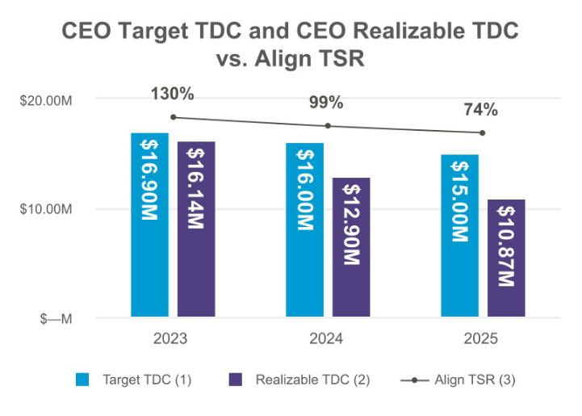

Approximately 91% of our CEO’s and 82% of our other NEOs’ target TDC for 2025 was at-risk pay, and we consider realizable pay an essential component of evaluating the effectiveness of our pay for performance philosophy. The grant date fair values of our equity awards increase or decrease with fluctuations in our stock price and our financial performance. Realizable pay reflects (i) the actual payouts for annual cash incentive awards based on our financial performance, and (ii) the approximate market value of previously-granted equity awards to the executive as of year-end, which we believe is important to consider in addition to the grant date fair values included in the Summary Compensation Table.

As shown in the table below, for 2025, our CEO’s cumulative 3-year realizable TDC was 83% of his cumulative 3-year target TDC and 53% of his cumulative 3-year reported TDC, which is impacted by the reportable valuation of our TSR-linked awards, which is often more than the price of our stock on the date of grant. Further, as shown below, in the comparisons of target pay, realizable pay, and our total shareholder return (“TSR”), positive real pay delivery for our executives is heavily dependent on the creation of stockholder value. Just as positive returns and the generation of stockholder value can increase pay above target, depressions in stock price can drive realizable TDC below target. Our Compensation and Human Capital Committee believes that this correlation between real pay delivery and stock price, visible in the following charts, demonstrates that our equity compensation programs are working as intended, providing meaningful incentives for our executive officers to drive strong stockholder returns relative to our peer group over the long-term.

CEO Realizable TDC vs. Target TDC and Reported TDC

 |  |  |  |  |  | Realizable Pay
 | Target TDC⁽¹⁾ | Reported TDC⁽⁴⁾ |  |  | Realizable TDC⁽²⁾ | % of Target TDC | % of Reported
 |  |  |  |  |  |  | TDC
2025 | $15.00M | $19.19M |  | 2025 | $10.87M | 72% | 57%
2024 | $16.00M | $27.32M |  | 2024 | $12.90M | 81% | 47%
2023 | $16.90M | $28.95M |  | 2023 | $16.14M | 96% | 56%
3-Year Cumulative | $47.90M | $75.47M |  | 3-Year Cumulative | $39.91M | 83% | 53%

- Target TDC: Target TDC is the sum of our CEO’s base salary as disclosed in the Compensation Discussion and Analysis sections of this and prior proxy statements, the target annual incentive amount (which is the target bonus percentage multiplied by the respective base salary) and the target value of our CEO’s long-term incentive awards (which is the amount used to determine the number of shares underlying such awards). No other amounts are included.

  - Realizable TDC: Realizable TDC is the sum of our CEO’s base salary, actual earned non-equity incentive plan compensation, and equity award values of RSUs and MSUs (calculated for MSUs as described in the following sentence). The 2025 MSU award values represent target amounts multiplied by the closing stock price per share on the last day of fiscal year 2025 of $156.15. The Realizable TDC for 2023 and 2024 are the amounts that were provided in our 2025 proxy statement, as amended, that was filed on April 8, 2025.
  - TSR: TSR is calculated by taking the stock price per share on the last day of fiscal years 2023 to 2025 of $274.00, $208.51, and $156.15 respectively, and dividing each by the stock price per share on the last day of fiscal year 2022 of $210.90.
  - Reported TDC: Reported TDC represents the total compensation figures reported in the Summary Compensation Table with respect to each year. As described in the Target Pay and Reported Value section, below, these figures are heavily impacted by the reportable valuation of our TSR-linked awards, which is often more than the price of our stock on the date of grant.

54

Target Pay Versus Reported Value

The target value of the MSUs and RSUs granted to our CEO in 2025 was $11.5 million. However, the value reported in the Summary Compensation Table is $16.56 million, due primarily to a 183.27% premium placed on the value of our TSR-linked equity awards as assessed under the applicable accounting and SEC rules.

Notwithstanding this reported value, our MSUs, which make up the vast majority of the 2025 long-term incentive for our NEOs, vest only after positive performance over three years. As a result, realizable pay is dependent on generating positive stockholder outcomes over three years and is not tied to the point-in-time value assessed by applicable accounting rules. As shown in the prior section, cumulative realizable TDC has averaged 53% of reported TDC over the past three years.

Our Executive Compensation Program

Our program is designed to closely align executive compensation with investors’ interests. The program provides a mix of annual cash and equity, heavily weighted towards longer-term incentives and ties the majority of the compensation paid to our executive management to the achievement of performance goals. The intent of the compensation mix is to attract and retain high-caliber executives in a competitive market for talent and encourage our executive management to implement strategies and take actions in the long-term best interests of the Company and our stockholders.

Executive Compensation Philosophy and Core Objectives

The objective of our Executive Compensation Program is to encourage our corporate leaders to achieve our financial and strategic objectives, thereby creating long-term value for our stockholders. We remain committed to this longstanding philosophy.

Our compensation program is structured to align pay outcomes closely with performance: If we meet robust expectations overall, outcomes should approximate target, with upside and downside pay opportunities where we exceed or fall short of those expectations. In designing our compensation program, the Compensation and Human Capital Committee adheres to compensation governance best practices, including the following:

Offer competitive | We seek to provide competitive compensation opportunities to attract, retain and incentivize superior talent
compensation
Reward performance | A significant portion of the target total direct compensation of our NEOs is tied to the achievement of financial
Reward performance | and strategic objectives, directly linking rewards to achievement of measurable results
Link the interests of | A significant portion of the target total direct compensation of our NEOs is in the form of long-term equity-
executive management with based compensation. This structure is designed to focus decision-making and behavior on goals consistent

our stockholders with our overall strategy over a period of years

_{Solely Independent Directors} Our Compensation and Human Capital Committee is composed solely of independent directors who exercise discretion to ensure pay is linked to performance, and retains an independent compensation consultant

We submit annual proposals on the compensation of our NEOs (“say-on-pay”) to stockholders for advisory

_{Annual Say-on-Pay Votes} votes, with approximately 87% of votes cast in favor of our compensation plan in 2025. Our Compensation and Human Capital Committee considers the outcome of the vote each year in making future compensation

decisions

55

 | We maintain meaningful stock ownership guidelines for executive management and non-employee directors
 | as a matter of good corporate governance and to demonstrate that the interests of executive management
Stock Ownership | and non-employee directors are consistent with those of our stockholders. In 2025, our CEO was subject to a
Guidelines⁽¹⁾ | stock ownership guideline equal to 6x his annual base salary. He has purchased approximately $8 million of
 | our common stock using personal funds since his last sale in 2021.⁽²⁾ Each other member of executive
 | management was subject to a stock ownership guideline in 2025 equal to 3x their annual base salary
 | All of our post-employment cash compensation arrangements in the event of a change in control of the
 | Company are "double-trigger" arrangements requiring both a change in control and a qualifying termination
No “single-trigger” on Cash | of employment before any cash payments are made. In addition, the employment agreements entered into
No “single-trigger” on Cash | by our CEO and CFO, as well as others who join or are promoted to an executive management role after
or Equity Compensation | September 2016, provide that such individuals will only receive accelerated vesting of their outstanding and
 | unvested equity awards if they are terminated without cause or for convenience within 18 months of a
 | change of control (double trigger)
 | Our compensation policies are structured to discourage inappropriate risk-taking. There are no guarantees
 | that bonuses will be paid or paid in the amounts anticipated under our annual cash bonus incentive program
Annual Compensation- | (none were paid in 2022, the payouts in 2023, 2024 and 2025 were all below target) and we cap the
Annual Compensation- | maximum bonus awards in part to discourage excessive risk-taking. The Compensation Risk Assessment
Related Risk Assessment
Related Risk Assessment | located below in this proxy statement describes our Compensation and Human Capital Committee’s
 | assessment that the risks arising from our company-wide compensation programs are reasonable, in the
 | best interest of our stockholders, and unlikely to have a material adverse effect on us
 | Employees (including officers) and directors may not directly or indirectly engage in transactions intended to
No Hedging or Pledging of | hedge or offset the market value of our common stock they own. In addition, our Insider Trading Policy
Our Stock | prohibits employees (including officers) and directors from directly or indirectly pledging our common stock
 | as collateral for any obligation
 | We are committed to carefully managing the dilutive impact of equity compensation awards. Management
 | and the Compensation and Human Capital Committee regularly evaluate share utilization levels by reviewing
 | the dilutive impact of stock compensation. For 2025, our overall equity-award-based gross burn rate for our
 | 2005 Incentive Plan was 1.1%. Gross burn rate is defined as the number of equity awards granted in the
 | year divided by shares outstanding. While we no longer issue stock options and do not have any vested or
Careful Management of | unvested stock options outstanding, if we were to do so, we have pledged to not reprice, buyout or exchange
Careful Management of | underwater stock options and there is no liberal counting or recycling of shares. We believe this gross burn
Equity Burn Rates
Equity Burn Rates | rate reflects our judicious and responsible approach to equity grant practices. Despite our stock repurchases
 | during this period, our gross burn rate percentage is significantly below the benchmark published by a
 | leading proxy advisory service for our index classification. We believe that our stock repurchase program has
 | mitigated dilution attributable to our compensation program while modestly raising our burn rate percentage.
 | In particular, over the course of fiscal 2023, 2024 and 2025, we have repurchased approximately 6.8 million
 | shares of our common stock
 | We have adopted an Insider Trading Policy governing the purchase, sale and other dispositions of our
 | securities by our directors, officers, employees, consultants, contractors and our agents that we believe is
Insider Trading Policies | reasonably designed to promote compliance with insider trading laws, rules and regulations and Nasdaq
 | listing standards. In addition, it is our policy that any trades by us will comply with applicable law, including
 | laws with respect to insider trading
 | We have a clawback policy that provides for the recoupment of executive compensation in certain
Clawback Policy | circumstances as required by the SEC’s rules that implement the Dodd-Frank Wall Street Reform and
 | Consumer Protection Act of 2010 and corresponding Nasdaq listing standards
 | 56

Regular Stockholder Outreach

We have an extensive and continuous stockholder outreach program through which we regularly connect members of our Board, executive management and other senior leaders with our stockholders for input and suggestions on a wide variety of topics, including our pay practices and governance and our executive compensation program reflects their input and suggestions. See section entitled “Stockholder Outreach and Engagement” for more information

Policies and Practices Related to the Grant of Certain Equity Awards

We do not grant stock options, stock appreciation rights, or similar option-like instruments and, as such, do not have any policy or practice in place on the timing of awards of options, stock appreciation rights, or similar option-like instruments in relation to the disclosure of material nonpublic information

- For purposes of this policy, “ownership” includes shares of our common stock directly held or held in trust for the benefit of such director, member of executive management or their family members living in the same household and shares of our underlying RSUs held directly, whether or not yet vested. “Ownership” does not include vested or unvested options to purchase our common stock or shares underlying unvested MSUs.
- Valued at the time of each purchase of our common stock.

57

Principal Elements of Executive Compensation

2025 Target Compensation Mix

The 2025 target TDC for our CEO and non-CEO named executive officers consists primarily of the following elements. Performance is a key consideration for all aspects of our compensation, and for 2025, 91% of target annual TDC for the CEO and 82% of the target annual TDC for our other named executive officers was performance-based or at-risk.
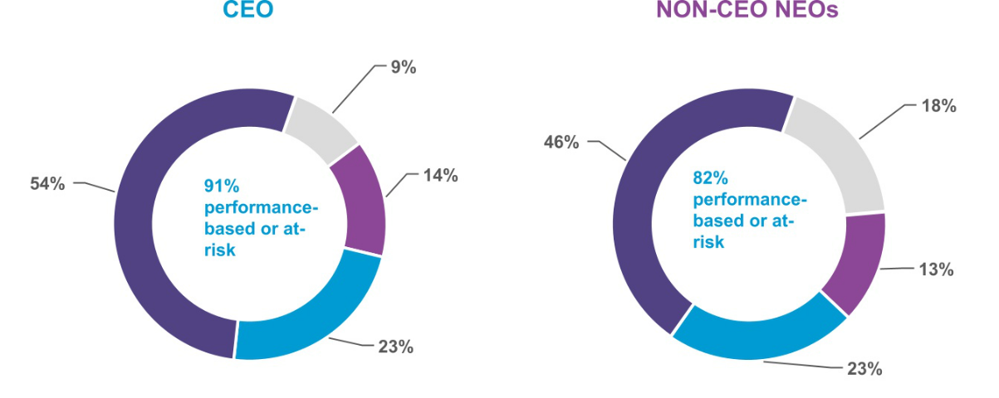

Base Salary Bonus Restricted Stock Units Market Stock Units

 |  |  |  | Element of Compensation |  | Rationale
 |  |  |  | Base Salary |  | • Provide a fixed, baseline level of compensation
 |  |  |  |  |  | that is not contingent upon Align’s performance
 |  |  |  |  |  | • Attract and retain talent with competitive pay that
 |  |  |  |  |  | reflects each executive’s experience, role and
 |  |  |  |  |  | responsibilities.
 |  |  |  | Annual Cash Incentive |  | • Incentivize and reward for achieving and
 |  |  |  | Cash-based bonus paid based upon annual |  | surpassing pre-established short-term financial
 |  |  |  | performance across 3 metrics: |  | goals that support our long-term strategy.
 |  |  |  | • | Constant Currency Revenue (60%) | • Reward individual contributions with an individual
 |  |  |  | • Constant Currency Operating Profit |  | performance factor modifier.
 |  |  |  | • | (40%)
 |  |  |  | • | Individual Performance Factor
 |  |  |  | Restricted Stock Units (RSUs) |  | • Encourage ownership accumulation (and
 |  |  |  | Time-based equity award vesting over 4 |  | alignment with stockholders) in both up and down
 |  |  |  | years. |  | markets.
 |  |  |  | Market Stock Units (MSUs) |  | • Encourage a long-term focus on outperforming
 |  |  |  | Performance-based equity award vesting |  | stock price growth and execution of our strategic
 |  |  |  | only after 3 years, subject to Align's stock |  | plan.
 |  |  |  | performance relative to the Nasdaq
 |  |  |  | Composite Index.
 |  |  |  |  |  | 58


Base Salary

Base salary is intended to provide a fixed, baseline level of compensation that is not contingent upon our performance. Consistent with our pay for performance philosophy, base salaries generally represent a modest proportion of the target TDC opportunity for each member of executive management. In January 2025, our Compensation and Human Capital Committee reviewed the base salaries of our NEOs, comparing their salaries to the base salary levels of companies in our peer group, as well as considering their roles and responsibilities, expectations for future performance, tenure and their positioning for other elements of their compensation. After this review, our Compensation and Human Capital Committee made the adjustments to base salaries set forth in the table below.

Name |  | 2024 Base Salary |  | 2025 Base Salary | Percentage Increase
Joseph M. Hogan | $ | 1,400,000 | $ | 1,400,000 | —%
John F. Morici | $ | 680,000 | $ | 700,000 | 2.9%
Julie Coletti | $ | 600,000 | $ | 650,000 | 8.3%
Stuart Hockridge | $ | 520,000 | $ | 540,000 | 3.8%

In the case of Mr. Hogan, his base salary reflects his position as our most senior executive officer, his years of successful leadership since joining us as our CEO, our strong performance throughout much of his tenure, his passion and dedication to the success of the Company and the recognition of the salary that someone with his proven ability and track record could command in the competitive market.

Annual Cash Incentive Compensation

We use an annual cash incentive compensation plan (the “Bonus Plan”) to reward executive management, including our NEOs, for

performance against pre-established financial goals intended to reward short-term strategic benefits, and an individual performance factor. The Bonus Plan target award opportunity is the amount of cash compensation that each member of executive management can earn if we achieved our financial performance goals at target levels for the year. The incentive targets for members of executive management were set by our Compensation and Human Capital Committee based on the scope and significance of their roles as our leaders, with our CEO receiving the highest target award opportunity due to his greater responsibilities.

The 2025 target award as a percentage of base salary for each member of executive management (other than our CEO) was 75% of base salary, consistent with 2024, to compete effectively with practices observed in our peer group. Mr. Hogan’s 2025 target award opportunity remained unchanged at 150% of his base salary. In order to appropriately encourage and reward a range of acceptable performance and contributions in 2025, our awards were structured so that the actual payout to a member of executive management could be as low as 0% up to a maximum of 240% of target.

How our 2025 Annual Cash Incentive Works

In February 2025, our Compensation and Human Capital Committee conducted its annual review of our Bonus Plan. Based on its review, the Committee determined all of our executive management’s 2025 cash incentive would payout based on our performance relative to pre-established goals under the two following financial metrics, weighted as in prior years and identified below, and an individual performance factor, with total payouts limited to 240% of target. Our Compensation and Human Capital Committee believed it was appropriate to set the company multiplier financial metric goals on a constant currency basis given the high volatility in currency exchange rates leading up to approval of the 2025 Bonus Plan.


Target Bonus Percentage | Company Multiplier | Individual Performance
Target Bonus Percentage | Company Multiplier | Factor

 |  |  | x |  |  |  | x |  |  | = | Bonus Payout
 |  |  | x |  | Constant | Constant | x |  |  | = | Bonus Payout
 |  |  | x |  | Constant | Constant | x |  | Individual Goals | = | (capped at 240% of target)
Base Salary | x | Target Bonus |  |  | Currency Net | Currency |  |  | Individual Goals
Base Salary | x | Percentage |  |  | Revenues - | Operating |  |  | (0% to 200%)
 |  |  |  |  | 60% | Income - 40%

59

Considered in the aggregate, the Committee believes these metrics are strong indicators of our overall performance and our ability to create stockholder value. These measures balance propelling growth while encouraging efficiency and are aligned with our strategic priorities of international expansion, GP dentist treatment, patient demand and conversion and orthodontic utilization.

Measure/Weight |  | Why do we use this measure?

Constant Currency Net Revenues (60%)

Constant Currency Operating Income (40%)

Individual Performance Factor

Improvement in this measure aligns with our overall growth strategy

Directly links incentive payments to profitability and provides incentives to employees (including management) to share in our profitability
Rewards individual contributions based on the achievement of individual goals during the year on a scale from 0% to 200%

The Committee has the ability to adjust the actual results of the cash incentive award to eliminate the distorting effects of certain extraordinary items or events and therefore more accurately reflect the overall performance of the management team. As in prior years, our 2025 Bonus Plan expressly contemplated permissive adjustment for (i) significant and/or extraordinary items not indicative of our core operating performance separately stated on our financial statements, such as restructuring costs and certain settlements; (ii) items identified as non-GAAP in our earnings announcements; and (iii) other discrete items as necessary that may result in unintended gain or loss under the 2025 Bonus Plan. As discussed below, for the 2025 Bonus Plan, the Committee made no adjustment to our constant currency revenue attainment, but excluded certain assets write-down, accelerated depreciation, restructuring charges, and legal settlement, which are all extraordinary and non-recurring items identified as non-GAAP adjustments in our earnings announcements, from the measurement of our constant currency operating income as further discussed below in “2025 Bonus Plan Financial Targets and Attainment.” The Committee did not make any adjustments to constant currency operating income for stock-based compensation or amortization of intangibles.

In addition, our Board did not authorize any discretionary bonus payments to our NEOs in 2025.

2025 Bonus Plan Financial Targets and Attainment

In determining the design of our targets for our Bonus Plan, we consider our annual operating plan as well as historical performance and revenue and operating profit growth rates at select comparable medical device companies. When establishing the 2025 executive compensation cash bonus targets in February of 2025, the Committee considered our 2024 results, our long-term business strategy and desire to return to historical levels of growth, continuing macroeconomic dynamics, inflation expectations and customer and consumer demand among other factors.

The Committee set rigorous target goals and objectives intended to reward executive management for achieving notable growth over 2024’s actual results relative to our industry, notwithstanding the continued challenging business environment. Accordingly, for 2025, our goals for each financial metric were as follows, and were set above prior year actual performance, with payouts calculated based on linear interpolation for achievements between threshold, target and maximum.
Measure/Weighting | Threshold | Target | Max
Measure/Weighting | (millions) | (millions) | (millions)
Constant Currency Net Revenues (60%)⁽¹⁾ | $3,999 | $4,230 - $4,330 | $4,500
Constant Currency Operating Income (40%)⁽²⁾ | $681 | $769 - $811 | $859

- We define constant currency net revenues as total net revenues excluding the effect of foreign exchange rate movements and use it to determine the percentage for the constant currency impact on net revenues on a sequential, year-over-year and current year versus prior year basis. Constant currency impact in dollars is calculated by translating the current period GAAP net revenues using the foreign currency exchange rates that were in effect during the previous comparable period and subtracting it by the current period GAAP net revenues. The percentage for the constant currency impact on net revenues is calculated by dividing the constant currency impact in dollars (numerator) by constant currency net revenues in dollars (denominator).
- We define constant currency income from operations as GAAP income from operations excluding the effect of foreign exchange rate movements for GAAP net revenues and operating expenses on a sequential, year-over-year and current year versus prior year basis. Constant currency impact in dollars is calculated by translating the current period GAAP net revenues and operating expenses using the foreign currency exchange rates that were in effect during the previous comparable period and subtracting it by the current period GAAP net revenues and operating expenses.

60

In 2025, we achieved GAAP net revenues of $4.035 billion, exceeding our 2024 results by $36 million. Our GAAP operating income was down in 2025 to $546 million compared to $608 million in 2024, based in part on $164 million in extraordinary and non-recurring expenses

associated with assets write-down, accelerated depreciation, restructuring charges, and legal settlements as discussed below. Adjusting for these expenses, and on a constant currency basis, our adjusted operating income was $715 million. In addition, our constant currency net

revenues were $4.030 billion. Our constant currency net revenues and constant currency operating income performance, and our payout levels under each component of the plan, are shown below:

Measure/Weight | Achievement (2025) | Payout
Measure/Weight | (millions) | Payout
GAAP Net Revenues | $4,035
Constant currency impact | $(4.875)
Constant Currency Net Revenues (60%)⁽¹⁾ | $4,030 | 54.6%
GAAP Operating Income | $546
Income from operations constant currency impact | $4.935
Operating Income Adjustments⁽²⁾ | $164
Constant Currency Operating Income (40%)⁽¹⁾ | $715 | 63.2%
COMPANY MULTIPLIER PAYOUT |  | 58.1%

- Payouts for each individual financial measure is determined based on linear interpolation for achievement between threshold, target, and maximum (as shown above). Attainment of revenue results were not adjusted relative to our non-GAAP reporter financials. Operating Income results were adjusted pursuant to the Bonus Plan as described below.

- Operating Income results were adjusted pursuant to the Bonus Plan as described below.

Consistent with prior years, our 2025 Bonus Plan expressly contemplated adjustment for costs and non-recurring items not indicative of core operating performance. In 2025, pursuant to this authority, our Compensation and Human Capital Committee made the following adjustments to the measurement of attainment under the constant currency operating income component of the 2025 Bonus Plan, all of which are included in the non-GAAP adjustments we make to operating income each year when reporting our adjusted earnings. Specifically, in order to align 2025 Bonus Plan payouts with the underlying performance of our business, the Committee excluded $164 million in expenses from our constant currency operating income, as shown above. Without these adjustments, the constant currency operating income component of the 2025 Bonus Plan would not have paid out. No adjustment was made to the constant currency net revenue component of the Bonus Plan. The thresholds for the 2026 Bonus Plan are based on our achieved results in 2025, including the as-adjusted operating income, and our 2026 Bonus Plan will not pay out unless we achieve results that are above those achieved in 2025, as-adjusted.

Constant Currency Operating Income Adjustments Rationale


– Excluded $43M in restructuring costs.

These restructuring costs and other non-recurring items, which were
– Excluded $117M in impairment loss on assets write-down, primarily recorded during the third and fourth quarter of 2025, and
accelerated depreciation, and inventory impairment | meant to be margin accretive to the business by streamlining our go-
 | forward operating expenses.
– Excluded $4M related to certain legal settlements. | These costs resulted from the conclusion of multi-year legal disputes
 | that are non-recurring and separate from the core operations of our
 | business.

2025 Bonus Plan Individual Performance Factor Attainment

Our Compensation and Human Capital Committee determined that, for 2025, our executives continued to perform in line with expectations in the context of a difficult macroeconomic environment, and graded all our executives’ individual performance factor at target. As a result, the 2025 individual performance factor component of our Bonus Plan did not modify payouts determined under our financial multipliers.

2025 Bonus Plan Payouts

61

The following chart shows attainment under our cash bonus plan for each of our executives. Our Compensation and Human Capital Committee did not exercise its discretion to increase or decrease the formulaic payout of our Bonus Plan.

 | Target Incentive | Target Incentive |  | Company | Individual | Actual Incentive |  | Actual Award as
Name | Award (as % of |  |  | Company | Performance |  |  | Actual Award as
Name | Base Salary) |  | Award | Multiplier | Factor |  | Award | % of Target
Joseph M. Hogan | 150 % | $ | 2,100,000 | 58.1% | 100% | $ | 1,220,100 | 58.1%
John F. Morici | 75 % | $ | 525,000 | 58.1% | 100% | $ | 305,025 | 58.1%
Julie Coletti | 75 % | $ | 487,500 | 58.1% | 100% | $ | 283,238 | 58.1%
Stuart Hockridge | 75 % | $ | 405,000 | 58.1% | 100% | $ | 235,305 | 58.1%

Long-Term Incentive Compensation

We use equity awards to more closely align our executive management’s long-term interests with those of our stockholders and to attract and retain high-caliber executives through recognition of anticipated future performance. We determine appropriate award amounts, if any, by reviewing competitive market data, individual performance assessments and business objectives with our Compensation and Human Capital Committee at least annually. In 2025, the Committee reviewed our program and determined that our long-term incentive plan should continue to consist of time-based restricted stock units and relative-TSR based market stock units, as shown below.

Award Type | Rationale for 2025 Portfolio | Vesting Detail
Why RSUs? | We believe RSUs provide a measure of retention while remaining exposed to stock price | Typically vest over four
 | movement, and thus incentivizing executives to grow the value of our common stock. In | years with 25% vesting
 | addition, RSUs enable our executive management to accumulate ownership of our common | annually
 | stock, which reinforces the alignment of their objectives with those of our stockholders.

Why MSUs? We believe MSUs provide a consistent value delivery that also aligns the long-term interests

of executive management and stockholders by rewarding executive management for our

performance measured in relation to other companies over a specified period. The actual

number of shares eligible to vest is determined by the percentile ranking of our TSR during

the 3-year performance period compared to the TSR of the constituents of the Nasdaq

Composite Index over the same period (Relative TSR). Our TSR and the TSR of the indexed

companies is calculated based on the change in the 30-day average closing price on the first

day of the performance period (typically February 15) and the last day of the performance

period (typically February 15), in each case assuming dividend reinvestment. The threshold

levels of Relative TSR are as follows:

Three-year performance period with vesting ranging from 0% - 250% of target, with any vesting occurring entirely at the end of year three

Relative Total Stockholder Return Shares Subject to the Award

Below 25th percentile 0%

25th percentile 50%

50th percentile 100%

90th percentile 250%

Linear interpolation will be used to determine the percentage of the shares subject to the MSU awards that are earned and will vest between each threshold. The number of shares that vest may not exceed 100% of the target shares if total stockholder return is negative.

62

2025 LTI Awards

In 2025, our Compensation and Human Capital Committee reviewed our long-term incentive program and concluded that the mix of RSUs and MSUs was generally aligned with market practices and aligned executive interests with our long-term growth. Therefore, the Committee continued to grant MSUs and RSUs as set forth in the below table, with an increased percentage of MSUs for our CEO.
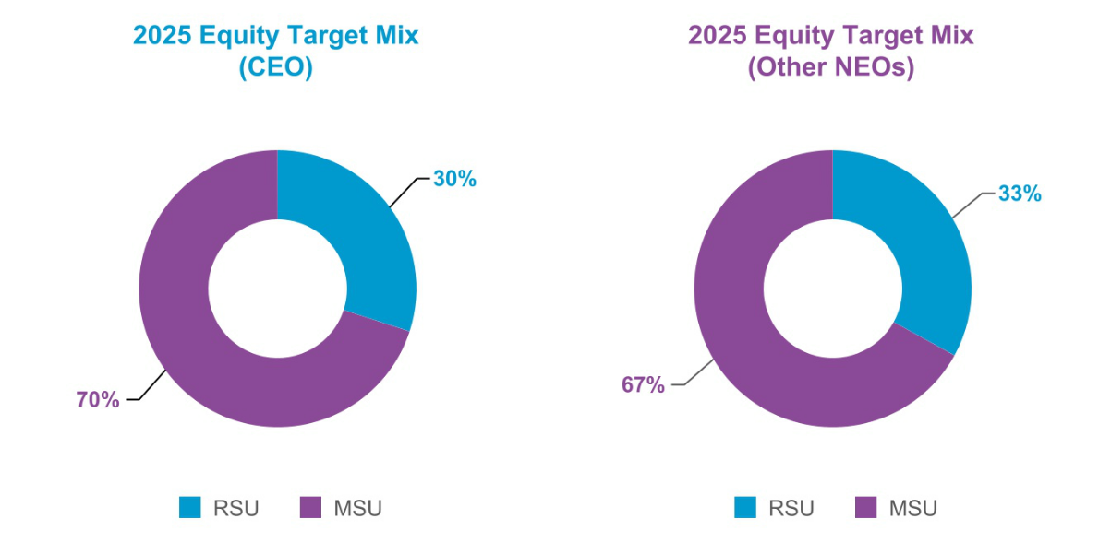

 |  | Target Value | RSU |  | Target Value | Target MSUs
Name |  | (RSUs) ⁽¹⁾ | (Shares) |  | (MSUs) ⁽¹⁾ | (Shares) ⁽¹⁾
Joseph M. Hogan | $ | 3,450,000 | 15,843 | $ | 8,050,000 | 36,969
John F. Morici | $ | 1,089,000 | 5,001 | $ | 2,211,000 | 10,153
Julie Coletti | $ | 825,000 | 3,788 | $ | 1,675,000 | 7,692
Stuart Hockridge | $ | 462,000 | 2,121 | $ | 938,000 | 4,307

- The number of MSUs set forth in this column represents the number of shares at target; however, the actual number of shares that may be earned, if any, is determined based on the formula set forth above, up to a maximum of 250% of the amount of the Target Shares. The Target Value of RSUs and MSUs may not reflect the value of those RSUs and MSUs upon vesting.

The Committee calculated the target values for equity awards to achieve this desired mix and converted this to shares using a look back price that was based on the 30-trading day average closing price of our common stock for the period ending February 15, 2025. Based on this price per share, the total number of targeted shares was determined, then split between time-based RSUs and performance-based MSUs for non-CEO executive management and our CEO in the aforementioned ratios, each rounded down to the nearest whole share.

2023 MSU Payout

The 2023 MSUs were earned based on our relative stockholder return over a three-year performance period ending February 15, 2026, compared to the Nasdaq Composite Index, with the earned shares eligible to vest only at the end of that three year period. The relative goals for vesting of these MSUs were based on the same TSR performance goals relative to the constituents of the Nasdaq composite Index as shown above for the 2025 MSUs. Over the relevant three year period, our TSR was (36.76)% which was at the 39.9th percentile of the Nasdaq Composite index. Based on this relative performance to the Nasdaq Composite Index, MSUs granted in February 2023 to our NEOs vested at 79.8% of target in February of 2026.

63

Other Compensation Arrangements

Welfare and Other Employee Benefits

We maintain a tax-qualified Section 401(k) retirement plan with a matching contribution by Align for all U.S. employees, including members of executive management.

In addition, we provide health and welfare benefits to executive management on the same basis as our full-time employees in the country in which they are resident. These benefits may include medical, dental and vision benefits, medical and dependent care flexible spending accounts, short-term and long-term disability insurance, accidental death, basic life insurance coverage, and participation in our employee stock purchase plan. We design our employee benefits programs to be affordable and competitive in relation to the market, as well as compliant with applicable laws and practices. We adjust our employee benefits programs as needed based upon regular monitoring of applicable laws and practices and the competitive market.

Perquisites and Other Personal Benefits

Consistent with the practices of our peer group companies, we provide limited perquisites to members of executive management, including the NEOs, and perquisites do not play a significant role in our compensation program.

Executive management may be reimbursed for travel by a non-employee companion (e.g., spouse) to customer events and certain other corporate events where appropriate and it is in our interest that the member of executive management have a companion join them. See “Summary Compensation Table for Fiscal Year 2025” below for more information concerning these benefits, if any. In the future, we may provide perquisites or other personal benefits in limited circumstances, such as where we believe it appropriate to assist a member of executive management in the performance of their duties, to make them more efficient and effective, and for recruitment, motivation, or retention purposes. All future practices with respect to perquisites or other personal benefits will be approved and subject to periodic review by the Compensation and Human Capital Committee.

Corporate Tax Deduction on Compensation in Excess of $1 Million a Year

Section 162(m) of the Internal Revenue Code, as amended by the Tax Cuts and Jobs Act of 2017, generally disallows a deduction for federal tax purposes to any publicly traded corporation for any remuneration in excess of $1,000,000 paid in any taxable year to its covered employees for that taxable year, who consist of its CEO, CFO, up to three other members of executive management who are among the corporation’s five most highly compensated executive officers for that taxable year, and any individual who was a covered employee for any preceding taxable year beginning after December 31, 2016. While we consider the deductibility of awards in determining compensation payable to executive management, the Compensation and Human Capital Committee’s reserves flexibility to provide, and has provided, one or more covered executive officers with the opportunity to earn compensation that is nondeductible under Section 162(m) when the Compensation and Human Capital Committee believes that such compensation is appropriate to attract and retain executive talent.

For taxable years beginning after December 31, 2026, the American Rescue Plan Act of 2021 (ARPA) expands the definition of covered employees to include the next five highest-compensated employees, even if such employees are not officers (Additional Employees). However, unlike current covered employees, who will remain covered employees for all future taxable years, Additional Employees will be covered employees only for the years in which they are compensated as one of the next five highest-compensated employees within their publicly held corporation.

64

How We Implement and Manage Our Executive Compensation Program

In addition to our Board’s role in approving compensation for our CEO, our Compensation and Human Capital Committee, its consultants and executive management contribute to the implementation of the executive compensation program. The table below specifies the responsible parties and their respective roles in determining our NEOs’ compensation:

Responsible Party | Roles and Responsibilities
Compensation and Human Capital | Sets our overall compensation philosophy, which our Board reviews and approves
Committee
 | Reviews and approves our compensation programs; designs and monitors the execution of these
 | programs
 | Reviews and approves all forms of compensation for executive management (other than our CEO)
 | Reviews and recommends to our Board all forms of compensation for our CEO
 | No member of the Committee is a former or current officer of Align or any of our subsidiaries. No
 | member of executive management serves as a member of the board of directors or the
 | compensation committee of any entity that has any members of executive management serving on
 | our Board or the Committee
 | The Committee may delegate such portions of its authority as the Committee may deem
 | appropriate, to one or more members of the Committee to the extent permitted by applicable law,
 | our bylaws and any applicable resolutions of our Board
Consultant to the Compensation | Compensia attends meetings of our Compensation and Human Capital Committee and
and Human Capital Committee | communicates outside of meetings with its members and management with respect to the design
(Compensia, Inc., an independent | and assessment of compensation packages for executive management. In 2025, Compensia
executive compensation consulting | provided the services below for, or at the request of, the Committee, according to the instructions
firm retained directly by the | provided by the Committee:
Compensation and Human Capital | • Analyzed whether the elements of compensation and target TDC of executive management
Committee to assist it in performing its | were consistent with our compensation philosophy and the competitive market (as defined by
responsibilities) | our compensation peer group companies);
 | • Assisted in defining the appropriate peer group of comparable companies;
 | • Assisted in the design of our incentive compensation programs for executive management and
 | compensation arrangements for Board members, including discussing evolving compensation
 | trends;
 | • Provided advice on stock ownership guidelines for executive management and non-employee
 | directors;
 | • Compiled and provided competitive market data to assist in our compensation philosophy,
 | establishment of plan parameters and selection of corporate performance measures;
 | • Conducted a comprehensive review of Board compensation and provided recommendations to
 | the Committee and Board regarding non-employee director pay structure;
 | • Provided updates on Nasdaq listing standards, say-on-pay results, and regulatory
 | developments; and,
 | • Assisted with the strategy for developing disclosure in support of our say-on-pay proposal.
 | In addition, the Committee conducted a formal review of Compensia’s independence and is
 | satisfied with the qualifications, performance and independence of Compensia. Compensia
 | performed no other work for us
 | 65

Executive Management (Assisted by company staff)

Management’s role is to advise our Compensation and Human Capital Committee regarding the alignment and weighting of our performance measures under our annual cash incentive compensation plan with our overall strategy, the impact of the design of our equity incentive awards on our ability to attract, motivate and retain highly talented executives and the competitiveness of our compensation programs. Our CEO plays a significant role in setting the compensation for the members of our executive management team (other than himself). The CEO conducts performance reviews for the other NEOs and makes recommendations to the Committee with respect to the other NEOs’ compensation. The Committee has the discretion to accept, reject, or modify the CEO’s recommendations. Ultimately, all decisions regarding executive management compensation are made by the Committee or in the case of our CEO’s compensation, the independent members of our Board upon the Committee's recommendation

How We Determine Compensation

Within the overall framework of the objectives and principles discussed above, our Compensation and Human Capital Committee exercises its judgment when making executive management compensation decisions. The Committee considers the individual’s competitive position, market data, Align’s performance and the individual’s performance.

Competitive Positioning

Our Compensation and Human Capital Committee takes into consideration the unique roles played by each member of executive management and seeks to individually tailor their compensation to align their pay based on various factors, including:

- market compensation data (peer group data and survey data);

- the scope of the individual's role;

- the individual's experience, qualifications, skills, and performance during the fiscal year (see discussion below under “Role of Individual Performance”);

- internal equity; and

- our operational and financial performance.

After reviewing these various competitive positioning factors (none of which is determinative or weighted in any predetermined manner), the Committee relies upon the judgment of its members to make appropriate adjustments and recommendations to the compensation of executive management to meet our corporate objectives.

The Use of Market Comparison Data

In connection with our Compensation and Human Capital Committee’s continuing assessment of the competitiveness of executive management’s pay levels and practices relative to its peers, the Committee considers compensation data gathered from: (i) a selected peer group of companies, and (ii) published surveys with data from a broader mix of technology and life science companies.

Peer Group. Our Compensation and Human Capital Committee reviews our peer group at least annually and makes adjustments to its composition, taking into account changes in both our business and the businesses of the companies in the peer group. For compensation decisions applicable to 2025, the Committee, with the assistance of Compensia, reviewed and approved a peer group chosen based on the following selection criteria:

- Industry - medical device companies and technology companies, which are the industries which we primarily recruit from and compete with for executive talent;
- Market Capitalization - companies with a market capitalization between approximately $5.55 billion and $88.77 billion based upon the companies’ trading ranges at the time of selection which approximated 0.25 to 4.0 times our market capitalization at that time; and

66

- Revenue - companies with revenue between approximately $1.29 billion to $11.75 billion based upon the last four quarters of revenue at the time of selection which approximated 0.33 to 3.0 times our rolling four quarters of revenues at that time.

As a result of its review of the foregoing criteria, the Committee elected to make no changes to the peer group for 2025. At the time of the

Committee’s assessment of potential peers performed in the second quarter of 2024, we compared to the 2025 peer group as follows:

 | Revenue ($B) | Market Capitalization | Market Capitalization as a Multiple
 | Revenue ($B) | ($B) | of Revenue
Peer Group 50th Percentile | $3.9 | $19.2 | 4.9
Align | $4.0 | $22.2 | 5.7
Percentile Rank | 52nd | 59th

Based on its analysis and review of our existing peer group relative to the foregoing criteria and on the recommendation of our independent compensation consultant, our Compensation and Human Capital Committee elected to make no changes to the peer group. As a result, the Compensation and Human Capital Committee determined that the following peer group continued to constitute an appropriate comparative reference for determining executive management compensation for 2025:

Performance Peers

 | Agilent Technologies | Hologic | Revvity
 | Avantor | IDEXX Laboratories | STERIS
 | Bio-Rad Laboratories | Illumina | Teleflex
 | Dentsply Sirona | Insulet | The Cooper Companies
 | DexCom | Masimo | Waters
 | Edwards Lifesciences | Mettler-Toledo | Zimmer Biomet
 |  | ResMed

Reference Peers. Our Compensation and Human Capital Committee also considers the compensation data of other companies as reference peers, which are companies identified by management as key business or labor market comparators. The compensation data of these companies was used for informational purposes only and was not used in setting executive management compensation levels because the financial profiles of these companies are outside the peer group development parameters.

Survey Data. When peer data is unavailable, our Compensation and Human Capital Committee reviews various pay surveys, including the Radford Technology Survey. In addition, the Committee may review the data separately to understand pay differences, if any, by industry or business segment and to assess whether any changes in pay data from year to year reflect true market trends.

Role of Competitive Data and our Compensation and Human Capital Committee’s Discretion. Our Compensation and Human Capital Committee uses peer group and survey data as reference points for assessing appropriate base salary, target total cash compensation and equity compensation for our executive officers. While we believe that comparisons to market data are useful, the Committee does not believe it appropriate to establish executive management compensation levels based solely on a comparison to market data. Due to the variations between companies reporting and the roles for which compensation for these companies is ultimately disclosed, directly comparable information is not always available from each peer group company with respect to each of our NEOs.

In considering market compensation data, the Committee recognizes that executive management roles at different companies can vary significantly, with different responsibilities and scopes of work, even though they may hold similar titles or nominal positions. The Committee therefore uses the market data only as a reference point and incorporates flexibility into our compensation programs and in the assessment process to respond to and adjust for the evolving business environment and other subjective elements described in the competitive positioning factors

67

above. After reviewing these various factors, the Committee relies upon the judgment of its members to adjust executive management compensation below or above these percentile ranges as it deems appropriate and to make recommendations to the independent members of our Board about the compensation of our CEO.

Role of Company Performance

Our Compensation and Human Capital Committee believes that executive management should be rewarded based on their collective success working as a team. Consistent with this belief, the achievement of shared financial and critical strategic goals, which we describe below under “Annual Cash Incentive Compensation” is the primary factor in determining whether and how much members of executive management are eligible to receive as cash incentive payments.

Role of Individual Performance

Although our Compensation and Human Capital Committee believes that the largest portion of the target TDC of each member of executive management should be based on their collaborative success and thus based on achievement of shared financial and critical strategic goals, it also believes there should be some flexibility to reward individual contributions. To evaluate individual performance, the Committee considers annual individual goals set for each member of executive management. These include shared financial and strategic objectives as well as objectives directly related to each individual's specific business function. Except with respect to the CEO’s own performance, this assessment is based on our CEO's recommendation to the Committee on how well an individual performed their job, and such assessment is largely (although not exclusively) qualitative, not quantitative, in nature. There is no specific weight given to any one individual goal or objective. This subjective evaluation of the impact of the individual contributions on actual compensation is not a formula-based process resulting in a quantifiable amount of impact, but rather involves the exercise of discretion and judgment. This enables the Committee to differentiate among individuals and emphasize the link between performance specific to their respective roles and compensation.

The Use of Tally Sheets

Our Compensation and Human Capital Committee uses tally sheets to understand executive management total annual compensation and to provide perspective on wealth accumulation from our compensation programs. Compensation previously paid to each individual, including amounts realized or not realized under prior equity-based compensation awards, did not affect the Committee's compensation decisions for 2025. The Committee believes that compensation should reflect an individual’s performance and the market value of their services and does not want to create a disincentive for exceptional performance.

Compensation Program Evaluation and Risk Management

Our Compensation and Human Capital Committee evaluates the various elements of our compensation programs to avoid encouraging, and to mitigate against, excessive risk taking, by promoting behaviors that support sustainable value creation. The Committee annually assesses the various components of our compensation programs and believes our compensation policies and practices do not create risks that are reasonably likely to have a material adverse effect on the Company.

In performing its assessment, our Compensation and Human Capital Committee monitors and evaluates our compensation programs to ensure that:

- We provide a mix of cash and equity, that in the aggregate are heavily weighted towards longer-term incentives to encourage strategies and actions in the long-term best interests of the Company and our stockholders;
- We set base salaries consistent with each employee’s responsibilities so that they are not motivated to take excessive risks to achieve a reasonable level of financial security;

- We set appropriate performance goals that we believe:

  - are reasonable in light of past performance and market conditions, and

  - encourage success without encouraging excessive risk-taking to achieve short-term results;

- We set annual cash incentive plan performance goals that are Company-wide in order to encourage sound decision-making and performance throughout Align and that are in the best long-term interests of Align and our stockholders as a whole;

68

- We do not employ an “all-or-nothing” approach. Under our annual cash incentive plan, achievement of performance goals at levels below full target goals reduces only the payout related to that goal, not the other goals;
- We cap the amount executive management can receive under our cash incentive compensation plan at a maximum of 240% of their targets to avoid incentivizing excessive risk-taking; and

- We use a portfolio of equity-based awards for executive management that incentivizes performance over a variety of time periods with respect to several balanced goals. For example:

  - RSUs retain value even in depressed markets making it less likely employees will take unreasonable risks to get, or keep, their equity awards “in the money;”

  - Performance-based MSUs measure relative stockholder return over a three-year performance cycle, thereby potentially retaining value even if the price of our common stock decreases in a market downturn, provided that the decrease is not more than 33 percentage points greater than other companies;

  - The number of shares potentially earned are capped at a maximum of 250% of the number of target shares to limit stockholder dilution; and

- Executive management is subject to material stock ownership guidelines.

69

Severance and Change of Control Arrangements

Each NEO is eligible to receive payments and benefits under certain conditions in accordance with their respective employment agreement,

RSU or MSU agreements. Each such agreement provides for payments and benefits upon:

- a change of control of the Company; and

- termination without cause or for convenience.

In adopting the change of control provisions in these agreements, our Compensation and Human Capital Committee's primary objective was to ensure members of executive management have sufficient security such that they are not biased against a sale of the Company in the event a stockholder favorable merger and acquisition transaction is presented. If we pursue a change of control transaction beneficial to our stockholders, the Committee believes that executive management's active support of the transaction through closing would be critical to ensuring the success of such a transaction.

The severance payments and benefits are intended to provide consideration for executive management's service to Align and the expected length of time until subsequent employment is secured. The severance provisions also assist in recruiting members of executive management given that their roles tend to carry higher risks.

Our Compensation and Human Capital Committee periodically reviews the terms and conditions of our change of control and severance compensation practices against those of our peers. As industry trends and best practices have evolved over the years, the Committee modifies its approach to change of control and severance compensation by looking for opportunities to prospectively implement modifications for new members of executive management and for members of executive management with existing agreements when circumstances allow. For instance, in September 2016, the Committee materially changed our practices regarding change of control payments and benefits. Prior to September 2016, upon a change of control alone, agreements with members of executive management allowed for the acceleration of vesting of outstanding and unvested RSUs as if the executive had performed twelve months of additional service and pro-rata MSU awards based upon the closing of the change in control ("single trigger"). Beginning in and after September 2016, the change of control acceleration benefits for new members of executive management also requires a termination of employment after a qualifying change of control event ("double trigger").

The amounts that each of our current NEOs would have been entitled to if one of the termination or change of control events described above occurred on December 31, 2025, are set forth in “Potential Payments Upon Termination or Change of Control” below.

Change of Control Only

Though the cash severance amounts payable to Messrs. Hogan and Hockridge in connection with a change of control are subject to a “double trigger” (meaning to get paid out the cash portion of their change of control severance arrangement, first there has to be a change of control and then the employment of the individual must be terminated without cause or for convenience within a specified period of time of such change of control), Mr. Hogan’s RSU and MSU agreements and Mr. Hockridge’s pre-September 2016 employment agreements, RSU and MSU agreements include a “single trigger” for these individuals whereby the vesting of outstanding and unvested equity awards would be accelerated upon a change of control. Mr. Hogan’s RSUs and MSUs will vest pro rata as of the date a change of control and Mr. Hockridge’s MSUs will vest pro rata as of the date a change of control and the vesting of their RSUs will be accelerated by one year upon a change of control. As previously disclosed, in September 2025, Mr. Hockridge’s employment was terminated without cause, effective May 2026.

With respect to Mr. Morici and Ms. Coletti (as well as any other individual who joins us or is promoted to an executive management position after September 2016), our Compensation and Human Capital Committee eliminated all single trigger severance and equity acceleration provisions. Rather, severance payments and equity acceleration for these members of executive management are subject to “double trigger” arrangements that require both a change of control plus a qualifying termination event before any cash payments are paid or any equity award acceleration occurs.

70

Termination Following a Change of Control

In the event any of the NEOs are terminated without cause or for convenience within 18 months (12 months in the case of Mr. Hockridge) of a change of control (“double trigger”), 100% of all remaining outstanding and unvested equity awards would be accelerated and a cash severance payment would be made.

Termination Unrelated to a Change of Control

For termination of employment without cause or for convenience unrelated to a change of control, the vesting of equity awards held by Mr. Hockridge, is immediately accelerated by one year and a cash severance payment will be made. Messrs. Hogan and Morici and Ms. Coletti (as well as any other individual who joins us or is promoted to an executive management position after September 2016) would receive only a cash severance payment (no equity acceleration) if their employment is terminated without cause or for convenience unrelated to a change of control.

Retirement

Our RSU and MSU award agreements provide for continued vesting for our executive officers upon their retirement from Align subject to the following terms: (i) the executive officer is required to provide twelve months advance written notice of their desire to retire with such notice being subject to our CEO’s written pre-approval; (ii) the executive officer must be 55 years or older and have a minimum of ten years of continuous service at the time they provide their notice to the CEO; and (iii) the executive officer must have a minimum of six months of service after an equity grant award for such grant to be eligible for continued vesting under this retirement provision (collectively, the “Retirement Eligibility Terms”). If each of the Retirement Eligibility Terms are met, (i) each outstanding RSU award belonging to an executive officer will continue to vest for twelve months after the executive officer’s date of retirement from Align; (ii) for each outstanding MSU award belonging to the executive officer will be entitled to receive a pro-rated vesting of shares at the end of the applicable MSU performance period based on the date of retirement and subject to the conditions for vesting and release of shares under the original terms of the MSU are achieved in accordance with the terms of the applicable MSU award. The pro-rated vesting shall be based on the amount of time the executive officer was employed during the performance period and any vesting of shares under a RSU award and MSU award are subject to the executive officer complying with lawful non-compete, non-solicit, confidentiality and release of claims provisions set forth in the agreement. These Retirement Eligibility Terms help better ensure retention of retiring executives through the hiring of their replacements and a smoother transition upon retirement. It also recognizes the service of the retiring executive to Align. As of December 31, 2025, only Mr. Hogan has attained the age of 55 and a minimum of ten years of continuous service to Align and is the sole executive eligible for this benefit.

2025 Stockholder Say-on-Pay Vote Results

At our Annual Meeting of Stockholders in May 2025 (the “2025 Meeting”), our stockholders were asked to cast a non-binding advisory vote ("say-on-pay") to approve the compensation for our 2024 named executive officers. At the 2025 Meeting, approximately 87% of the votes cast by our stockholders were in support of our “say-on-pay” proposal. Based on the results of this vote and our regular stockholder outreach and engagement, our Compensation and Human Capital Committee believes that our stockholders understand its philosophy on executive compensation, recognize how our compensation program aligns with our strategic goals and objectives and support our approach to executive compensation.

Compensation and Human Capital Committee Report

The Compensation and Human Capital Committee has reviewed and discussed the Compensation Discussion and Analysis included in this proxy statement with management. Based on the Compensation and Human Capital Committee’s review and discussion with management, the Compensation and Human Capital Committee recommended to the Board that the Compensation Discussion and Analysis be included in this proxy statement.

71

THE COMPENSATION AND HUMAN CAPITAL COMMITTEE

Kevin T. Conroy, Chair

George J. Morrow

Anne M. Myong

Andrea L. Saia

72

Compensation Tables

Summary Compensation Table for Fiscal Year 2025
Grants of Plan-Based Awards for Fiscal Year 2025
Outstanding Equity Awards at Fiscal 2025 Year End

Option Exercises and Stock Vested During Fiscal Year 2025
Potential Payments Upon Termination or Change of Control
CEO Pay Ratio
Pay Versus Performance


73

Summary Compensation Table for Fiscal Year 2025

The following Summary Compensation Table sets forth certain information regarding the compensation for fiscal 2025, 2024 and 2023 of (i) our President and Chief Executive Officer, (ii) our Chief Financial Officer and (iii) our three next most highly compensated executive officers during fiscal year 2025.

 |  |  |  | Non-Equity | All Other
Name and Principal |  | Salary | Stock Awards | Incentive Plan | All Other | Total
Name and Principal | Year | Salary | Stock Awards | Compensation | Compensation | Total
Position | Year | ($) | ($)⁽¹⁾ | ($) | _{($)}(2) | ($)
Joseph M. Hogan, | 2025 | 1,400,000 | 16,556,872 | 1,220,100 | 17,016 | 19,193,988 | (3)
President and Chief Executive | 2024 | 1,396,904 | 23,848,513 | 2,058,000 | 17,762 | 27,321,179
Officer | 2023 | 1,354,769 | 26,230,870 | 1,346,200 | 20,572 | 28,952,411
John F. Morici, | 2025 | 697,692 | 4,675,834 | 305,025 | 21,783 | 5,700,334
Chief Financial Officer and | 2024 | 675,385 | 5,249,435 | 500,000 | 11,567 | 6,436,387
Executive Vice President, Global | 2023
Finance | 2023 | 618,461 | 4,581,010 | 286,000 | 77,410 | 5,562,881
Julie Coletti, | 2025 | 644,231 | 3,542,293 | 283,238 | 13,652 | 4,483,414
Executive Vice President, Chief
Executive Vice President, Chief | 2024 | 597,692 | 3,749,021 | 441,000 | 11,502 | 4,799,215
Legal and Regulatory Officer
Legal and Regulatory Officer | 2023 | 566,154 | 3,435,758 | 263,000 | 11,016 | 4,275,928
Stuart Hockridge, | 2025 | 537,692 | 1,983,440 | 235,305 | 17,872 | 2,774,309
Executive Vice President, Global | 2024 | 518,462 | 2,624,717 | 382,000 | 18,398 | 3,543,577
Human Resources⁽⁴⁾ | 2023 | 498,462 | 2,672,150 | 231,000 | 10,879 | 3,412,491

- The amounts shown in this column reflect the aggregate grant date fair value computed in accordance with Financial Accounting Standards Board (“FASB”) Accounting Standards Codification (“ASC”) Topic 718. Assumptions used in the calculations of these amounts are included in Note 1 - Summary of Significant Accounting Policies, Stock-Based Compensation and Note 10 - Stockholders’ Equity (collectively, “Notes 1 and 10”) to our audited financial statements for the year ended December 31, 2025 included in our Annual Report. This same method was used for the years ended December 31, 2024 and 2023.
- For a further description of the amounts included in this column, please see the paragraph entitled “All Other Compensation” below.
- Mr. Hogan’s 2025 realizable total direct compensation is $10.87M. We believe realizable pay reflects a closer approximation of the value of equity awards to the executive as of the year-end and that it is important to consider the effect of such year-end value of our stock on those awards over time in addition to the grant date fair values included in the Summary Compensation Table. See “Executive Compensation—Executive Summary—Realizable Pay” above, including the calculations used to determine realizable total direct compensation.

- As previously disclosed, in September 2025, Mr. Hockridge’s employment was terminated without cause, effective May 2026.

The grant date fair value of the MSU awards reflected in the Stock Awards column and the tables below is computed based on the probable outcome of the performance conditions as of the grant date. This amount is consistent with the estimate of aggregate compensation cost we expect to recognize over the three-year performance period of the award determined as of the grant date under FASB ASC Topic 718. Refer to Notes 1 and 10 of our audited financial statements for the year ended December 31, 2025, included in our Annual Report for the assumptions used to value the RSU and MSU awards. The amounts shown in the Stock Awards column and the tables below exclude the impact of estimated forfeitures and there can be no assurance that the grant date fair value amounts will ever be realized.

Name |  | Fiscal Year 2025 RSUs |  | Fiscal Year 2025 MSUs
Joseph M. Hogan | $ | 3,137,865 | $ | 13,419,008
John F. Morici | $ | 990,498 | $ | 3,685,336
Julie Coletti | $ | 750,251 | $ | 2,792,042
Stuart Hockridge | $ | 420,085 | $ | 1,563,355
 | 74

Assuming that the highest level of performance conditions is achieved, the aggregate fair value of the MSU awards at the grant date is as follows:
Name | Value of Fiscal Year 2025 MSUs Assuming Maximum
Name |  | Performance
Joseph M. Hogan | $ | 33,547,519
John F. Morici | $ | 9,213,340
Julie Coletti | $ | 6,980,105
Stuart Hockridge | $ | 3,908,387

Total Compensation

The non-CEO NEOs’ decrease in total compensation in 2025 compared to 2024 was due to the grant date fair value of equity awarded and lower cash bonuses paid for 2025, partially offset by an increase in base salary for the non-CEO officers. The CEO’s decrease in total compensation in 2025 compared to 2024 was due primarily to the decreased grant date fair value of equity awarded. For additional information regarding the amounts included in the Summary Compensation Table, see “Executive Compensation—Compensation Discussion and Analysis” above.

Stock Awards

Stock awards for 2025 include time-based RSUs that typically vest over a four-year period, as well as MSUs which are earned based on a comparison of our stock price performance to the Nasdaq Composite Index over a three-year performance period and vest at the end of the third year.

Non-Equity Incentive Plan Compensation

The amounts shown in this column represent employee annual Bonus Plan payments and are reported for the year in which they were earned, though they were paid in the following year. The material terms of our Bonus Plan are described under “Executive Compensation— Principal Elements of Executive Compensation—Annual Cash Incentive Compensation” above.

All Other Compensation

The amounts shown in this column and detailed in the tables below represent the aggregate dollar amount for each NEO for life insurance and accidental death and dismemberment premiums, our 401(k) matching program, as well as health spending account contributions, reimbursements for medical expenses, relocation expenses, personal and travel companion airfare expenses, and Invisalign treatment.

 |  | Dollar Value of |  | Matching |  |  |  | Employer
 |  | Dollar Value of |  | contributions |  | Airfare for |  | Employer
Name |  | Life Insurance |  | under our 401(k) |  | Airfare for |  | Contributions to |  | Other⁽²⁾
Name |  | Premiums |  | Plan |  | travel⁽¹⁾ |  | HSA |  | Other⁽²⁾
Mr. Hogan | $ | 1,728 | $ | 10,500 | $ | 4,560 | $ | — | $ | 228
Mr. Morici | $ | 1,152 | $ | 10,500 | $ | 8,424 | $ | — | $ | 1,707
Ms. Coletti | $ | 1,152 | $ | 10,500 | $ | — $ |  | — $ |  | 2,000
Mr. Hockridge | $ | 1,089 | $ | 10,500 | $ | — | $ | 2,000 | $ | 4,283

- Includes travel cost of $2,606 with the remainder to make the travel cost tax neutral for Mr. Hogan, and travel cost of $4,898 with the remainder to make the travel cost tax neutral for Mr. Morici.

- Includes reimbursement payments for medical expenses, Invisalign treatment and inventor awards.

75

Grants of Plan-Based Awards for Fiscal Year 2025

The following table shows all plan-based awards granted to our NEOs during 2025 including:

- cash amounts that could have been received in 2025 by our NEOs under the terms of our Bonus Plan; and

- time-vested RSUs and performance-based MSUs awards granted to our NEOs in 2025 reflected on an individual grant basis.

2025 Grants of Plan-Based Awards

 |  |  |  |  | Estimated
 |  |  |  |  | Future
 |  |  |  |  | Payouts |  | Estimated Future
 |  |  |  |  | Under
 |  |  |  |  | Non-Equity | Non-equity | Payouts Under
 |  |  |  |  | Incentive Plan | Non-equity | Equity Incentive Plan
 |  |  |  |  | Awards | Incentive | Awards |  | All
 |  |  |  |  |  |  |  |  | Other
 |  |  |  |  |  |  |  |  | Stock
 |  |  |  |  |  |  |  |  | Awards:
 |  |  |  |  |  |  |  |  | Number
 |  |  |  |  |  |  |  |  | of
 |  | Type |  |  |  |  |  |  | Shares | Grant Date
 |  | Type | Grant | Approval | Target |  | Target | Maximum | of Stock | Grant Date
Name |  | of | Grant | Approval | Target | Maximum ($) | Target | Maximum | or Units | Fair value
Name |  | Award | Date | Date | ($) | Maximum ($) | (#) | (#) | (#) | of Awards ($)
Joseph M. |  | Bonus Plan |  |  | 2,100,000 | 5,040,000
Hogan |  | RSU | 2/20/2025 | 1/16/2025 |  |  |  |  | 15,843 | 3,137,865
 |  | MSU | 2/20/2025 | 1/16/2025 |  |  | 36,969 | 92,422 |  | 13,419,008
John F. Morici |  | Bonus Plan |  |  | 525,000 | 1,260,000
 |  | RSU | 2/20/2025 | 1/16/2025 |  |  |  |  | 5,001 | 990,498
 |  | MSU | 2/20/2025 | 1/16/2025 |  |  | 10,153 | 25,382 |  | 3,685,336
Julie Coletti |  | Bonus Plan |  |  | 487,500 | 1,170,000
 |  | RSU | 2/20/2025 | 1/16/2025 |  |  |  |  | 3,788 | 750,251
 |  | MSU | 2/20/2025 | 1/16/2025 |  |  | 7,692 | 19,230 |  | 2,792,042
Stuart |  | Bonus Plan |  |  | 405,000 | 972,000
Hockridge |  | RSU | 2/20/2025 | 1/16/2025 |  |  |  |  | 2,121 | 420,085
 |  | MSU | 2/20/2025 | 1/16/2025 |  |  | 4,307 | 10,767 |  | 1,563,355

Approval Date

For each NEO equity grant, our Compensation and Human Capital Committee met on January 16, 2025 to review the grant of annual equity awards. Upon approval of the RSU and MSU awards on January 16, 2025, the Committee determined that the actual date of grant would be February 20, 2025. This grant date was chosen in order to allow sufficient time for the CEO to notify each NEO and other members of the executive management team of their grants.

Estimated Future Payouts under Non-Equity Incentive Plan Awards

The amounts shown under this column represent the possible dollar payouts the NEOs could have earned for 2025 at target. For 2025, the target cash incentive award for the CEO was 150% of his base salary and for each NEO (other than the CEO) was 75% of their base salary.

For a description of the performance objectives applicable to the receipt of these payments, see “Executive Compensation—Principal Elements of Executive Compensation—Annual Cash Incentive Compensation.” The actual amount paid to each NEO for 2025 performance is set forth in the Summary Compensation Table above in the column “Non-Equity Incentive Plan Compensation.”

76

Threshold. There is no threshold performance level. Rather, our financial performance below a specific target automatically reduces only the payout related to that specific goal, not the other goals, because we want executive management to have the same incentive to achieve strategic priorities as well as their individual performance goals even if our financial performance tracks below the target during the course of the year.

Target. The target amounts assume a corporate performance percentage of 100% and that the NEO would be entitled to receive 100% of the targeted amount.

Maximum. The maximum amount a NEO can receive was capped at 240% of their target award opportunity.

Estimated Future Payouts under Equity Incentive Plan Awards

Focal Awards Granted February 2025. The amounts shown for MSU awards granted in February 2025 represent the potential share payouts with respect to MSUs. Each MSU vests at the conclusion of a three-year performance period, with the number of shares vesting, if any, to be determined in February 2028. The actual number of shares eligible to vest will be determined based on a comparison of our stock price performance relative to the performance of the constituents of the Nasdaq Composite Index over the three-year performance period, up to a maximum of 250% of the number of target shares. The number of shares will vest based on our relative total stockholder return compared to the stock price of the constituents of the Nasdaq Composite Index in the period beginning in February 2025 (on the date the performance-based vesting restricted stock units were granted by our Compensation and Human Capital Committee) and ending in February 2028, as follows:

Relative Total Stockholder Return | Shares Subject to the Award that Become Vested
Below 25th percentile | 0%
25th percentile | 50%
50th percentile | 100%
90th percentile | 250%

Linear interpolation will be used to determine the percentage of the shares subject to the MSU awards that will be earned and vest between each threshold. Vesting may not exceed 100% if total stockholder return is less than zero.

Stock Awards. Stock awards represent grants of RSUs and MSUs under our 2005 Incentive Plan. Since RSUs and MSUs are taxable to each NEO when they vest and are settled, the number of shares we issue to each will be net following settlement of applicable withholding taxes, which we will withhold and pay on behalf of each NEO. The RSUs and MSUs will result in payment to the NEO only if the vesting criteria is met and the NEO then sells the stock that has vested. Each RSU granted to our NEOs vests over a four-year period with 25% of the shares vesting each anniversary of the date of grant, with full vesting in four years.

Grant Date Fair Value

The amounts shown in this column reflect the aggregate grant date fair value computed in accordance with FASB ASC Topic 718 of awards of RSUs and MSUs, excluding the effect of estimated forfeitures. Assumptions used in the calculations of MSUs amounts are included in Notes 1 and 10 to our audited financial statements for the year ended December 31, 2025, included in our Annual Report on Form 10-K filed with the SEC on February 27, 2026. There is no assurance that the grant date fair value amounts will be realized. The RSUs are time-based awards and are not subject to performance conditions. Amounts for MSUs represent the estimate of the aggregate compensation cost to be recognized over the three-year performance period determined as of the grant date. For MSU awards granted in February 2025, the actual number of shares that will be paid out will depend on our stock price performance relative to the performance of the Nasdaq Composite Index over the three-year performance period, up to a maximum of 250% of the number of target shares.

77

Timing of Equity Grants

Our Compensation and Human Capital Committee, in consultation with management, our independent auditors and legal counsel, has adopted the following practices on equity compensation awards:

- Consistent with our historical practice described in the paragraph below, all awards of equity compensation for new employees (other than new members of executive management) are made on the first day of the month for those employees who started during the period between the 16th day of the month that is two months prior to the grant date and the 15th day of the month prior to the month of the grant date. For example, May 1, 2025, grants will cover new hires starting between March 16, 2025 and April 15, 2025; and

- Annual incentive grants likewise have historically been granted on or about the same day for all employees (including members of executive management); in each of 2025, 2024, and 2023 such date was February 20, in each case during an open trading window under our Amended and Restated Insider Trading Policy. The Committee sets the actual grant date approximately one week following approval of the size of each grant in order to provide management with adequate time to inform each employee individually of their grant.

78

Outstanding Equity Awards at Fiscal 2025 Year End

The following table sets forth information regarding outstanding equity awards as of December 31, 2025 for each NEO. All vesting is contingent upon their continued service with Align on the applicable vesting date. Market values and payout values in this table are calculated based on the closing market price of our common stock of $156.15 per share, as reported on the Nasdaq Global Select Market on December 31, 2025, which was the last trading day of the year.

 |  | Stock Awards
 |  | Market Value of Shares or | Equity Incentive Plan | Equity Incentive Plan
 | Number of Shares or Units | Market Value of Shares or | Awards: Number of | Awards: Market or Payout
 | Number of Shares or Units | Units of Stock That Have | Unearned Shares, Units or | Value of Unearned Shares,
 | of Stock That Have Not | Not | Other Rights that have Not | Units or Other Rights That
Name | Vested | Vested | Vested⁽⁶⁾ | Have Not Vested
Name | (#) | ($) | (#) | ($)

Joseph M. Hogan

John F. Morici

Julie Coletti

Stuart Hockridge

1,865 | (1) | 291,220
1,865 | (2) | 291,220
7,344 | (2) | 1,146,766
10,191 | (3) | 1,591,325
15,843 | (4) | 2,473,884
 |  | 34,277 | (5) | 5,352,354
 |  | 31,707 |  | 4,951,048
 |  | 36,969 |  | 5,772,709
389 | (1) | 60,742
1,436 | (2) | 224,231
2,511 | (3) | 392,093
5,001 | (4) | 780,906 | (5)
 |  | 5,832 | (5) | 910,667
 |  | 6,798 |  | 1,061,508
 |  | 10,153 |  | 1,585,391
291 | (1) | 45,440
1,076 | (2) | 168,017
1,793 | (3) | 279,977
3,788 | (4) | 591,496
 |  | 4,374 | (5) | 683,000
 |  | 4,855 |  | 758,108
 |  | 7,692 |  | 1,201,106
227 | (1) | 35,446
837 | (2) | 130,698
1,255 | (3) | 195,968
2,121 | (4) | 331,194 | (5)
 |  | 3,402 | (5) | 531,222
 |  | 3,399 |  | 530,754
 |  | 4,307 |  | 672,538

- RSUs vest at a rate of 25% of the total number of shares on the first year, second year, third year and fourth year anniversary of the date of grant for vesting on February 20, 2023, February 20, 2024, February 20, 2025, and February 20, 2026.
- RSUs vest at a rate of 25% of the total number of shares on the first year, second year, third year and fourth year anniversary of the date of grant for vesting on February 20, 2024, February 20, 2025, February 20, 2026, and February 20, 2027.
- RSUs vest at a rate of 25% of the total number of shares on the first year, second year, third year and fourth year anniversary of the date of grant for vesting on February 20, 2025, February 20, 2026, February 20, 2027, and February 20, 2028.
- RSUs vest at a rate of 25% of the total number of shares on the first year, second year, third year and fourth year anniversary of the date of grant for vesting on February 20, 2026, February 20, 2027, February 20, 2028, and February 20, 2029.
- MSUs fully vested on February 20, 2026. The number of shares that vested on February 20, 2026 were 27,353 for Mr. Hogan; 4,653 for Mr. Morici; 3,490 for Ms. Coletti and 2,714 for Mr. Hockridge.

79

- These columns include unvested MSUs granted for the performance periods from (i) February 15, 2023 to February 15, 2026, (ii) February 15, 2024 to February 15, 2027 and (iii) February 15, 2025 to February 15, 2028 (collectively, the “Outstanding MSUs”), in each case, as of December 31, 2025. The Outstanding MSUs are eligible to vest on the
20th of February following the conclusion of the applicable three-year performance period. Our Compensation and Human Capital Committee determines the actual number of shares of the Outstanding MSUs that will vest on the applicable vesting date based on Align’s TSR relative to companies comprising the Nasdaq Composite Index (the “TSR Performance Measure”), in each case calculated on the applicable vesting date and up to a maximum of 250% of the target number of MSUs. It is not possible to determine the actual number of shares of the Outstanding MSUs that will vest, if any, until the applicable vesting date. In accordance with SEC rules, the amounts reported in these columns assumes that TSR Performance Measure is achieved at target (100%). Because the Outstanding MSUs will be settled in shares of our common stock, actual values will be based on the closing price of Align’s common stock at the time of settlement.

80

Option Exercises and Stock Vested During Fiscal Year 2025

The following table provides information concerning the vesting of Stock Awards for each NEO during the fiscal year ended December 31, 2025:

 | Stock Awards
 | Number of |  | Value Realized
Name | Shares Acquired |  | Value Realized
Name | on Vesting ⁽¹⁾ |  | on Vesting ⁽²⁾
Joseph M. Hogan | 21,149 | $ | 4,188,771
John F. Morici | 4,539 | $ | 898,994
Julie Coletti | 3,341 | $ | 661,718
Stuart Hockridge | 2,587 | $ | 512,381

- Each number of shares reported represents the gross number of shares acquired by the NEO on the vesting date; however, because RSUs and MSUs are taxable to the individuals when they vest and are settled, the number of shares we issue to each of our NEOs is net of the amount of applicable withholding taxes due, which are paid by us on their behalf.

- The value realized on vesting equals the closing price per share of our common stock as reported on the Nasdaq Global Select Market on the vesting date multiplied by the gross number of shares acquired on vesting as described above in footnote 1.

81

Potential Payments Upon Termination or Change of Control

Each of the tables in this section describes the potential payments upon termination or a change of control for our NEOs. All amounts are estimated based on an assumed triggering date of December 31, 2025, the closing sale price of our common stock of $156.15, on the Nasdaq Global Select Market on December 31, 2025, which was the last trading day of the year, and assuming maximum achievement of MSU performance requirements of 250% of target.

Mr. Hogan

Mr. Hogan serves as our President and CEO pursuant to an employment agreement entered into on April 17, 2015. The employment agreement provides that Mr. Hogan is entitled to an annual target bonus of 150% of his base salary based upon the attainment of performance objectives agreed upon in each fiscal year and established by the Board.

The following table describes the potential payments upon termination or a change of control for Mr. Hogan:

 |  |  | Payments Upon |  | Payments Upon
 |  |  | Involuntary or Good |  | Involuntary or Good |  | Change of
 |  |  | Reason Termination |  | Reason Termination |  | Change of
Name | Type of Payment |  | Unrelated to |  | Related to a Change of |  | Control
Name | Type of Payment |  | Change of Control |  | Control |  | Only
Joseph M. Hogan | Severance Payment | $ | 8,050,000 | $ | 8,050,000 | $ | —
 | RSUs |  | — |  | 5,503,194 |  | 2,013,554
 | MSUs |  | — |  | 40,190,043 |  | 24,631,427
 | Health and Welfare Benefits |  | 38,403 |  | 38,403 |  | —
 |  | Total $ | 8,088,403 | $ | 53,781,640 | $ | 26,644,981

Termination Unrelated to a Change of Control

A termination unrelated to a change of control is a termination that occurs either before or 18 months after the change of control date. In the event Mr. Hogan is terminated other than for cause, death or disability or he resigns for good reason, Mr. Hogan is entitled to a payment (payable in a lump sum) equal to:

- twice his then current annual base salary;

- the then current year’s target bonus, prorated for the number of days Mr. Hogan has been employed during the year; and

- the greater of 150% of the then current year’s target bonus or the prior year’s actual bonus.

Mr. Hogan’s employment agreement also provides that we will pay his monthly premium under COBRA until the earliest of 18 months following the termination of employment if terminated without cause or resignation for good reason or the date upon which Mr. Hogan commences new employment.

Change of Control Only

In the event of a change of control, Mr. Hogan will immediately vest in an additional number of shares under all outstanding RSU awards as if he had performed 12 additional months of service. For the purposes of determining the number of MSUs that will vest:

- the performance period shall be deemed to end upon the closing of the change of control in order to determine our stock price performance relative to the Nasdaq Composite Index for the purpose of calculating the amount that we have over or underperformed the Nasdaq Composite Index (with the MSUs converting into shares of Align stock either being reduced from 100% (in the case of underperformance) or increased from 100% (in the case of over-performance) (the “Performance Multiplier”); and
- our stock price performance will be based on the per share value of our common stock paid to our stockholders in connection with the change of control.

82

On the date of the change of control, Mr. Hogan will vest in that number of MSUs equal to (A)/36*(X)*(Y) with (A) representing the number of months (including partial months) that have elapsed from the commencement of the performance period through the date of the change of control and (X) representing the total number of MSUs subject to the award and (Y) representing the Performance Multiplier.

Termination Related to a Change of Control

A termination related to a change of control is a termination that occurs within 18 months after the change of control date. If within 18 months after a change of control either Mr. Hogan's employment is terminated other than for cause, death or disability or Mr. Hogan resigns for good reason, he would immediately vest in all outstanding equity awards and receive a payment (payable in a lump sum) equal to:

- twice his then current annual salary;

- the then current year's target bonus, prorated for the number of days Mr. Hogan has been employed during the year; and

- the greater of 150% of the then current year's target bonus or the prior year’s actual bonus.

Mr. Hogan's employment agreement also provides that we will pay his monthly premium under COBRA until the earliest of 18 months following the termination of employment if terminated without cause or resignation for good reason or the date upon which Mr. Hogan commences new employment.

Conditions to Payment

Prior to receiving any payments upon termination of his employment, Mr. Hogan must execute a general release of all known and unknown claims that he may have against Align and agree not to prosecute any legal action or other proceedings based upon any of such claims. In addition, he has agreed, for a period of one year following termination, not to solicit our employees and has further agreed to be bound by the terms of a confidentiality agreement with us.

Mr. Morici and Ms. Coletti

Mr. Morici serves as our Chief Financial Officer pursuant to an employment agreement entered into on November 7, 2016, and Ms. Coletti serves as our Executive Vice President, Chief Legal and Regulatory Officer pursuant to a similar agreement entered into on May 17, 2019. In determining the terms of their agreements, our Compensation and Human Capital Committee determined that Mr. Morici and Ms. Coletti (as well as any other individual who joins us or is promoted to an executive management position after September 2016) would have a similar form of employment agreement and MSU agreements with severance and change of control provisions described in the table below. Specifically, these updated forms of employment agreement provide only for one year’s base salary upon termination by us for convenience unrelated to a change of control which is a termination that occurs either before or 18 months after the change of control date. In addition, in the event of a change of control, the Committee has determined that all cash severance and equity acceleration is subject to a double trigger as described below. Mr. Morici and Ms. Coletti are not eligible under the terms of their agreements for any additional or accelerated cash or equity compensation solely as a result of a change of control.

83

The following table describes the potential payments upon termination or a change of control for Mr. Morici and Ms. Coletti:

 |  |  | Payments Upon Involuntary or Good |  | Payments Upon Involuntary or Good
Name | Type of Payment |  | Reason Termination Unrelated |  | Reason Termination Related to a
Name | Type of Payment |  | to Change of Control |  | Change of Control
John F. Morici | Severance Payment | $ | 700,000 | $ | 1,750,000
 | RSUs |  | — |  | 1,457,972
 | MSUs |  | — |  | 8,893,835
 | Health and Welfare Benefits |  | — |  | 37,220
 |  | Total $ | 700,000 | $ | 12,139,027
Julie Coletti | Severance Payment |  | 650,000 |  | 1,625,000
 | RSUs |  | — |  | 1,084,930
 | MSUs |  | — |  | 6,605,458
 | Health and Welfare Benefits |  | — |  | 11,711
 |  | Total $ | 650,000 | $ | 9,327,099

Termination Unrelated to a Change of Control

A termination for convenience unrelated to a change of control is a termination that occurs either before or 18 months after the change of control date. Upon such occurrence, the employment agreements of Mr. Morici and Ms. Coletti each provide that if their employment is terminated without cause or if either resigns for good reason, they will receive one year’s base salary.

A Termination Related to a Change of Control

A termination related to a change of control is a termination that occurs within 18 months after the date of a change of control. If within 18 months after a change of control the employment of either Mr. Morici or Ms. Coletti is terminated without cause or they resign for good reason, then they would:

- immediately vest in all outstanding equity awards;

- receive a lump sum payment equal to:

  - their then current annual base salary;

  - their then current year’s target bonus, prorated for the number of days they have been employed during the year; and

  - the greater of their then current year’s target bonus or the prior year’s actual bonus.

The employment agreements also provide that we will pay their monthly premium under COBRA until the earliest of 12 months following the termination of employment if terminated without cause or resignation for good reason or the date upon which they commence new employment.

Conditions to Payment

Prior to receiving any payments upon termination of employment, Mr. Morici and Ms. Coletti must each execute a general release of all known and unknown claims that they may have against us and agree not to prosecute any legal action or other proceedings based upon any of such claims. In addition, each of Mr. Morici and Ms. Coletti has agreed, for a period of one year following termination, not to solicit our employees and has further agreed to be bound by the terms of a confidentiality agreement with us.

84

Mr. Hockridge

Mr. Hockridge serves as our Executive Vice President, Global Human Resources pursuant to an agreement entered into on May 23, 2016. The employment agreement sets forth the base salary, bonus opportunity, equity awards, benefits and the responsibilities of his position in effect at the time of execution of the agreement. In addition, the agreement requires us to provide compensation to Mr. Hockridge in the event of termination of employment or a change of control. The compensation due in the event of the termination of the employment agreement varies depending on the nature of the termination. What is meant by the terms “cause,” “good reason” and “change of control” under the employment agreements of all NEOs is described more fully at the end of this section under the heading “Employment Agreement Definitions.”

 |  | Payments Upon Involuntary or Good |  | Payments Upon Involuntary or Good |  | Change of
Name | Type of Payment | Reason Termination Unrelated to Change |  | Reason Termination Related to a Change |  | Change of
Name | Type of Payment | of Control |  | of Control |  | Control Only
Stuart Hockridge | Severance Payment $ | 1,350,000 | $ | 1,350,000 | $ | —
 | RSUs | 249,215 |  | 693,306 |  | 249,215
 | MSUs | 2,577,444 |  | 4,336,130 |  | 2,577,444
 | Health and Welfare | 28,707 |  | 28,707 |  | —
 | Benefits | 28,707 |  | 28,707 |  | —
 | Total $ | 4,205,366 | $ | 6,408,143 | $ | 2,826,659

Termination Unrelated to a Change of Control

A termination for convenience unrelated to a change of control is a termination that occurs either before or 12 months after the change of control date. Upon such occurrence, Mr. Hockridge’s employment agreement provides that in the event his employment is terminated without cause or he resigns for good reason, it will:

- immediately vest in an additional number of shares under all outstanding option and RSU awards as if he had performed 12 additional months of service;
- in the case of MSUs, the performance period shall be deemed to end upon his employment termination date for the purpose of determining the percentage amount that our stock over or underperformed the Nasdaq Composite Index (the “Performance Multiplier”). The Performance Multiplier is calculated as follows:

  - if our stock under-performs the Nasdaq Composite index, the percentage at which the MSUs convert into shares of our stock will be reduced from 100% at a rate of three to one; and

  - if we outperform the index, the percentage at which the MSUs convert to shares will be increased from 100% at a rate of three to one.

Mr. Hockridge will then vest in that number of MSUs equal to (A)/36*(X)*(Y) with (A) representing the number of months (including partial months) that have elapsed from the commencement of the performance period through the date of the termination of employment and

- representing the total number of MSUs subject to the award and (Y) representing the Performance Multiplier. With respect to the MSU awards, from the beginning of the performance period in each of February 2023, 2024 and 2025 until the assumed December 31, 2025 termination date, if we had outperformed the Nasdaq Composite Index by more than 50% for the 2023, 2024 and 2025 grants which resulted in a Performance Multiplier of a maximum of 250% in the calculations set forth in the above table.

  - he is also entitled to receive a lump sum payment equal to:

    - his then current annual base salary;

    - his then current year's target bonus, prorated for the number of days he has been employed during the year; and

    - the greater of his then current year's target bonus or the prior year's actual bonus.

Mr. Hockridge’s employment agreement also provides that we will pay his monthly premium under COBRA until the earliest of 12 months following the termination of employment if terminated without cause or resignation for good reason or the date upon which he commences new employment.

85

As previously disclosed, in September 2025, Mr. Hockridge’s employment was terminated without cause, effective May 2026. Upon termination, Mr. Hockridge may receive the severance payments and benefits outlined under this heading.

Change of Control Only

The employment agreement with Mr. Hockridge also provides that in the event of a change of control it will immediately vest in an additional number of shares under all outstanding equity awards as if he had performed 12 additional months of service. For the purposes of determining the number of MSUs that will vest:

- the performance period shall be deemed to end upon the closing of the change of control in order to determine our stock price performance relative to the Nasdaq Composite Index for the purpose of calculating the amount that we have over or underperformed the Nasdaq Composite Index (with the MSUs converting into shares of Align stock either being reduced from 100% (in the case of underperformance) or increased from 100% (in the case of over performance) at a rate of three to one (the "Performance Multiplier"); and

- our stock price performance will be based on the per share value of our common stock paid to our stockholders in connection with the change of control.

On the date of the change of control, he will vest in that number of MSUs equal to (A)/36*(X)*(Y) with (A) representing the number of months (including partial months) that have elapsed from the commencement of the performance period through the date of the change of control and (X) representing the total number of MSUs subject to the award and (Y) representing the Performance Multiplier.

A Termination Related to a Change of Control

A termination related to a change of control is a termination that occurs within 12 months from the change of control date. The employment agreement with Mr. Hockridge provides that, if, within 12 months of a change of control his employment is terminated without cause or he resigns for good reason then he will:

- immediately vest in all outstanding equity awards; and

- be entitled to a payment (payable in a lump sum) equal to:

  - his then current annual base salary;

  - his then current year's target bonus prorated for the number of days employed during the year, and

  - the greater of his then current year's target bonus or the prior year's actual bonus.

In addition, Mr. Hockridge’s MSU agreements provide that if, within 12 months of a change of control, his employment is terminated without cause or he resigns for good reason, he will immediately vest in 100% of all his outstanding MSU awards.

Mr. Hockridge’s employment agreement also provides that we will pay his monthly premium under COBRA until the earliest of 12 months following the termination of employment if terminated without cause or resignation for good reason or the date upon which he commences new employment.

Conditions to Payment

Prior to receiving any payments upon termination of employment or retirement, if applicable, Mr. Hockridge must execute a general release of all known and unknown claims that he may have against us and agree not to prosecute any legal action or other proceedings based upon any of such claims. In addition, he has agreed, for a period of one year following termination, not to solicit our employees and further agreed to be bound by the terms of a confidentiality agreement with us.

Employment Agreement Definitions

Definition of Cause

In the executive employment agreements described above, cause generally means any of the following:

- unauthorized use or disclosure of our confidential information or trade secrets;

- any breach of the employment agreement, the Employee Proprietary Information and Inventions Agreement or the Align Protection Agreement between them and us;

86

- conviction of, or a plea of “guilty” or “no contest” to, a felony under the laws of the United States or any state thereof;

- misappropriation of our assets or any act of fraud or embezzlement by them, or any act of dishonesty by in connection with the performance of their duties for us that adversely affects our business or affairs;

- intentional misconduct; or

- the individual's failure to satisfactorily perform their duties after having received written notice of such failure and was provided at least thirty (30) days to cure such failure.

Definition of Good Reason

In the executive employment agreements described above, good reason generally means the individual's resignation within 90 days of the occurrence of any one or more of the following events:

- their position, authority or responsibilities being significantly reduced;

- their being asked to relocate their principal place of employment such that the commuting distance from their residence prior to the change of control is increased by over 35 miles;

- their annual base salary or bonus being reduced; or

- their benefits being materially reduced.

Definition of Change of Control

In the executive employment agreements described above, change of control generally means any of the following:

- a sale of all or substantially all of our assets;

- the acquisition of more than 50% of our common stock by any person or group of persons;

- a reorganization wherein the holders of our common stock receive stock in another company (other than a subsidiary of ours), a merger of us with another company wherein there is a 50% or greater change in the ownership of our common stock as a result of such merger, or any other transaction in which we (other than as the parent corporation) are consolidated for federal income tax purposes or are eligible to be consolidated for federal income tax purposes with another corporation; or

- in the event that the common stock is traded on an established securities market, a public announcement that any person has acquired or has the right to acquire beneficial ownership of more than 50% of our then outstanding common stock, or the commencement of or public announcement of an intention to make a tender offer or exchange offer for more than 50% of our then outstanding common stock.

Other Termination of Employment and Change of Control Arrangements

In addition to the termination of employment and change of control arrangements described above, our Compensation and Human Capital Committee has the authority as Plan Administrator of the 2005 Incentive Plan (as amended) to accelerate the vesting of outstanding equity immediately upon an acquisition or change in ownership or majority of our Board.

87

CEO Pay Ratio

Our compensation and benefits philosophy and the overall structure of our compensation and benefit programs are broadly similar across the organization. Compensation rates are benchmarked and set to be market-competitive in the country in which the jobs are performed.

As permitted by Item 402(u) of Regulation S-K, for fiscal year 2025, we used the same median employee for the pay ratio as was used for the pay ratio in the Proxy Statement for fiscal year 2024. We determined that during 2025, as compared to 2024, there were no material changes in our employee population or our employee compensation arrangements that we believe would significantly impact our pay ratio disclosure. To identify the median employee compensation from our employee population, as well as to determine the annual total compensation of our median employee, we took the following steps:

- We determined that, as of December 31, 2025, we had 20,383 total employees worldwide, of which 1,858 were employed in the United States; 14,153 (approximately 70% of our global workforce) were employed in one of our manufacturing, technician and commercial operations in China, Costa Rica, Germany, Mexico, Poland or Spain, and the remaining 4,271 employees were employed in 42 other countries.

- We considered actual annual base pay, actual bonus payout, and equity income, for the purposes of determining the median employee.

- We annualized the salaries for those employees that were hired in 2025. We did not perform adjustments to the compensation paid to part-time employees to calculate what they would have been paid on a full-time basis.

- In determining the annual total compensation of the median employee, we calculated such employee’s compensation in accordance with Item 402(c)(2)(x) of Regulation S-K as required pursuant to SEC executive compensation disclosure rules. This calculation is the same calculation used to determine total compensation for purposes of the 2025 Summary Compensation Table with respect to each of the NEOs.

Using this methodology, we determined that our median employee was a Supervisor, Tool Crib, working in our manufacturing facility in Juarez, Mexico. Our median employee compensation for a Supervisor, Tool Crib position in Juarez, Mexico in 2025 as calculated using Summary Compensation Table requirements was $ 31,454. Our CEO’s compensation as reported in the Summary Compensation Table was 19,193,988. Therefore, our CEO to median employee pay ratio is 610 to 1.

This information is being provided for compliance purposes. Neither our Compensation and Human Capital Committee nor our executive management used the pay ratio measure in making compensation decisions.

88

Pay Versus Performance

In accordance with rules adopted by the SEC pursuant to the Dodd-Frank Wall Street Reform and Consumer Protection Act of 2010, we provide the following disclosure regarding executive compensation for our principal executive officer (“PEO”) and Non-PEO NEOs and Company performance for the fiscal years listed below.

Year | Summary | Compensation | Average Summary | Average | Value of Initial Fixed |  |  | Net Income | Net Revenues
 | Compensation Table | Actually Paid to | Compensation | Compensation | $100 Investment based |  |  | ($ Millions) | (5)
 |  |  |  |  |  |  |  |  | ($ Millions)
 | Total for Joseph M. Joseph M. Hogan⁽¹⁾ |  | Table Total for Non- | Actually Paid to |  | on:⁽⁴⁾ |  |  | ($ Millions)
 | Hogan⁽¹⁾ | (2) (3) | PEO NEOs⁽¹⁾ | Non-PEO NEOs⁽¹⁾
 | Hogan⁽¹⁾ | ($) | PEO NEOs⁽¹⁾ | Non-PEO NEOs⁽¹⁾
 | ($) | ($) | ($) | (2) (3)
 | ($) |  | ($) | ($) | TSR |  | Peer Group
 |  |  |  |  | ($) |  | TSR
 |  |  |  |  |  |  | ($)
2025 | 19,193,988 | 3,855,982 | 4,319,352 | 1,766,695 | 29 |  | 117 | 410 | 4,035
2024 | 27,321,179 | 5,198,289 | 4,788,150 | 1,542,978 | 39 | 110 |  | 421 | 3,999
2023 | 28,952,411 | 29,461,070 | 4,375,124 | 4,701,234 | 51 | 100 |  | 445 | 3,862
2022 | 18,684,044 | (61,348,849) | 3,376,160 | (10,393,452) | 39 | 93 |  | 362 | 3,735
2021 | 21,591,400 | 76,152,942 | 4,328,778 | 9,498,811 | 123 | 119 |  | 772 | 3,953

- Joseph Hogan was our PEO for each year presented. The individuals comprising the Non-PEO NEOs for each year presented are listed below.

2021 - 2024 | 2025
Julie Coletti | Julie Coletti
Stuart Hockridge | Stuart Hockridge
John F. Morici | John F. Morici
Emory Wright

The amounts shown for Compensation Actually Paid have been calculated in accordance with Item 402(v) of Regulation S-K and do not reflect compensation actually earned, realized or received by the NEOs. These amounts reflect the Summary Compensation Table Total with certain adjustments as described in footnote 3 below.
- Compensation Actually Paid reflects the exclusions and inclusions of certain amounts for the PEO and the Non-PEO NEOs as set forth below. Equity values are calculated in accordance with FASB ASC Topic 718. Amounts in the Exclusion of Stock Awards column are the amounts from the Stock Awards column set forth in the Summary Compensation Table.

Year | Summary Compensation Table Exclusion of Stock Awards for |  | Inclusion of Equity Values for | Compensation Actually Paid to
 | Total for PEO ($) | PEO | PEO | PEO
 |  | ($) | ($) | ($)
2025 | 19,193,988 | (16,556,872) | 1,218,866 | 3,855,982
Year | Average Summary | Average Exclusion of Stock | Average Inclusion of Equity | Average Compensation
 | Compensation Table Total for | Awards for Non-PEO NEOs | Values for Non-PEO NEOs | Actually Paid to Non-PEO
 | Non-PEO NEOs | ($) | ($) | NEOs
 | ($) |  |  | ($)
2025 | 4,319,352 | (3,400,522) | 847,865 | 1,766,695

89

The amounts in the Inclusion of Equity Values in the tables above are derived from the amounts set forth in the following tables:

Year | Year-End Fair Value of Equity | Change in Fair Value from Last Change in Fair Value from Last |  | Total - Inclusion of Equity
 | Awards Granted During Year | Day of Prior Year to Last Day | Day of Prior Year to Vesting | Values for PEO
 | That Remained Unvested as of | of Year of Unvested Equity | Date of Unvested Equity | ($)
 | Last Day of Year for PEO | Awards for PEO | Awards that Vested During
 | ($) | ($) | Year for PEO
 |  |  | ($)
2025 | 11,380,710 | (10,031,323) | (130,521) | 1,218,866
Year | Average Year-End Fair Value of | Average Change in Fair Value | Average Change in Fair Value | Total - Average Inclusion of
 | Equity Awards Granted During | from Last Day of Prior Year to | from Last Day of Prior Year to | Equity Values for Non-PEO
 | Year That Remained Unvested | Last Day of Year of Unvested | Vesting Date of Unvested | NEOs
 | as of Last Day of Year for Non- | Equity Awards for Non-PEO | Equity Awards that Vested | ($)
 | PEO NEOs | NEOs | During Year for Non-PEO
 | ($) | ($) | NEOs
 |  |  | ($)
2025 | 2,346,870 | (1,477,227) | (21,778) | 847,865

- The Peer Group TSR set forth in this table utilizes the S&P 1500 Composite Health Care Equipment & Supplies Index (“Index”), which we also utilize in the stock performance graph required by Item 201(e) of Regulation S-K included in our Annual Report for the year ended December 31, 2025. The comparison assumes $100 was invested for the period starting December 31, 2020, through the end of the listed year in Align and in the Index, respectively. Historical stock performance is not necessarily indicative of future stock performance.
- We determined Net Revenues to be the most important financial performance measure used to link Align’s performance to Compensation Actually Paid to our PEO and Non-PEO NEOs in 2025. For additional information regarding Net Revenue, including how the measure was determined for purposes of our executive compensation program, see “Executive Compensation—Compensation Discussion and Analysis” above.

Relationship Between Compensation Actually Paid and Company and Peer Group TSR

The following chart sets forth the relationship between Compensation Actually Paid to our PEO, Align’s cumulative TSR over the five most recently completed fiscal years and the Index’s TSR over the same period.
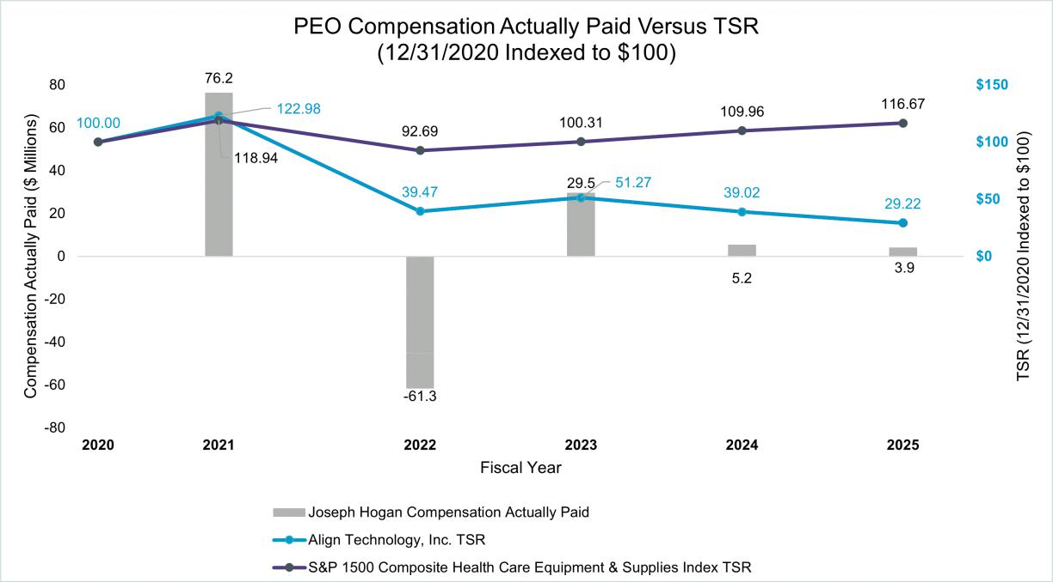

90

The following chart sets forth the relationship between the average of Compensation Actually Paid to our Non-PEO NEOs, Align’s cumulative TSR over the five most recently completed fiscal years, and the Index’s TSR over the same period.
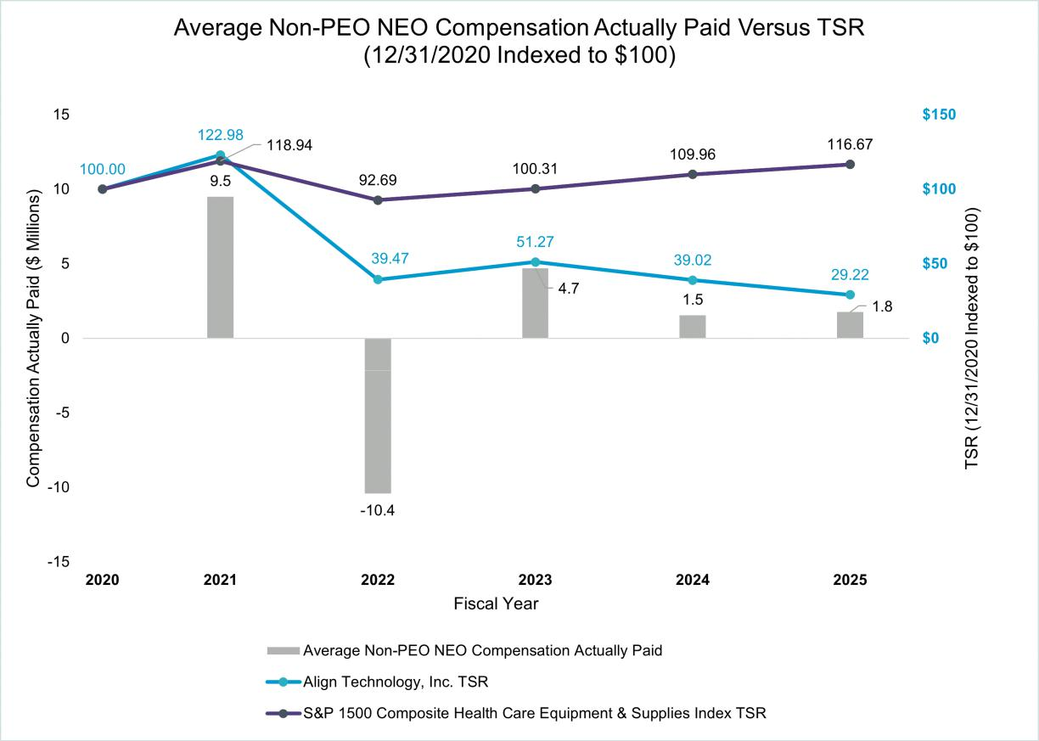

Relationship Between Compensation Actually Paid and Net Income

The following chart sets forth the relationship between Compensation Actually Paid to our PEO and our net income during the five most recently completed fiscal years.

91

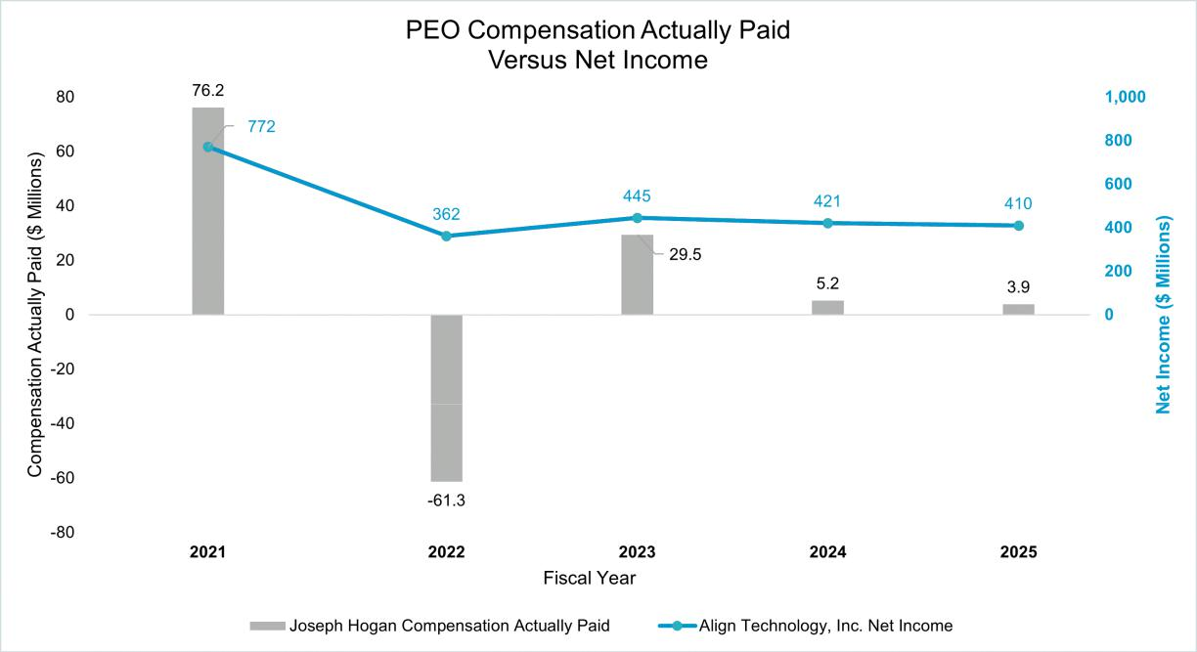

The following chart sets forth the relationship between the average of Compensation Actually Paid to our Non-PEO NEOs and our net income during the five most recently completed fiscal years.
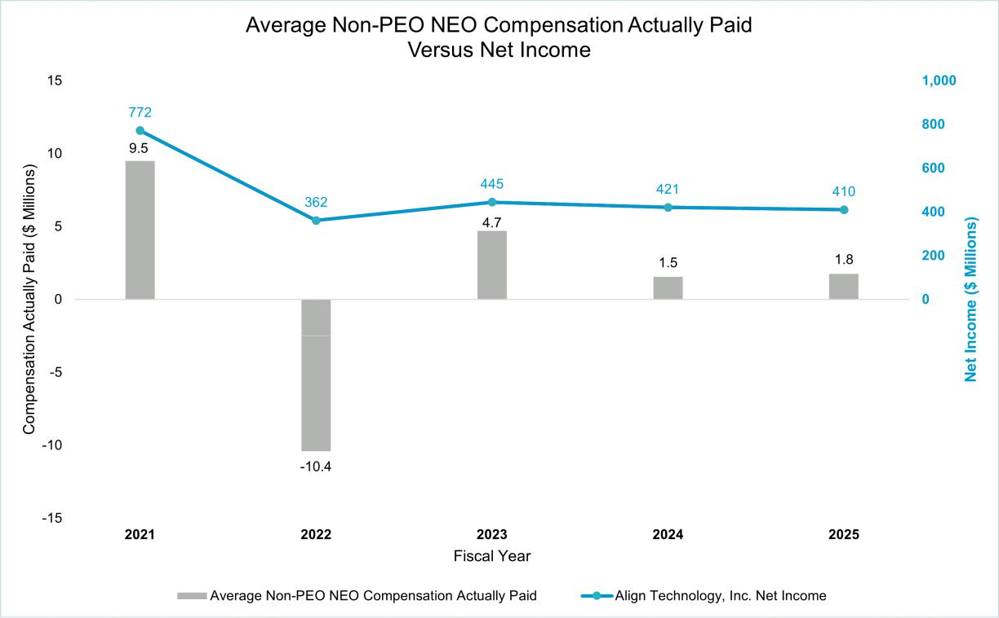

92

Relationship Between Compensation Actually Paid and Net Revenues

The following chart sets forth the relationship between Compensation Actually Paid to our PEO and our Net Revenues during the five most recently completed fiscal years.
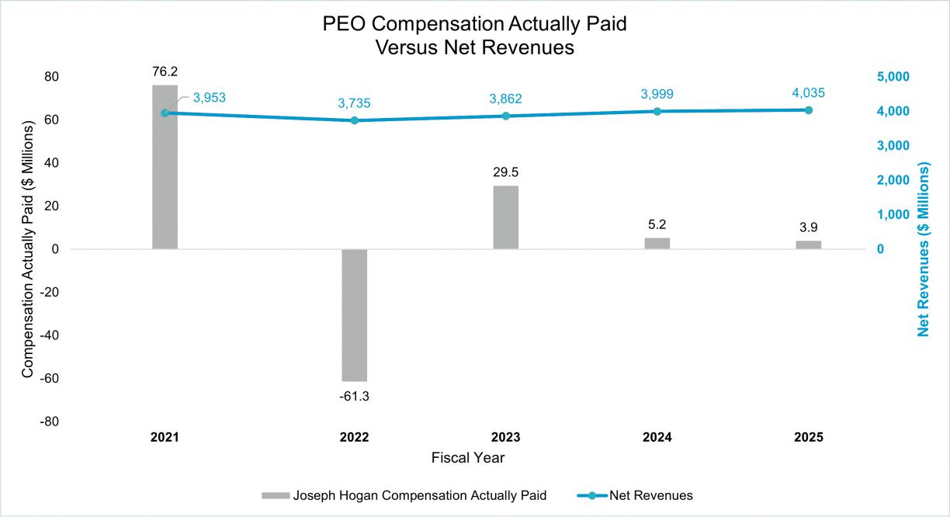

93

The following chart sets forth the relationship between Compensation Actually Paid to our Non-PEO NEOs and our Net Revenues during the five most recently completed fiscal years.
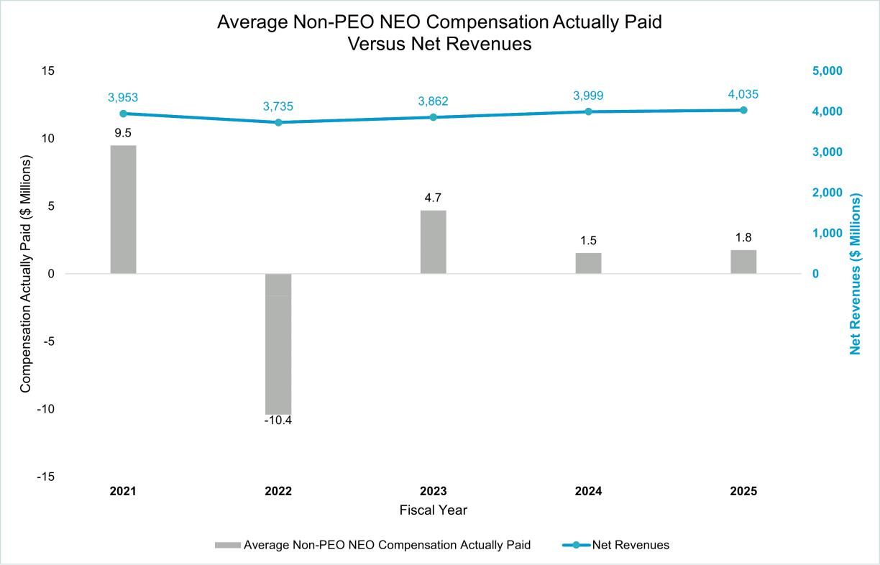

Tabular List of Most Important Financial Performance Measures

The following table presents the financial performance measures that we consider to have been the most important in linking Compensation Actually Paid to our NEOs for 2025 to Align’s performance. The measures in this table are not ranked.


Operating Income

Net Revenues

Stock Price

94

Audit Committee

Our Auditor

Report of the Audit Committee of the Board


95

Our Auditor

Our Audit Committee has selected PricewaterhouseCoopers LLP (“PwC”), independent registered public accounting firm, to audit our financial statements for the year ending December 31, 2026.

Fees to PwC for 2025 and 2024

The following table presents fees for professional services rendered by PwC for the audit of our annual financial statements for 2025 and 2024 and fees billed for audit-related services and tax services rendered by PwC for 2025 and 2024:

 | 2025 | 2024
Audit fees ⁽¹⁾ | 6,152,575 | 5,726,176
Audit-related fees ⁽²⁾ | — | —
Tax fees ⁽³⁾ | 1,913,378 | 1,929,326
All other fees ⁽⁴⁾ | 2,450 | 4,400
Total fees | 8,068,403 | 7,659,902

- Audit fees consist of fees for professional services performed for the annual audit of our financial statements and review of financial statements included in our quarterly filings, and services that are normally provided in connection with statutory and regulatory filings or engagements, and attest services, except those not required by statute or regulation. This category also includes advice on accounting matters that arose during, or as a result of, the audit or the review of interim financial statements.

- Audit-related fees consist of fees related to assurance and related services.
- Tax fees consist of fees for professional services performed with respect to tax compliance, tax advice and tax planning.

- All other fees consist of all other fees billed to us for professional services performed and not reported under “Audit fees,” “Audit-related fees” and “Tax fees.”

Audit Committee’s Policy of Pre-Approval of Audit and Permissible Non-Audit Services

Our Audit Committee’s policy is to pre-approve all audit and permissible non-audit services provided by our independent registered public accounting firm subject to limited discretionary authority granted to our Chief Financial Officer. These services may include audit services, audit-related services, tax services and other services. Pre-approval is detailed as to the particular service or category of services and is generally subject to a specific budget. Our independent registered public accounting firm and management are required to periodically report to our Audit Committee regarding the extent of services provided by the independent registered public accounting firm in accordance with this pre-approval and the fees for the services performed to date. All services provided by PwC in 2025 and 2024 were pre-approved by our Audit Committee.

96

Report of the Audit Committee

The following is the report of the Audit Committee with respect to Align’s audited financial statements for the year ended December 31, 2025, which include our consolidated balance sheets as of December 31, 2025 and 2024, and the related consolidated statements of operations, comprehensive income, stockholders’ equity and cash flows for each of the years ended December 31, 2025, 2024 and 2023 and the notes thereto.

The Audit Committee is comprised entirely of independent directors who meet all applicable Nasdaq and SEC independence requirements. In accordance with the written charter adopted by the Board of Directors of Align, the purpose of the Audit Committee is to assist the Board of Directors in its oversight and monitoring of among other things:

- the integrity of Align’s financial statements;

- Align’s compliance with legal and regulatory requirements;

- the independent registered public accounting firm's qualifications, independence and performance;

- Align's internal control over financial reporting and disclosure controls and procedures; and

- Align’s internal audit department.

The full text of the Audit Committee’s charter is available on the “Investors” section of Align’s website (https://investor.aligntech.com/corporate-gov/documents). The Audit Committee regularly reviews its charter to ensure that it is meeting all relevant audit committee policy requirements of the SEC and Nasdaq listing standards.

In carrying out its responsibilities, the Audit Committee, among other things, is responsible for:

- providing guidance with respect to Align’s relationship with the independent auditors, including having responsibility for their appointment, compensation, retention, evaluation and oversight;

- providing guidance with respect to the selection of the audit firm’s lead engagement partner;

- reviewing the results and audit scope;

- approving audit and non-audit services;

- reviewing and discussing with management the quarterly and annual financial reports;

- overseeing and reviewing Align’s cybersecurity, data privacy and other information technology risks; and

- overseeing management’s implementation and maintenance of effective systems of internal control over financial reporting and disclosure controls and procedures.

The Audit Committee recognizes the importance of maintaining the independence of Align’s independent registered public accounting firm. Each year, the Audit Committee evaluates the qualifications, performance and independence of Align’s independent registered public accounting firm and determines whether to re-engage the current independent firm. This included a review of the qualifications of the engagement team, the quality control procedures the firm has established, as well as its reputation for integrity and competence in the fields of accounting and auditing. Based on this evaluation, the Audit Committee has retained PwC as Align’s independent registered public accounting firm for the fiscal year ending December 31, 2026.

The Audit Committee has reviewed and discussed the audited financial statements for the year ended December 31, 2025 with Align’s management and PwC. The Audit Committee has also discussed with PwC the matters required to be discussed by Auditing Standard No. 1301, “Communications with Audit Committees” issued by the Public Company Accounting Oversight Board (“PCAOB”) and per the requirements of the SEC.

The Audit Committee also has received and reviewed the written disclosures and the letter from PwC required by applicable requirements of the PCAOB regarding PwC’s communications with the Audit Committee concerning independence and has discussed with PwC its independence. The Audit Committee has concluded that the provision by PwC of non-audit related services is compatible with maintaining the independence of PwC as Align’s independent registered public accounting firm.

Based upon the Audit Committee’s discussion with management and the independent registered public accounting firm and the Audit Committee's review of the representations of management and the report of the independent registered public accounting firm to the Audit Committee, the Audit Committee recommended that the Board of Directors include Align’s audited consolidated financial statements in Align’s Annual Report on Form 10-K for the year ended December 31, 2025 for filing with the SEC.

97

98

Audit Committee Members

Anne M. Myong (Chair)

Kevin J. Dallas

Mojdeh Poul

Andrea L. Saia

Britt Vitalone

99

Security Ownership and Related Party Transactions

Security Ownership of Certain Beneficial Owners and Management Certain Relationships and Related Party Transactions


100

Security Ownership of Certain Beneficial Owners and Management

Except as otherwise noted in the footnotes, the information contained in the table below sets forth the beneficial ownership of our common stock as of March 23, 2026 by:

- each stockholder known by us to own beneficially more than 5% of our common stock;

- each of our NEOs listed in the table entitled “Summary Compensation Table for Fiscal Year 2025” in the section of this proxy statement entitled “Compensation Tables”;

- each of our directors; and

- all of our current directors and executive officers as a group 14 persons).

Beneficial ownership is determined based on the rules of the SEC. The column captioned “Total Shares Beneficially Owned” represents the number of shares of our common stock beneficially owned and the number of shares of our common stock subject to RSUs and MSUs that will vest on or before May 22, 2026. The number of shares subject to RSUs and MSUs that will vest on or before May 22, 2026 is listed separately under the column “Number of Shares Underlying RSUs/MSUs vesting on or before May 22, 2026.” The beneficial owners listed do not hold options in our common stock. The shares noted below are not deemed exercisable or vested for purposes of computing the percentage of shares beneficially owned by any other person. “Percentage of Outstanding Shares Beneficially Owned” is based upon 71,617,275 shares of our common stock outstanding as of March 23, 2026. The address for those individuals for which an address is not otherwise provided is c/o Align Technology, Inc., 410 N. Scottsdale Rd., Suite 1300, Tempe, AZ 85288. Unless otherwise indicated, we believe the stockholders listed below have sole voting or investment power with respect to all shares, subject to applicable community property laws.

 |  | Number of
 | Number of | Shares |  | Percentage of
 | Number of | Underlying |  | Percentage of
 | Outstanding | RSUs/MSUs | Total Shares | Outstanding
 | Shares | vesting on or | Total Shares | Shares
Name and Address | Beneficially | before May 22, | Beneficially | Beneficially
Name and Address | Owned | 2026⁽¹⁾ | Owned | Owned
The Vanguard Group⁽²⁾ | 8,349,611 | — | 8,349,611 | 11.7 %
Capital International Investors⁽³⁾ | 4,881,512 | — | 4,881,512 | 6.8 %
BlackRock, Inc.⁽⁴⁾ | 4,113,442 | — | 4,113,442 | 5.7 %
Joseph M. Hogan⁽⁵⁾ | 266,037 | — | 266,037 | *
John F. Morici | 13,536 | — | 13,536 | *
Julie Coletti | 11,445 | — | 11,445 | *
Stuart Hockridge | 14,892 | — | 14,892 | *
Kevin T. Conroy | 1,808 | 1,745 | 3,553 | *
Kevin J. Dallas | 14,423 | 1,745 | 16,168 | *
Joseph Lacob⁽⁶⁾ | 134,171 | 1,745 | 135,916 | *
C. Raymond Larkin, Jr. | 25,128 | 2,326 | 27,454 | *
George J. Morrow⁽⁷⁾ | 6,564 | 1,745 | 8,309 | *
Anne M. Myong | 8,085 | 1,745 | 9,830 | *
Mojdeh Poul | 1,808 | 1,745 | 3,553 | *
Andrea L. Saia | 15,573 | 1,745 | 17,318 | *
Susan E. Siegel | 8,978 | 1,745 | 10,723 | *
Britt Vitalone⁽⁸⁾ | — | 1,443 | 1,443
All current executive officers and directors as a group (14 | 522,448 | 17,729 | 540,177 | *
persons)

- Less than 1%

- Except as otherwise set forth in the footnotes below, represents shares of common stock that can be acquired upon the vesting and release of restricted stock units on or before May 22, 2026. There are no stock options outstanding that can be exercised to acquire shares of our common stock. This column includes the full amount of RSUs/MSUs that will vest and be released on or before May 22, 2026.

- Based on a filing with the SEC on Schedule 13G/A on February 13, 2024 indicating beneficial ownership as of December 29, 2023. Includes shares held by direct and indirect subsidiaries. The mailing address for The Vanguard Group is 100 Vanguard Boulevard, Malvern, Pennsylvania 19355. The Vanguard Group subsequently reported on a Schedule 13G/A filed on March 26, 2026 that due to an internal

101

realignment it no longer has, or is deemed to have, beneficial ownership over Align Technology, Inc. securities beneficially owned by various subsidiaries and/or business divisions. The Vanguard Group also reported that certain subsidiaries or business divisions that formerly had, or were deemed to have, beneficial ownership with The Vanguard Group will report beneficial ownership separately (on a disaggregated basis).
- Based on a filing with the SEC on Schedule 13G on February 13, 2026 indicating beneficial ownership as of December 31, 2025. Includes shares held by direct and indirect subsidiaries. The mailing address for Capital International Investors is 333 South Hope Street, 55th Fl, Los Angeles, CA 90071.
- Based on a filing with the SEC on Schedule 13G/A on January 21, 2026 indicating beneficial ownership as of December 31, 2025. Includes shares held by direct and indirect subsidiaries. The mailing address for BlackRock, Inc. is 50 Hudson Yards, New York, New York 10001.
- Includes 55,267 shares held by the Hogan 2025 GRAT, for which the Reporting Person serves as trustee, and 1,500 shares held directly by the spouse of the Reporting Person.

- Shares are held directly by a trust for the Reporting Person.
- Includes 3,291 shares held directly by the Reporting Person and 3,273 shares held directly by a family trust for the Reporting Person.
- Mr. Vitalone joined our Board on July 2, 2025 and was granted an initial award of 1,443 RSUs.

Certain Relationships and Related Party Transactions

Review, Approval or Ratification of Related Party Transactions

Our Global Code of Conduct is applicable to all directors, officers and employees of Align, including our principal executive officer, principal financial officer and controller. Under the Code and pursuant to our other policies and procedures, we encourage our directors, officers and employees to avoid actual or potential conflicts of interest, including by discouraging conducting company business with a relative or significant other, or with a business in which a director employee, a relative or significant other is associated in any significant role or has a financial interest (each a “Related Party”). If, however, such a Related Party transaction is unavoidable, all employees (other than our directors and executive officers) who are entering into a Related Party transaction must fully disclose the nature of the relationship and the transaction to their supervisor, and the Chief Legal and Regulatory Officer must approve in advance the Related Party transaction. If, however:

- the person is a director or member of executive management and they desire to enter into a transaction with a Related Party (as defined above); or
- the person is an employee (other than a director or member of executive management) and they desire to enter into a transaction with a Related Party that the Chief Legal and Regulatory Officer has deemed to be material to Align and is reportable under the rules and regulations of the Exchange Act,

the nature of the transaction must be fully disclosed to, and approved by, our Audit Committee.

Related Party Transaction Disclosure

In April 2018, we entered into a membership agreement with an affiliate of the Golden State Warriors, pursuant to which we purchase tickets to Golden State Warriors home games on an annual basis. Joseph Lacob, a member of our Board, is the Governor, Co-Executive Chairman and CEO of Golden State Warriors, LLC. The cost associated with the agreement is in excess of $120,000 per year but is not an amount material to us. This related party transaction was not approved in advance of entering into the contract which was inconsistent with the related party pre-approval requirements of the charter of the Audit Committee of our Board. The Audit Committee ratified this related party transaction in March 2025.

In February 2021, as amended in June 2023, August 2024 and March 2025, we entered into a sponsorship agreement with the Golden State Warriors, LLC, pursuant to which the Invisalign brand is the Official Smile Partner of the Golden State Warriors of the National Basketball Association and the Santa Cruz Warriors of the NBA G League. The sponsorship includes an omni-channel activation across television, digital media, social media and in-arena rights to display advertising. Additionally, we sponsored two NCAA Women’s basketball games in 2024 that took place in the Chase Center, the arena for the Golden State Warriors. Joseph Lacob, a member of our Board, is the Governor, Co-Executive Chairman and CEO of Golden State Warriors, LLC. The cost associated with the agreement is in excess of $120,000 per year but is not an amount material to us.

The son-in-law of John Morici, our Chief Financial Officer and Executive Vice President, Global Finance, is employed by us as a Territory Manager in our North America Sales organization. In 2025, the aggregate value of the

102

compensation paid to Mr. Morici’s son-in-law was in excess of $120,000, consisting of salary, commission and RSUs. In addition, Mr. Morici’s son-in-law received standard benefits provided to other non-executive employees.

103

Proposals

Company Proposals

Proposal 1 Election of Directors

Proposal 2 Advisory Vote to Approve the Compensation of our Named Executive Officers Proposal 3 Ratification of Appointment of Independent Registered Public Accounting Firm Proposal 4 Ratification of Special Meeting Provision in our Bylaws


104

COMPANY PROPOSAL 1

Election of Directors

Our Amended and Restated Bylaws (our “Bylaws”) provide that our Board will consist of one or more members with the number of directors determined from time to time by resolution of our Board. As of the date of this proxy statement, the number of directors is set at eleven (11).

George Morrow, who currently serves as a member of our Compensation and Human Capital Committee and our Nominating and Governance Committee, will not stand for re-election at the Annual Meeting. His term as a member of our Board and the committees on which he currently serves will end at the commencement of the Annual Meeting. As a result, our Board has resolved that the size of our Board will be reduced from eleven (11) to ten (10) directors at the conclusion of Mr. Morrow’s term of office.

Upon the recommendation of the Nominating and Governance Committee, our Board has nominated the ten (10) director nominees named below for election at the Annual Meeting, each to serve for a one-year term or until a successor is elected and qualified or appointed (the “Nominees”).

Our Board unanimously recommends that you vote “FOR” each of the Nominees named below

C. Raymond Larkin, Jr. | Kevin T. Conroy
Kevin J. Dallas | Joseph M. Hogan
Joseph Lacob | Anne M. Myong
Mojdeh Poul | Andrea L. Saia
Susan E. Siegel | Britt Vitalone

Information concerning each of the Nominees can be found above in the section entitled “Director Nominees.”

In the event a Nominee is unable or declines to serve as a director at the time of the Annual Meeting, the proxies will be voted for any director nominee who shall be designated by the then current Board to fill the vacancy. As of the date of this proxy statement, we are not aware of any Nominee who is unable or will decline to serve as a director.

Each Nominee is currently serving on our Board. If a Nominee is not re-elected at the Annual Meeting, Delaware law provides that the director will continue to serve as a “holdover director.” Under our Bylaws and Guidelines, each director has submitted a contingent, irrevocable resignation that our Board may accept if the director is not re-elected. If that were to occur, our Nominating and Governance Committee would make a recommendation to our Board whether to accept or reject the resignation, or whether to take other action. Our Board would act on the Nominating and Governance Committee's recommendation, and publicly disclose its decision and the rationale behind it within 90 days following the date the election results are certified.

Vote Required

You may vote “FOR”, “AGAINST” or “ABSTAIN” from voting on this matter.

Our Bylaws state that a director nominee is elected by the vote of the majority of the votes cast at any meeting for the election of directors at which a quorum is present. A “majority of the votes cast” means that the number of shares voted “FOR” a director’s election exceeds 50% of the number of votes cast with respect to that director’s election. In determining the total number of votes cast, votes “FOR” and “AGAINST” will be counted. Abstention votes, which are votes marked “ABSTAIN,” will not be counted toward the total number of votes cast. The holders of a majority of the voting power of the capital stock issued and outstanding and entitled to vote as of the record date, present in person or represented by proxy, shall constitute a quorum.

Unless marked otherwise, properly executed proxies returned to us will be voted “FOR” each of the Nominees named above. If you hold your shares through a broker, bank or other nominee holder of record you must instruct your broker, bank or other nominee how to vote your shares so that your vote can be counted for this Proposal 1. If you do not provide voting instructions to your broker, bank or other nominee, your shares will be considered “broker

105

non-votes” with regard to this matter. Broker non-votes are counted for the purposes of determining a quorum but will be excluded from determining the number of votes cast and therefore will have no effect on the vote for this Proposal 1.
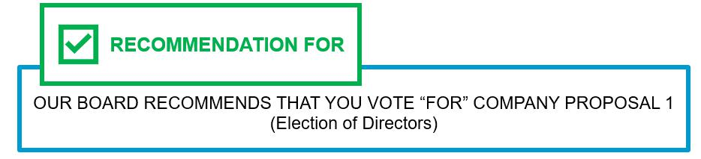

106

COMPANY PROPOSAL 2

Advisory Vote to Approve the Compensation of our Named Executive Officers

We are requesting that our stockholders approve, on an advisory basis, the compensation of our NEOs as described in this proxy statement, including the section entitled “Compensation Discussion and Analysis,” the compensation tables and the related narrative disclosure in this proxy statement.

Our Board believes that an annual advisory vote to approve the compensation of our NEOs allows our stockholders to provide us with their direct input on our compensation philosophy, policies and practices described in our proxy statement every year and is consistent with our policy of seeking input from, and engaging in discussions with, our stockholders on these matters. This vote is not intended to address any specific item of compensation, but rather the overall compensation of our NEOs and the related compensation philosophy, policies, and practices described in this proxy statement.

Our compensation program is designed to motivate and reward exceptional performance in a straight-forward and effective way, while also recognizing the success of our business. Our 2025 financial results improved relative to 2024 and in general we achieved our internal financial objectives for the year. The actual compensation paid to our executives in 2025 reflects that financial performance, although total shareholder return did not meet our long-term expectations. Overall, we believe our compensation program operated as designed and is aligned with the long-term interests of our stockholders. We encourage stockholders to read the section in this proxy statement entitled “Compensation Discussion and Analysis,” which describes the details of our executive compensation program and the decisions made by the Compensation and Human Capital Committee in 2025.

Stockholders are being asked to approve the following resolution at the Annual Meeting:

“RESOLVED, that the compensation paid to our named executive officers, as disclosed pursuant to Item 402 of Regulation S-K, including the Compensation Discussion and Analysis, compensation tables, and narrative discussion, is hereby APPROVED.”

As an advisory vote, this proposal is not binding on us, our Board, or our Compensation and Human Capital Committee. However, the Committee and Board value the opinions expressed by stockholders in their votes on this proposal and will consider the outcome of the vote when making future compensation decisions regarding our named executive officers. We expect the next say-on-pay vote will occur at our annual meeting of stockholders in 2029.

Vote Required

Approval of this Proposal 2 requires that the holders of a majority of the voting power of the shares present in person or represented by proxy and entitled to vote at the Annual Meeting vote “FOR” this Proposal 2. You may vote “FOR”, “AGAINST” or “ABSTAIN” from voting on this matter. An “ABSTAIN” vote will have the same effect as an “AGAINST” vote for this Proposal 2.

Unless marked otherwise, properly executed proxies returned to us will be voted “FOR” this Proposal 2. If you hold your shares through a broker, bank or other nominee holder of record you must instruct your broker, banker or other nominee how to vote your shares so that your vote can count for this Proposal 2. If you do not provide voting instructions to your broker, bank or other nominee holder of record, your shares will be considered “broker non-votes” with regard to this matter. Broker non-votes will have no effect on the vote for this Proposal 2.
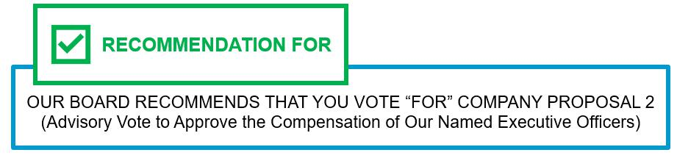

107

COMPANY PROPOSAL 3

Ratification of Appointment of Independent Registered Public Accounting Firm

The Audit Committee of our Board (our “Audit Committee”) has selected PricewaterhouseCoopers LLP (“PwC”), independent registered public accounting firm, to audit our financial statements for the year ending December 31, 2026. In making its recommendation to appoint PwC, our Audit Committee considered whether the provision of the non-audit services rendered by PwC is compatible with maintaining the firm’s independence.

Representatives of PwC are expected to be present at the Annual Meeting with the opportunity to make a statement if they desire to do so and are expected to be available to respond to appropriate questions.

Although stockholder ratification of the selection of PwC as our independent registered public accounting firm is not required by our Bylaws or any other applicable law, our Audit Committee is submitting the appointment of PwC to our stockholders for ratification as a matter of good corporate practice. If our stockholders fail to ratify the appointment of PwC, our Audit Committee and Board will reconsider whether or not to retain PwC. Even if the selection is ratified, our Audit Committee, in its discretion, may direct the appointment of a different firm to act as our independent registered public accounting firm at any time during the year if it determines that such a change would be in the best interests of Align and our stockholders.

Vote Required

Approval of this Proposal 3 requires that the holders of a majority of the voting power of the shares present in person or represented by proxy and entitled to vote at the Annual Meeting vote “FOR” this Proposal 3.

You may vote “FOR”, “AGAINST” or “ABSTAIN” from voting on this matter. An “ABSTAIN” vote will have the same effect as an “AGAINST” vote FOR this Proposal 3.

Unless marked otherwise, properly executed proxies returned to us will be voted “FOR” this Proposal 3. Discretionary votes by brokers, banks or other nominees on this routine proposal will be counted toward the quorum requirement and will affect the outcome of the vote. Broker non-votes, if any, will have no effect on the vote for this Proposal 3.
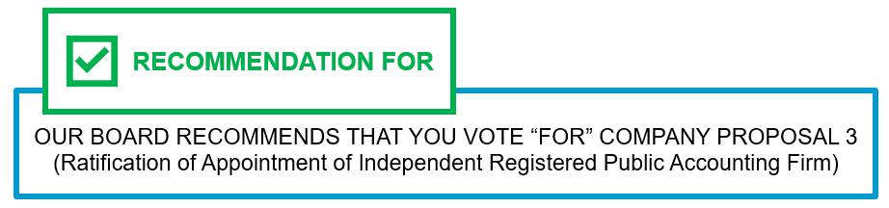

108

COMPANY PROPOSAL 4

Ratification of Special Meeting Provision in our Bylaws

Background

At our 2025 annual meeting of stockholders, our stockholders voted on a non-binding advisory proposal submitted by our Board to gather stockholder perspectives on allowing stockholders holding 25% of our outstanding common stock the right to call a special meeting of stockholders (the “Prior Align Proposal”). The Prior Align Proposal received the support of 65% of the votes cast on the proposal (representing 53% of our outstanding common stock). At that meeting, our stockholders also voted on a non-binding proposal submitted by a stockholder, Mr. John Chevedden, requesting that our Board allow stockholders holding 10% of our outstanding common stock the right to call a special meeting (the “Prior Stockholder Proposal”). The Prior Stockholder Proposal received the support of 45% of the votes cast on the proposal (representing 36% of our outstanding common stock).

Following the 2025 annual meeting of stockholders, our Nominating and Governance Committee, which oversees and advises our Board with respect to corporate governance matters, policies and practices, coordinated with management to review the support received on the Prior Align Proposal and Prior Stockholder Proposal, and analyze industry practices. Thereafter, we engaged with stockholders seeking further clarification regarding their assessment of the votes as well as a variety of other issues raised either by them or us. From November 2025 to

February 2026, we met with holders of over 28% of our common stock to specifically engage on the right of stockholder to call a special meeting after affirmatively reaching out to nearly 65% of our stockholders.

On February 24, 2026, upon the recommendation of our Nominating and Governance Committee, our Board amended and restated Section 2.3 of our Bylaws to provide that the Board shall call a special meeting of stockholders if properly requested by one or more stockholders of record (or beneficial owners, if any) that have continuously held not less than 25% of our outstanding shares of voting stock entitled to vote on each of the matters proposed to be considered at the special meeting (the “Requisite Percentage”) for at least one year prior the date of mailing of the request (the “One-Year Period”), and have otherwise complied with each requirement in Section 2.3 of our Bylaws (the “Special Meeting Provision”).

Overview of the Proposal

We are providing our stockholders with the opportunity to ratify, on a non-binding basis, the retention of the Special Meeting Provision in Section 2.3 of our Bylaws.

In addition to the Requisite Percentage and the One-Year Period, to be in proper form to call a special meeting of stockholders, the stockholder request must be delivered via registered mail to our Corporate Secretary at our principal executive offices, and the requesting

stockholder(s) must continue to own the Requisite Percentage through the adjournment of the special meeting. Additionally, the request must include certain information, including a statement of the specific purpose(s) of the special meeting and the matter(s) proposed to be acted on

at the special meeting, an acknowledgement that any disposition of shares prior to the special meeting will be deemed a revocation with respect to the disposed shares and for purposes of satisfying the Requisite Percentage, and certain information and representations required under the advance notice provisions contained in Section 2.4 of our Bylaws applicable to stockholder business or director nominations at our annual meetings. The Special Meeting Provision also includes certain requirements intended to prevent duplicative and unnecessary meetings.

We believe that the Special Meeting Provision is consistent with market practice, given that approximately 37% of S&P 500 companies set the ownership threshold at or above 25%, compared to approximately 24% that set the threshold between 10% and 25%, 16% that set the threshold at 10% or lower, and 23% that do not allow stockholders to call a special meeting. Providing a special meeting request right at a lower threshold risks giving a small number of stockholders a disproportionate amount of influence over our affairs and the ability to act unilaterally, or threaten to do so, to apply short-term pressure on Align to advance their own narrow interests at the expense of Align and other stockholders. Since 2018, we have repurchased an aggregate of approximately 12.1 million shares of our common stock pursuant to

authorized stock repurchase programs. As a result of these repurchases, the number of shares of common stock issued and outstanding has decreased by approximately 10.5%, from 80,026,978 shares as of December 31, 2017 to 71,617,275 shares as of March 23, 2026, thereby

reducing the number of shares required by the Requisite Percentage by approximately 2.1 million shares.

We believe that the 25% threshold contained in the Special Meeting Provision is reasonable and strikes the appropriate balance between enhancing our stockholders’ ability to act on important and urgent matters and protecting against misuse by a limited number of stockholders whose interests are not widely shared by the

109

stockholder base as a whole. To ensure material matters of interest to our stockholders are brought to the attention of our Board, we have a significant stockholder outreach program in which we regularly meet with stockholders to discuss matters of importance to them and we have

a history of responding to their input with meaningful governance changes. For instance, in 2023, 2024 and 2025, we met with stockholders representing approximately 22%, 39% and 30%, respectively, of our shares outstanding.

This and earlier outreach has resulted in our adopting numerous stockholder rights provisions including: adopting proxy access Bylaws (2023), eliminating supermajority voting requirements (2025) and most recently, empowering 25% of our stockholders to call a special meeting.

Accordingly, we believe that special meetings should only be called to discuss critical, time-sensitive issues that cannot wait until our next annual meeting of stockholders in cases where stockholders that have held a meaningful minority of Align’s outstanding shares of common stock for a meaningful amount of time agree that the unusual step of convening a meeting in advance of the regularly scheduled annual meeting process is warranted. A failure to receive the support of 25% of stockholders to convene a special meeting is a strong indicator that the issue is unduly narrow and not deemed critical by our stockholders generally.

The full text of the Special Meeting Provision, which consists of the amendments to Section 2.3 of our Bylaws adopted on February 24, 2026, is included in Appendix A. The above summary of the Special Meeting Provision is qualified in its entirety by reference to Appendix A.

Vote Required

This Proposal 4 is not binding upon Align or our Board. Stockholder ratification of the Special Meeting Provision is not required by our

Bylaws or other applicable legal requirements. The outcome of this advisory vote will not overrule any decision by our Board (or any committee thereof), nor will it create or imply any obligation to submit for future stockholder ratification any subsequent change or addition to

our Bylaws. Notwithstanding the advisory nature of this proposal, our Board values the priorities and perspectives of our stockholders and will consider the outcome of the vote along with any further stockholder feedback we receive after the vote when making future decisions regarding corporate governance matters.

Approval of this Proposal 4 requires the affirmative vote of a majority of the voting power of the shares present in person or represented by proxy at the meeting and entitled to vote on this Proposal 4.

You may vote “FOR,” “AGAINST” or “ABSTAIN” from voting on this matter. An “ABSTAIN” vote will have the same effect as an “AGAINST” vote for this Proposal 4.

Unless marked otherwise, properly executed proxies returned to us will be voted “FOR” Proposal 4. If you hold your shares through a broker, bank or other nominee holder of record you must instruct your broker, banker or other nominee how to vote your shares so that your vote can count for this Proposal 4. If you do not provide voting instructions to your broker, bank or other nominee holder of record, your shares will be considered “broker non-votes” with regard to this matter. Broker non-votes will have no effect on the vote for this Proposal 4.
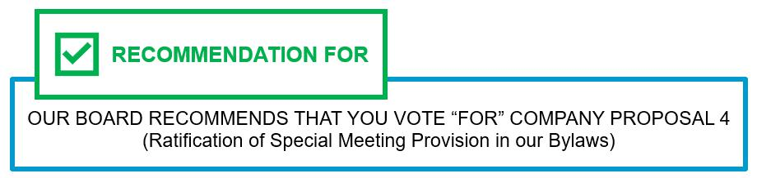

110

ALIGN TECHNOLOGY, INC.

410 N. Scottsdale Rd., Suite 1300

Tempe, AZ 85288

_______________________________

Proxy Statement for the

2026 Annual Meeting of Stockholders

__________________________________

GENERAL INFORMATION


Why am I receiving these materials?


We have made these materials available to you via the Internet or delivered paper copies to you by mail in connection with the solicitation by our Board of proxies to be voted at our 2026 Annual Meeting of Stockholders (“Annual Meeting”), which will take place online at 10:00 a.m., Mountain Standard Time, on Wednesday, May 20, 2026. As a stockholder, you are invited to participate in the Annual Meeting via live webcast and vote on the items of business described in this proxy statement.

What is included in these materials?

The proxy materials include:

- this proxy statement; and

- our Annual Report on Form 10-K for the fiscal year ended December 31, 2025 (“Annual Report”).

If you received a paper copy of these materials by mail, the proxy materials also include a proxy card for the Annual Meeting. If you received a Notice of Internet Availability of Proxy Materials instead of a paper copy of the proxy materials, see “How do I vote my shares during the Annual Meeting?” below.

What information is contained in these materials?

The information in this proxy statement contains important information regarding our Annual Meeting. Specifically, it:

- identifies the proposals on which you are being asked to vote;

- provides information regarding voting procedures at our Annual Meeting;

- discusses our corporate governance policies and practices;

- describes the compensation paid to our directors and certain executive officers; and

- discloses other information that we are required to provide to you under applicable laws and regulations.

111

Why did I receive a notice in the mail regarding the Internet availability of the proxy materials instead of a paper copy of the full set of proxy materials?

In accordance with rules adopted by the SEC, we are making our proxy materials available over the Internet. Stockholders will not receive printed copies of the proxy materials unless they request them. Instead, the Notice of Internet Availability of Proxy Materials (“Notice”) mailed to most of our stockholders describes how you may access and review the proxy materials on the Internet. The Notice also provides instructions as to how you may submit your proxy via the Internet. If you received the Notice by mail and would prefer to receive a printed copy of our proxy materials, you should follow the instructions for requesting such materials in the Notice.

How can I access the proxy materials over the Internet?

Our proxy materials are available at https://web.viewproxy.com/aligntech/2026 and will be available during the voting period at www.proxyvote.com.

Can I vote my shares by filling out and returning the Notice of Internet Availability of Proxy Materials?

No. The Notice only identifies the items to be voted on at the Annual Meeting. You cannot vote by marking the Notice and returning it. The Notice provides instructions as to how to cast your vote.

What is the difference between holding shares directly or as a beneficial owner, in street name?

Most of our stockholders hold their shares as beneficial owners through a brokerage firm, bank or other nominee. As summarized below, there are some differences between shares held directly (of record) and those owned beneficially.

Stockholder of Record: If on March 23, 2026 (the “Record Date”) your shares were registered directly in your name with our transfer agent, Computershare Limited, then you are considered the “stockholder of record.” As a stockholder of record, you may vote in person at the Annual Meeting or vote by proxy.

Beneficial Owner: If on the Record Date your shares were held on your behalf in an account with a brokerage firm, bank or other nominee, the brokerage firm, bank or other nominee is considered the stockholder of record of your shares and you are considered the beneficial owner of those shares held in “street name.” If you are a beneficial owner, these proxy materials are being forwarded to you by the organization considered the stockholder of record of your shares. As a beneficial owner, you may direct your nominee as to how to vote your shares. Your nominee should have enclosed or provided voting instructions for you to use directing it as to how to vote your shares. Please note that as a beneficial owner, you may not vote your shares at the Annual Meeting unless you request and obtain a valid proxy from the organization that is your nominee holding your shares, giving you the right to vote the shares at the Annual Meeting.

112

VIRTUAL ANNUAL MEETING INFORMATION

How can I participate in the Annual Meeting?

Our Annual Meeting will be an entirely virtual meeting conducted via live webcast. The Annual Meeting webcast will begin promptly at 10:00 a.m., Mountain Standard Time, on Wednesday, May 20, 2026. Online access will begin at 9:30 a.m., Mountain Standard Time, and we encourage you to access the Annual Meeting early.

To be admitted to the Annual Meeting, stockholders as of the Record Date must register in advance at https://web.viewproxy.com/aligntech/2026.

- Registered Stockholders: Stockholders who hold shares in their own name or have received a Notice or proxy card must click “Registration for Registered Holders” and enter their name, phone number, Virtual Control Number (found on your Notice or proxy card) and email address.

- “Street name” or Beneficial Stockholders: Stockholders who hold shares through a brokerage firm, bank or other nominee must click “Registration for Beneficial Holders” and enter their name, phone number and email, and click submit. Thereafter, please email a copy of your legal proxy or proof of ownership that you obtain from your bank or broker to Virtualmeeting@viewproxy.com. If you are unable to obtain a legal proxy to vote your shares, you will still be able to attend the Annual Meeting (but will not be able to vote your shares) so long as you demonstrate proof of stock ownership. Instructions on how to connect and participate via the Internet, including how to demonstrate proof of stock ownership, are posted at https://web.viewproxy.com/aligntech/2026.

Why is the Annual Meeting only virtual?

We have chosen to conduct the Annual Meeting in a virtual-only meeting format, via live audio webcast. A virtual meeting provides a convenient and efficient means to administer our Annual Meeting while enabling increased stockholder attendance and participation because stockholders can participate from any location around the world.

What if multiple stockholders share the same address?

To reduce expenses, we are delivering a single copy of the Notice and, if applicable, the proxy materials to certain stockholders who share a single address, unless otherwise requested by one of the stockholders. A separate proxy card is included in the voting materials for each of these stockholders. To receive a separate copy of the Notice and, if applicable, the proxy materials you may contact us by calling (602) 742-2000 or by writing to us at Align Technology, Inc., 410 N. Scottsdale Rd., Suite 1300, Tempe, AZ 85288, Attn: Investor Relations. You may also contact us by calling or writing if you would like to receive separate materials for future annual meetings.

113

How can I submit questions during the Annual Meeting?

During registration and the Annual Meeting, you may submit questions pertaining to the business of the Annual Meeting according to instructions that will be provided during either registration or the Annual Meeting. At the Annual Meeting, each stockholder will be limited to one question. Questions pertinent to the business of the Annual Meeting will be read aloud and answered, subject to time constraints, after the end of the business portion of the Annual Meeting.

What are the rules of procedure for the Annual Meeting?

The rules and procedures for the Annual Meeting will be available at https://web.viewproxy.com/aligntech/2026.

Will the list of stockholders be available during the Annual Meeting?

During the Annual Meeting, the list of our stockholders of record entitled to vote at the Annual Meeting will be available for viewing by stockholders as of the Record Date upon request, for any purpose germane to the Annual Meeting.

What if I have technical difficulties or trouble accessing the Annual Meeting?

We will have technicians ready to assist you with any technical difficulties you experience accessing the Annual Meeting. If you encounter any difficulties, please call:

866-612-8937(toll-free)

973-873-7684 (international)

VOTING INFORMATION

Who can vote at the Annual Meeting?

If you are a stockholder of record or a beneficial owner who owned our common stock at the close of business on the Record Date, you are entitled to vote at the Annual Meeting. As of the Record Date, 71,617,275 shares of our common stock were issued and outstanding and no shares of our preferred stock were issued and outstanding.

114

How do I vote my shares during the Annual Meeting?

By logging into the webcast, Registered Stockholders will be able to vote electronically on all proposals to be considered at the Annual Meeting. Please note, Beneficial Stockholders must submit a copy of their legal proxy or

proof of ownership in advance to https://web.viewproxy.com/aligntech/2026 in order to vote their shares during the Annual Meeting.

Even if you plan to participate in the Annual Meeting online, we recommend that you also vote by proxy as described below so that your vote will be counted if you later decide not to participate.

How can I vote my shares without participating in the Annual Meeting?

Internet. You may vote via the Internet by following the instructions on the Notice. Stockholders who receive printed proxy materials may vote via the Internet by following the instructions on the proxy card. Most of our stockholders who hold shares beneficially in street name may vote by accessing the website specified in the voting instructions provided by their broker, bank or other nominee. A number of banks and brokerage firms are participating in a program provided through Broadridge Investor Communication Solutions that offers the means to vote their shares through the Internet. If your shares are held in an account with a participating broker or bank, you may grant a proxy to vote those shares via the Internet by contacting the website shown on the instruction form received from your broker or bank. To be counted at the Annual Meeting, your vote must be received by 8:59 p.m. Mountain Standard Time, on May 19, 2026.

Telephone. Stockholders of record may vote by following the “Vote by Telephone” instructions on their Notice or on their proxy cards until 8:59 p.m. Mountain Standard Time, on May 19, 2026.

Mail. If you requested printed proxy materials, you can submit your vote by completing, signing and dating the proxy card mailed to you and returning it in the accompanying pre-addressed envelope. Proxy cards must be received prior to the closing of the polls at the Annual Meeting in order for the votes to be recorded.

115

What if I don’t give specific voting instructions?

In the election of directors, you may vote “FOR,” “AGAINST” or “ABSTAIN.” If you elect to “ABSTAIN” in the election of directors, the abstention will not impact the election of directors. In tabulating the voting results for the election of directors, only “FOR” and “AGAINST” votes are counted.

For the other items of business, you may vote “FOR,” “AGAINST” or “ABSTAIN.” For these other items of business, if you elect to abstain, the abstention will have the same effect as an “AGAINST” vote.

If you indicate your choice on your proxy on a particular matter to be acted upon, the shares will be voted as indicated.

If you are a Registered Stockholder and you return a signed proxy card but do not indicate how you wish to vote, the proxy holders will vote your shares in the manner recommended by the Board on all matters presented in this proxy statement and as the proxy holders may determine in their discretion with respect to any other matters properly presented for a vote at the Annual Meeting. If you do not return the proxy card, your shares will not be voted and will not be deemed present for the purpose of determining whether a quorum exists.

If you are a Beneficial Stockholder and the nominee organization holding your shares does not receive instructions from you as to how to vote those shares, under the rules of various national and regional securities exchanges, that organization may exercise discretionary authority to vote on routine proposals (e.g., the ratification of the appointment of PricewaterhouseCoopers LLP as our independent registered public accounting firm) but may not vote on non-routine proposals (each of the other proposals). We encourage you to provide instructions to your broker, banker or other nominee regarding the voting of your shares.

If you hold your shares through a broker, bank or other nominee, you must instruct your broker, banker or other nominee how to vote your shares so that your vote can count for each of the proposals. If you do not provide voting instructions to your broker, bank or other nominee, your shares will be considered “broker non-votes” with regard to that matter. Broker non-votes will be considered as represented for purposes of determining a quorum but will not be considered as entitled to vote with respect to a particular proposal and are not counted for purposes of determining the number of votes cast with respect to a particular proposal. Thus, a broker non-vote will make a quorum more readily obtainable, but the broker non-vote will not otherwise affect the outcome of the vote on Proposal 1 or on the proposals that require the affirmative vote of a majority of the shares entitled to vote and present in person or represented by proxy and will have no effect on Proposals 2, 3, and 4. For information regarding the required vote for each proposal, see “What are we voting on and what vote is required to approve each item?"

116

Can I change or revoke my vote?

You may change your proxy voting instructions at any time before your votes are cast at the Annual Meeting.

If you are a Registered Stockholder, you may either:

- grant a new proxy bearing a later date by following the instructions provided in the Notice or the proxy card, which will automatically revoke the previous proxy;

- provide written notice of the revocation to:

Corporate Secretary

Align Technology, Inc.

410 N. Scottsdale Rd., Suite 1300

Tempe, AZ 85288

prior to the time we take the vote at the Annual Meeting; or

- participate in the Annual Meeting and vote. Your presence at the Annual Meeting will not cause your previously granted proxy to be revoked unless you specifically request that it be revoked.

If you are a Beneficial Stockholder, you may either:

- timely submit new voting instructions to your broker or other nominee; or

- if you have obtained a legal proxy from your broker or other nominee giving you the right to vote your shares during the Annual Meeting, participate in the Annual Meeting and vote online.

117

What are we voting on and what vote is required to approve each item?

The proposals that will be presented at the Annual Meeting, the vote required for passage of each, our Board’s voting recommendations, and the way the vote is calculated for the proposals are as follows:

 |  |  | Board's Voting | Broker
PROPOSALS | Vote Required |  | Board's Voting | Discretionary
PROPOSALS |  |  | Recommendation | Voting Allowed?
COMPANY PROPOSALS
Proposal 1: Election of Directors | For Each Nominee, a Majority of the |  | FOR EACH | NO
 | Votes Cast when a Quorum is Present |  | NOMINEE | NO
Proposal 2: Advisory Vote to | Majority of the Voting Power of the
Approve the Compensation of our | Shares Present in Person or |  | FOR | NO
Named Executive Officers | Represented by Proxy at the Meeting |  | FOR | NO
 | and Entitled to Vote
Proposal 3: Ratification of | Majority of the Voting Power of the
Appointment of Independent | Shares Present in Person or |  | FOR | YES
Registered Public Accounting Firm | Represented by Proxy at the Meeting |  | FOR | YES
 | and Entitled to Vote
Proposal 4: Ratification of Special | Majority of the Outstanding Shares of
Meeting Provision in our Bylaws | Voting Stock, meaning Common Shares |  | FOR | NO
 | Outstanding

We will also consider any other business that properly comes before the Annual Meeting. As of April 7, 2026, we know

of no other matters to be submitted for consideration at the Annual Meeting. If any other matters properly come before the Annual Meeting, it is the intention of the persons named in the enclosed proxy card to vote such proxy as the Board may recommend or, if the Board has not provided a recommendation, in accordance with their own judgment,

including any matters dealing with the conduct of the Annual Meeting.

What constitutes a quorum?

A quorum, which is a majority of the outstanding shares of our common stock as of the Record Date, must be present or represented by proxy in order to hold the Annual Meeting and to conduct business. As of the Record Date, 71,617,275 shares of common stock, representing the same number of votes, were outstanding. That means that we need the holders of at least 35,808,638 shares of common stock to be represented for us to have a quorum. Your shares will be counted as present at the Annual Meeting if you attend the Annual Meeting in person. Your shares will be considered present and represented by proxy if you submit a properly executed proxy card or vote via the Internet or by telephone. Under the General Corporation Law of the State of Delaware, abstentions and broker “non-votes” are counted as present and entitled to vote and so are included for purposes of determining whether a quorum is present at the Annual Meeting.

If a quorum is not present at the scheduled time of the Annual Meeting, then either the chair of the Annual Meeting or the stockholders by vote of the holders of a majority of the stock having voting power present in person or represented by proxy at the Annual Meeting are authorized by our Bylaws to adjourn the Annual Meeting until a quorum is present or represented.

118

Who will bear the cost of soliciting votes for the Annual Meeting?

We will bear the entire cost of proxy solicitation, including the preparation, assembly, printing and mailing of proxy materials, and making the proxy materials and voting options available online and by phone. The original solicitation of proxies by mail may be supplemented by solicitation by telephone and other means by directors, and our employees. None of these officers, directors or employees will receive special compensation for such services. In addition, we may reimburse brokerage firms and other custodians for their reasonable out-of-pocket expenses for forwarding these proxy materials to you and establishing and administering the Annual Meeting.

Who will count the vote?

We expect a representative from Align will tabulate the proxies and act as inspector of the election.

ADDITIONAL INFORMATION

What is Align’s website address?


Our website address is www.aligntech.com. We make this proxy statement, our Annual Reports on Form 10-K, Quarterly Reports on Form 10-Q, Current Reports on Form 8-K and amendments to those reports filed or furnished pursuant to Section 13(a) or 15(d) of the Securities Exchange Act of 1934, as amended, available on our website in the “Investors” section, as soon as reasonably practicable after electronically filing such material with the SEC.

This information is also available free of charge at www.sec.gov, an Internet site maintained by the SEC that contains reports, proxy and information statements and other information regarding issuers that are filed electronically with the SEC. Stockholders may obtain free copies of the documents filed with the SEC by contacting our Investor Relations department by sending a written request to Align Technology, Inc., 410 N. Scottsdale Rd., Suite 1300, Tempe, AZ 85288, Attn: Investor Relations or by sending an email to investorinfo@aligntech.com.

Where can I find the voting results of the meeting?

We expect to announce preliminary results at the Annual Meeting. The final results will be published in a Current Report on Form 8-K, which we expect to file with the SEC by May 26, 2026.

119

Is there any information that I should know regarding future annual meetings?

Stockholder proposals that timely satisfy the conditions set forth in SEC regulations under Rule 14a-8 regarding the inclusion of stockholder proposals in company-sponsored proxy materials may be included in our proxy statement for an annual meeting. For a stockholder proposal to be considered for inclusion in our proxy statement for the 2027 Annual Meeting of Stockholders (“2027 Annual Meeting”), we must have received the proposal at our principal executive offices, addressed to the Corporate Secretary, no later than December 8, 2026. A stockholder proposal that is not intended for inclusion in our proxy statement under Rule 14a-8 (including a proposal to nominate a person for election to our Board) may be brought before the 2027 Annual Meeting so long as we received information and notice of the proposal in compliance with the requirements set forth in our Bylaws, addressed to the Corporate Secretary at our principal executive offices, not later than February 19, 2027, nor earlier than January 20, 2027. Additionally, pursuant to our proxy access provisions, a common stockholder (or a group of not more than 20 stockholders) holding at least 3% of our outstanding common stock continuously for at least three years is entitled to nominate and include in our proxy materials director nominees constituting up to the greater of two individuals or 20% of our Board provided that the nominating stockholder(s) and the nominee(s) satisfy the requirements specified in our Bylaws, including providing us with advance notice of the nomination and other ownership requirements. The required notice must include the the information and documents set forth in our Bylaws and, with respect to our 2027 annual meeting of stockholders, must be provided to the Corporate Secretary between November 8, 2026, and December 8, 2026, at the following address: Align Technology, Inc., 410 N. Scottsdale Rd. Suite 1300, Tempe, AZ 85288, Attn: Investor Relations or investorinfo@aligntech.com. Any notice of director nomination submitted to Align must include the additional information required by Rule 14a-19(b) under the Exchange Act.

120

Other Matters

We know of no other matters to be submitted at the Annual Meeting. If any other matters properly come before the Annual Meeting, it is the intention of the persons named in the enclosed proxy card to vote such proxy as the Board may recommend or, if the Board has not provided a recommendation, in accordance with their own judgment, including any matters dealing with the conduct of the Annual Meeting.

It is important that your shares be represented at the Annual Meeting, regardless of the number of shares that you hold. You are, therefore, urged to mark, sign, date, and return the accompanying proxy card as promptly as possible in the postage-prepaid envelope enclosed for that purpose.

THE BOARD OF DIRECTORS OF

ALIGN TECHNOLOGY, INC.

April 7, 2026

121

Appendix A

Special Meeting Provision

(Article II, Section 2.3 of our Amended and Restated Bylaws)

2.3 SPECIAL MEETINGS

- General.

  - A special meeting of stockholders may be called at any time by the board of directors.

  - A special meeting of stockholders shall be called by the board of directors upon a written request (each such request, a “Special Meeting Request”) delivered via certified or registered mail, return receipt requested, to the secretary of the corporation (the “secretary”) at the principal executive offices of the corporation, signed and dated by one or more stockholders of record, or beneficial owners, if any, of the corporation (the “Requesting Stockholders”) who own not less than twenty-five percent (25%) of the outstanding shares of the voting stock of the corporation entitled to vote on each of the matters proposed to be considered at such special meeting (the “Requisite Percentage”), who have held the Requisite Percentage continuously for at least one year prior to the date of mailing of the Special Meeting Request to the corporation via certified or registered mail, return receipt requested (such period, the “One-Year Period”), and who have complied with each requirement in this Section 2.3. Except as otherwise required by law, notice of the special meeting shall be given in accordance with Section 2.6 of this Article 2.

- Special Meetings Called by the Board of Directors. The board of directors may cancel, postpone or reschedule any previously scheduled special meeting called pursuant to Section 2.3(i)(a) at any time, before or after the notice for such meeting has been sent to the stockholders. Only such business shall be conducted at a special meeting of stockholders called pursuant to Section 2.3(i)(a) as shall have been brought before the meeting by or at the direction of the board of directors. Nothing contained in this Section 2.3(ii) shall be construed as limiting, fixing or affecting the time when a meeting of stockholders called by action of the board of directors pursuant to Section 2.3(i)(a) may be held.

- Special Meetings Called on Behalf of Requesting Stockholders. To be in proper form, any Special Meeting Requests (i) must be delivered in accordance with Section 2.3(i)(b) via certified or registered mail, return receipt requested, by one or more Requesting Stockholders each of whom (a) at the time each Special Meeting Request is delivered, have continuously owned, or are acting on behalf of persons who in the aggregate have continuously owned, the Requisite Percentage for the One-Year Period; (b) shall not revoke such Special Meeting Request prior to the adjournment of the special meeting; and (c) shall continue to own not less than the Requisite Percentage through the adjournment of the special meeting; (ii) must provide a statement of the specific purpose(s) of the special meeting, the matter(s) proposed to be acted on at the special meeting, the reason(s) for conducting such business at the special meeting and any material interest(s) in such business of each Requesting Stockholder; (iii) must contain such information and representations required by these bylaws as though such Requesting Stockholders are intending to propose other business to be brought before an annual meeting of stockholders pursuant to Section 2.4(i) of this Article 2 or nominate a candidate for director at an annual meeting of stockholders pursuant to Section 2.4(ii) of this Article 2; and (iv) must contain (a) an agreement by the Requesting Stockholders to notify the corporation promptly in the event of any disposition following the date of mailing of the Special Meeting Request of shares of the corporation’s common stock owned by the Requesting Stockholders and (b) an acknowledgement that any such disposition prior to the date of the special meeting shall be deemed to be a revocation of such Special Meeting Request with respect to such disposed shares and that such shares will no longer be included in determining whether the Requesting Stockholders have continuously held the Requisite Percentage for the One-Year Period.

In determining whether a request for a special meeting has been properly made and maintained in accordance with Section 2.3(i)(b), multiple Special Meeting Requests delivered to the secretary will be considered together only if (i) each Special Meeting Request identifies substantially the same purpose or purposes and substantially the same matters proposed to be acted on at such special meeting (which, if such purpose is the removal of directors, will mean that the exact same person or persons are proposed for removal in each relevant Special

Meeting Request), and in each case, as determined by the board of directors in accordance with the directors’ fiduciary duties, (ii) each such Special Meeting Request expressly states its intent to be aggregated with another identified Special Meeting Request, and (iii) such Special

Meeting Requests have been properly delivered to, and received by, the secretary

122

no later than the close of business on the tenth day following the earliest date of mailing of a Special Meeting Request (whether or not such earliest mailed Special Meeting Request later is revoked). Any Requesting Stockholder may revoke their Special Meeting Request at any time
prior to the date of the special meeting by written revocation to the secretary both delivered to, and received by, the secretary via certified or registered mail, return receipt requested, at the principal executive offices of the corporation. If, following such revocation there are unrevoked

requests from Requesting Stockholders each of whom have continuously held in the aggregate less than the Requisite Percentage for the One-Year Period, the board of directors, in its discretion, may cancel the special meeting. If none of the Requesting Stockholders who submitted a Special Meeting Request appears or sends a duly authorized representative to present the business proposed to be conducted at the special meeting, the corporation need not present such business for a vote at such special meeting, notwithstanding that proxies in respect of such matter may have been received by the corporation.

For purposes of this Section 2.3, the terms “owned,” “owning” and other variations of the word “own” shall have the meaning set forth in Section 2.5(iii) of these bylaws.

- Exceptions. The secretary shall not be required to call a special meeting pursuant to Section 2.3(i)(b) if, in the determination of the board of directors made in accordance with the directors’ fiduciary duties, (i) the Special Meeting Request does not comply with these bylaws; (ii) the matter(s) set forth in the Special Meeting Request relates to an item of business that is not a proper matter for stockholder action under the DGCL; (iii) the Special Meeting Request is received by the secretary during the period commencing 90 days prior to the first anniversary of the date of the immediately preceding annual meeting of stockholders and ending on the earlier of the close of business (x) on the date of the next annual meeting and (y) 30 days after the first anniversary of the date of the previous meeting; (iv) an identical or substantially similar item of business, as determined by the board of directors in accordance with the directors’ fiduciary duties (a “Similar Item”), other than the election of directors, was presented at a meeting of stockholders held not more than 12 months before the Special Meeting Request is received by the secretary; (v) a Similar Item was presented at a meeting of stockholders held not more than 120 days before the Special Meeting Request is received by the secretary; (vi) a Similar Item is included in the corporation’s notice of meeting as an item of business to be brought before an annual meeting or special meeting that has been called but not yet held or that is called for 120 days after the Special Meeting Request is received by the secretary; or (vii) the Special Meeting Request was made in a manner that involved a violation of Regulation 14A under the Securities Exchange Act of 1934, and the rules and regulations thereunder (as so amended and inclusive of such rules and regulations and any successors thereto (the “1934 Act”)), or other applicable law. For purposes of this Section 2.3(iv), the nomination, election or removal of directors shall be deemed to be a Similar Item with respect to all actions involving the nomination, election or removal of directors, changing the size of the board of directors and filling of vacancies and/or newly created directorships resulting from any increase in the authorized number of directors.

- A special meeting called pursuant to Section 2.3(i)(b) shall be held at such date, time and place, if any, as may be fixed by the board of directors in accordance with these bylaws, provided, however, that the special meeting shall not be held more than 120 days after receipt by the corporation of a valid Special Meeting Request. In fixing a date and time for any special meeting called pursuant to Section 2.3(i)(b), the board of directors may consider such factors as it deems relevant, including, without limitation, the nature of the matters to be considered, the facts and circumstances surrounding any request for the meeting and any plan of the board of directors to call an annual meeting or a special meeting. Each Requesting Stockholder is required to (i) update and supplement the Special Meeting Request delivered pursuant to Section 2.3(iii), if necessary so that it is true and correct as of the record date for the special meeting, not later than 10 days following the later of the record date for the meeting day or the date notice of the record date is first publicly disclosed to provide any material changes in the foregoing information as of such record date, (ii) update and supplement the Special Meeting Request delivered pursuant to Section 2.3(iii) in accordance with the requirements under Section 2.4(i) and Section 2.4(ii) of this Article 2, as applicable, as if such requirements applies herein mutatis mutandis and (ii) promptly provide any other information reasonably requested by the corporation. For the avoidance of doubt, the obligation to update and supplement as set forth in Section 2.3(i) shall not limit the corporation’s rights with respect to any deficiencies in any request provided by a stockholder, extend any applicable deadlines under these bylaws or enable or be deemed to permit a stockholder who has previously submitted a request under these bylaws to amend or update any proposal or to submit any new proposal, including by changing or adding nominees, matters, business and/or resolutions proposed to be brought before the special meeting of stockholders.

- To be properly brought before a special meeting, business must be (i) specified in the notice of the meeting (or any supplement thereto) given by or at the direction of the board of directors or (ii) otherwise properly brought before the meeting by or at the direction of the board of directors. Business transacted at any special meeting as a result of a valid Special Meeting Request shall be limited to (x) the purpose(s) stated in the Special Meeting Request(s) received from the Requesting Stockholders each of whom have held the Requisite Percentage for the One-Year Period and (y) any additional matters the board of directors determines to include in the corporation’s notice of the special meeting. Except as otherwise provided by the DGCL, the certificate of

123

incorporation or these bylaws, the chairperson of the special meeting shall have the power and authority, subject to the supervision of the board of directors, to determine whether any business proposed to be brought before a special meeting was proposed in accordance with the foregoing procedures. No business shall be conducted at a special meeting of stockholders except in accordance with this Section 2.3 or as required by the DGCL.



